Pure Substances and Mixtures
Do Now:
- Is CH₄ an element or a compound?
- Is Fe₁₀₀ an element or a compound?
- What is a compound?
- Name the change of state from gas to liquid
- The melting point of substance Z is -120°C and the boiling point is 54°C what state of matter will substance X be at -40°C?

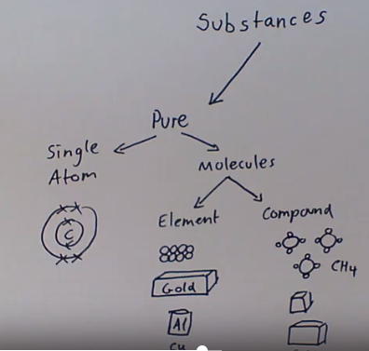 | Substances are either pure or impure.  Pure substances are only made of one substance. Impure substances are mixtures of more than one substance.  Single atoms, like an atom of carbon, are pure because they are just 1 atom so are just 1 substance.  A bar of gold is pure because it is made of just gold atoms. O₂ is pure because it is just two of the same atom, oxygen.  We can also have a substance made of a compound that is pure. For example table salt is a pure substance, it is a lot of NaCl. A sugar cube is a pure substance, it is made up of millions of molecules of the compound sucrose. Sucrose is a compound made of different atoms, carbon, hydrogen and oxygen, but because a sugar cube is just sucrose we call it a pure substance.
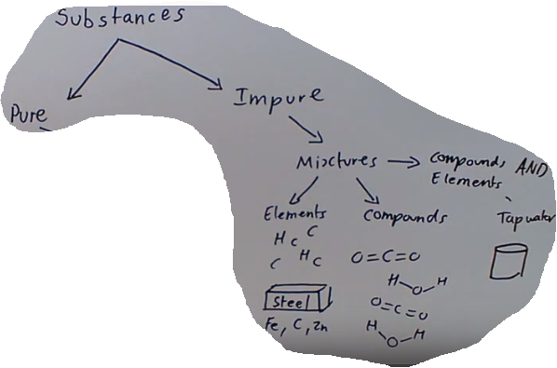 | Impure substances are mixtures.  They can be mixtures of different elements, such as steel which is a mixture of iron, carbon and zinc.  Impure substances can be mixtures of compounds such as salt water, which is NaCl dissolved in H₂O.  Or they can mixtures of different compounds and elements, air is an example of this. The air we breathe contains elements like oxygen, nitrogen and argon; and compounds like carbon dioxide and methane.  Or petrol which contains different compounds called hydrocarbons and impurities including nitrogen and sulphur.
Define ‘mixture.’ | Two or more different substances which are not chemically joined together.
Define ‘element.’ | An element is a substance composed of only one type of atom.
Define ‘compound.’ | Two or more different elements chemically joined together.
Key Knowledge
Complete your look, cover, write, check

Recall quiz
- Is petrol an element, compound or mixture?
- Saltwater is defined as a mixture because it is made up of…
- Sugar is a compound because…
- Diamond is not a compound or mixture because…

1.
2.
3.
4.
5.
6.
7.
8.
9.
10.
11.
12.

Are the above elements, compounds or mixtures?
- Mixture | - Mixture
- Element
- Compound (pure)

Are the above elements, compounds or mixtures?

Separation Techniques
Do Now:
- Name the impure substance: water, gold, air, nitrogen, carbon monoxide, glucose
- Name the pure substance: Seawater, air, oxygen, fruit juice
- How many atoms of carbon are there in C₅H₁₂?
- Which of these is a compound: O₂, H₂, O₃, H₂O
- Which of these is an element: H₂O, Cl₂, CO₂, C₅H₁₂

In our last lesson, we learned to tell the difference between a pure substance like an element or compound, and a mixture.
We learned about a certain type of mixture common in chemistry called a solution, where a solute is dissolved, evenly dispersed, throughout a solvent.
In chemistry and in the wider world, it is often important to separate mixtures. Most of us (at least in this country) do this every single day, whenever we make tea or coffee. Because the different substances in a mixture are not chemically combined, it is possible to use physical processes to separate out and purify the different substances in a mixture. These physical processes are called separation techniques.
Filtration | Filtration is the separation technique used when making tea or coffee. Filtration is used to separate an insoluble solid from a liquid. The mixture is poured through filter paper in a funnel. The solid trapped by the filter paper is called the residue, and the purified liquid is called the filtrate.
Crystallisation | Crystallisation is used when you want to separate a soluble solid from a solution. The solution is heated in an evaporating basin until the liquid part of the mixture evaporates, leaving behind solid crystals of the solute.
distillation | Distillation is the opposite of crystallisation, and is used to separate a liquid from a solution. Simple distillation is used to separate a liquid from a soluble solid. The solution is heated until the liquid evaporates. The vapour is then cooled back down until it condenses and is collected in a suitable container like a beaker.
chromatography | Chromatography is used to both separate and identify multiple dissolved substances. Our next lesson will examine chromatography in more depth.  Although these techniques may seem complicated, it is actually much easier to separate the substances in a mixture than it is to separate the elements in a compound. In other to separate the elements in a compound, the chemical bonds holding the atoms together must be broken. This requires a chemical reaction to take place. The substances in a mixture, however, can be separated through physical processes. No chemical reactions are needed.
How can mixtures be separated? | Physical processes which include the separation techniques: filtration, crystallisation, simple distillation, fractional distillation, and chromatography.
When is filtration used? | To separate an insoluble solid from a liquid.
When is crystallisation used? | To separate a soluble solid from a liquid.
When is simple distillation used? | To separate a liquid from a soluble solid.
When is chromatography used? | To separate dissolved substances from one another, frequently inks or dyes.
Key Knowledge
Complete your look, cover, write, check

Recall quiz
- Mixtures can be separated using…
- Three examples of these physical processes are…
- The technique I would use to separate salt from a salt water solution is…

Application task – 1:
Label the diagrams

Chromatography
Do Now:
- Is salt water a pure substance or an impure substance?
- Is petrol a pure substance or a mixture?
- Is water a compound or element?
- Name the state of matter in which particles can only vibrate.
- Name the state of matter which has a fixed volume, but no fixed shape.
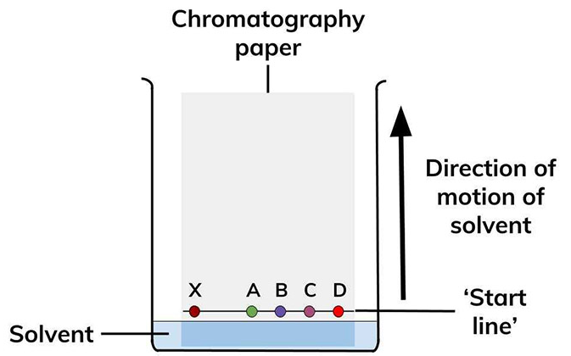 | Chromatography is used to both separate and identify multiple dissolved substances. Our next lesson will examine chromatography in more depth.  Although these techniques may seem complicated, it is actually much easier to separate the substances in a mixture than it is to separate the elements in a compound. In other to separate the elements in a compound, the chemical bonds holding the atoms together must be broken. This requires a chemical reaction to take place. The substances in a mixture, however, can be separated through physical processes. No chemical reactions are needed.
Practical Method – chromatography is done as a practical.
Use a ruler to draw a horizontal pencil line 2 cm from a short edge of the chromatography paper.
Mark five pencil spots at equal intervals across the line. Keep at least 1 cm away from each end.
Use a glass capillary tube to put a small spot of each of the known colourings on four of the pencil spots. Then use the glass capillary tube to put a small spot of the unknown mixture on the 5th pencil spot.
Try to make sure each spot is no more than 5 mm in diameter.
Label each spot in pencil.
Pour water into the beaker to a depth of no more than 1 cm.
Tape the edge of the chromatography paper to the glass rod. The paper needs to be taped at the end furthest from the spots.
Rest the rod on the top edge of the beaker. The bottom edge of the paper should dip into the water.
Ensure that the:
pencil line is above the water surface
sides of the paper do not touch the beaker wall.
Wait for the water solvent to travel at least three quarters of the way up the paper. Do not disturb the beaker during this time.
Carefully remove the paper. Draw another pencil line on the dry part of the paper as close to the wet edge as possible.
Hang the paper up to dry thoroughly.
Measure the distance in mm between the two pencil lines. This is the distance travelled by the water solvent.
Measure and record the same distance for each food colouring in the table below.

Define ‘mobile phase.’ | Phase in chromatography that moves, usually a solvent or mixture of solvents.
Define ‘stationary phase.’ | Phase in chromatography that does not move, i.e. the paper.
Explain why some substances travel further in chromatography than others. | Dissolved substances that travel further are more soluble/more strongly attracted to the mobile phase.
Define ‘retention factor (R_{f}) value.’ | The R_{f} value can be used to identify substances in chromatography. It is always between 0 and 1.
Give the formula used to calculate R_{f}. | $$R_{f}=\frac{distance travelled by substance}{distance travelled by solvent}$$
Key Knowledge
Complete your look, cover, write, check

Recall quiz
- Chromatography separates substances based on their…
- The R_{f} value describes the relative attraction of a solute to the mobile and stationary phases, and is always between…
- The formula to calculate the retention factor is…
- In paper chromatography, the stationary phase is the…

Application task – I do:  Calculate the Rf value of B.  $$R_{f}=\frac{distance travelled by substance}{distance travelled by solvent}$$  $$R_{f}=\frac{3}{5}$$  $$R_{f}=0.6$$ | 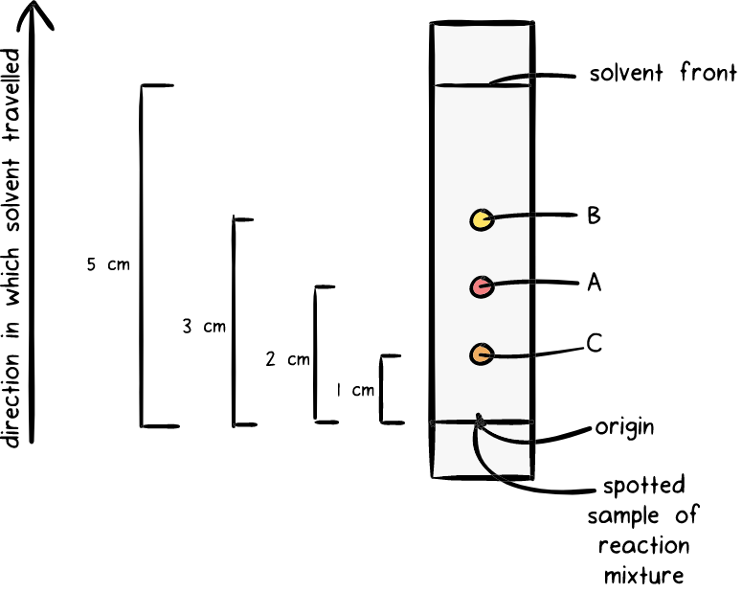
Application task – We do:
Calculate the Rf value of A.
$$R_{f}=\frac{ }{distance travelled by solvent}$$
$$R_{f}=\frac{ }{ }$$
$$R_{f}=$$

Application task – You do:
Calculate the Rf value of A.

Application task:  - Calculate the Rf value of the blue dot  - Calculate the Rf value of the red dot  - Calculate the Rf value of the green dot  - Calculate the Rf values of the three black dots | 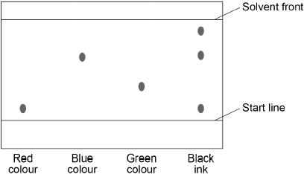
- Calculate the Rf value of the red (right) dot  - Calculate the Rf value of the purple (middle) dot  - Calculate the Rf value of the yellow (left) dot | 