Independent learning Pack
Year 10 – Reacting Substances
Summer 1

Week 5
Reversible Reactions

Level 1-4
Q1.
Read the information and then answer the questions.

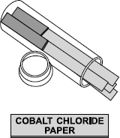
Cobalt chloride paper can be used to test for water.
The paper contains anhydrous cobalt chloride.
The jar containing the papers must be kept closed
when not being used.
The equation shows the reaction between anhydrous cobalt chloride and water.

CoCl₂ | + | 6 H₂O |  | CoCl₂.6H₂O
anhydrous cobalt chloride |  |  |  | hydrated cobalt chloride
(blue) |  |  |  | (pink)
(a) Choose one word from the box to complete the sentence.

endothermic | exothermic | reversible
The symbol means that the reaction is __________________________
(1)
(b) Describe the colour change when water is added to the cobalt chloride paper.
___________________________________________________________________
___________________________________________________________________
(1)
(c) Suggest why the jar containing the unused cobalt chloride papers must be kept closed.
___________________________________________________________________
___________________________________________________________________
(1)
(Total 3 marks)

Level 1-4
Q2.
Hydrogen gas is produced by the reaction of methane and steam.
(a) The diagram represents a molecule of hydrogen.
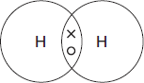
(i) What type of bond joins the atoms of hydrogen?
Tick (✔) one box.
Covalent
Metallic
Ionic
(1)
(ii) A catalyst is used in the reaction.Draw a ring around the correct answer to complete the sentence.

A catalyst | increases the rate of reaction.  increases the temperature.  increases the yield of a reaction.
(1)
(b) The equation for the reaction of methane and steam is:
CH₄(g) + H₂O(g) CO(g) + 3H₂(g)
(i) What is meant by the symbol ?
______________________________________________________________
(1)
(ii) Lowering the pressure reduces the rate of reaction.
Explain why, in terms of particles.
______________________________________________________________
______________________________________________________________
______________________________________________________________
(2)
(iii) The graph shows the yield of hydrogen at different temperatures.
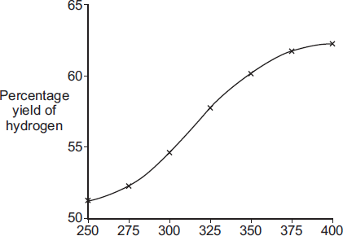
Temperature in °C
The forward reaction is endothermic.
How does the graph show that the forward reaction is endothermic?
______________________________________________________________
______________________________________________________________
(1)
(iv) Why is a higher yield produced if the reaction is repeated at a lower pressure?
______________________________________________________________
______________________________________________________________
(1)

Level 7-9

(c) Car engines are being developed that use hydrogen gas as a fuel instead of petrol.
The table compares the two fuels.

 | Hydrogen | Petrol
Energy | 5700 kJ per litre | 34 000 kJ per litre
State | Gas | Liquid
Equation for combustion | 2H₂ + O₂ → 2H₂O | 2C₈H₁₈ + 25O₂ → 16CO₂ + 18H₂O
How the fuel is obtained | Most hydrogen is produced from coal, oil or natural gas.  Hydrogen can be produced by the electrolysis of water or the solar decomposition of water. | Fractional distillation of crude oil.
Use the information in the table and your knowledge of fuels to evaluate the use of hydrogen instead of petrol as a fuel.
You should describe the advantages and disadvantages of using hydrogen instead of petrol.
___________________________________________________________________
___________________________________________________________________
___________________________________________________________________
___________________________________________________________________
___________________________________________________________________
___________________________________________________________________
___________________________________________________________________
___________________________________________________________________
___________________________________________________________________
___________________________________________________________________
(6)
(Total 13 marks)

Q3.
In industry ethanol is produced by the reaction of ethene and steam at 300°C and 60 atmospheres pressure using a catalyst.
The equation for the reaction is:
C₂H₄ (g) + H₂O (g) C₂H₅OH (g)
The figure below shows a flow diagram of the process.
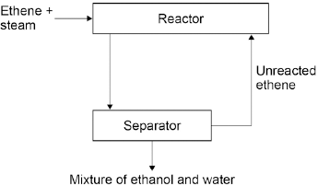
(a) Why does the mixture from the separator contain ethanol and water?
___________________________________________________________________
___________________________________________________________________
(1)
(b) The forward reaction is exothermic.
Use Le Chatelier’s Principle to predict the effect of increasing temperature on the amount of ethanol produced at equilibrium.
Give a reason for your prediction.
___________________________________________________________________
___________________________________________________________________
___________________________________________________________________
___________________________________________________________________
(2)
(c) Explain how increasing the pressure of the reactants will affect the amount of ethanol produced at equilibrium.
___________________________________________________________________
___________________________________________________________________
___________________________________________________________________
___________________________________________________________________
(2)
(Total 5 marks)

Calculations Part 1

Level 1-4
Q1.
This question is about carbon and gases in the air.
(a) Carbon atoms have protons, neutrons and electrons.
Complete the table by writing the relative mass of a neutron and an electron.

Name of particle | Relative mass
proton | 1
neutron
electron
(2)
(b) What is the total number of protons and neutrons in an atom called?

Tick () one box.
The atomic number
The mass number
One mole of the atom
(1)
(c) An atom of carbon has six electrons.
Which structure, A, B or C, represents the electronic structure of the carbon atom?
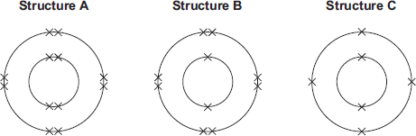

The carbon atom is structure
(1)
(d) Carbon reacts with oxygen to produce carbon dioxide (CO₂).
(i) How many different elements are in one molecule of carbon dioxide?
______________________________________________________________
(1)
(ii) What is the total number of atoms in one molecule of carbon dioxide?
______________________________________________________________
(1)
(e) Sometimes carbon reacts with oxygen to produce carbon monoxide (CO).
(i) Calculate the relative formula mass (M_{r}) of carbon monoxide.
Relative atomic masses (A_{r}): C = 12; O = 16
______________________________________________________________
______________________________________________________________
M_{r} of carbon monoxide = _______________
(1)
(f) Carbon dioxide is one of the gases in the air.
(i) The graph shows the percentage of argon and the percentage of carbon dioxide in the air.
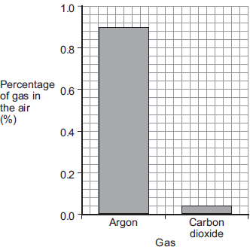
What is the percentage of argon in the air?
Percentage of argon = ____________________ %
(1)
(Total 10 marks)
Q2.
Printed pictures can be made using etchings.
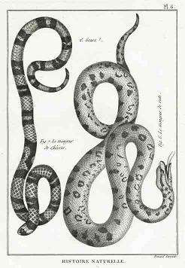
© Eduardo Jose Bernardino/iStock
An etching can be made when a sheet of brass reacts with iron chloride solution.
(a) Brass is a mixture of two metals, copper and zinc.
(i) A mixture of two metals is called ______________________________ .
(1)
(ii) Draw a ring around the correct answer to complete the sentence.
Copper and zinc atoms are different sizes.

 | harder
This makes brass | more flexible | than the pure metals.
 | softer
(1)
(b) Iron chloride has the formula FeCl₃
Relative atomic masses (A_{r}): Cl = 35.5; Fe = 56.
(i) Calculate the relative formula mass (M_{r}) of iron chloride (FeCl₃).
______________________________________________________________
______________________________________________________________
______________________________________________________________
Relative formula mass (M_{r}) of iron chloride = ___________________
(2)
(Total 6 marks)
Q3.
As the world population increases there is a greater demand for fertilisers.
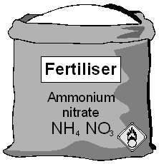
(b) The amount of nitrogen in a fertiliser is important.
(i) How many nitrogen atoms are there in the formula, NH₄NO₃?
______________________________________________________________
(1)
(ii) Work out the relative formula mass of ammonium nitrate, NH₄NO₃.
Relative atomic masses: H 1; N 14; O 16.
______________________________________________________________
______________________________________________________________
Relative formula mass of ammonium nitrate = ________________
(1)
(Total 4 marks)

Week 6
Calculations Part 2
Level 1-4
Q1. Balance the following equations
- ____Ca + ____O₂ → ____CaO
- ____Na₂O + ____H₂O → ____NaOH
- ____Al + ____O₂ → ____Al₂O₃
- ____Na + ____Cl₂ → ____NaCl
- ____Na₂CO₃ → ____Na₂O + ____CO₂
- ____K + ____O₂ → ____K₂O
- ____C₄H₈ + ____O₂ → ____CO₂ + ____H₂O
- ____Fe₂O₃ +____ HCl → ____FeCl₃ + ____H₂O
- ____F₂ + ____KBr → ____KF + ____Br₂
- ____C₅H₁₂ +____ O₂ → ____CO₂ + ____H₂O
- ____NH₃ + ____O₂ →____ NO + ____H₂O
- ____HNO₃ →____ NO₂ + ____H₂O + ____O₂

Q2. Calculate the moles for each substance

Substance | Mr | Mass | Moles
Na |  | 2g
H2O |  | 5g
LiCl |  | 7g
CuSO4 |  | 4g
MgO |  | 28g
H2SO4 |  | 96g

Q3.
Calcium oxide (quicklime) is made by heating calcium carbonate (limestone).
calcium carbonate → calcium oxide + carbon dioxide
100 g ? 44 g
(a) 44 grams of carbon dioxide is produced when 100 grams of calcium carbonate is heated.
Calculate the mass of calcium oxide produced when 100 grams of calcium carbonate is heated.
___________________________________________________________________
mass _____________ g
(1)
(b) What mass of carbon dioxide could be made from 100 tonnes of calcium carbonate?
mass ____________ tonnes
(1)
(Total 2 marks)

Level 5-6
Q4.
Magnesium reacts with steam to produce hydrogen gas and magnesium oxide.
A teacher demonstrated the reaction to a class. The figure below shows the apparatus the teacher used.
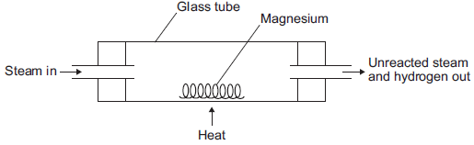
(b) The equation for the reaction is:
Mg(s) + H₂O(g) MgO(s) + H₂(g)
(i) The teacher used 1.00 g of magnesium.
Use the equation to calculate the maximum mass of magnesium oxide produced.
Give your answer to three significant figures.
Relative atomic masses (A _{r}): O = 16; Mg = 24
______________________________________________________________
______________________________________________________________
______________________________________________________________
Maximum mass = ____________________ g
(3)
(ii) The teacher’s demonstration produced 1.50 g of magnesium oxide.
Use your answer from part (b)(i) to calculate the percentage yield.
If you could not answer part (b)(i), use 1.82 g as the maximum mass of magnesium oxide. This is not the answer to part (b)(i).
______________________________________________________________
Percentage yield = ____________________ %
(2)
(iii) Give one reason why the percentage yield is less than 100%.
______________________________________________________________
______________________________________________________________
______________________________________________________________
(1)
(Total 10 marks)
Q5.
Scientists found that a compound contained:
22.8% sodium; 21.8% boron; and 55.4% oxygen.
Use the percentages to calculate the empirical formula of the compound.
Relative atomic masses (A _{r}): B = 11; O = 16; Na = 23
To gain full marks you must show all your working.
_______________________________________________________________________
_______________________________________________________________________
_______________________________________________________________________
_______________________________________________________________________
_______________________________________________________________________
_______________________________________________________________________
_______________________________________________________________________
_______________________________________________________________________
_______________________________________________________________________
_______________________________________________________________________
_______________________________________________________________________
_______________________________________________________________________
Empirical formula = ______________________________
(Total 5 marks)

Level 7-9
Q6.
Etching is a way of making printed circuit boards for computers.
© Dario Lo Presti/Shutterstock
Printed circuit boards are made when copper sheets are etched using iron(III) chloride solution. Where the copper has been etched, only plastic remains.
(b) Iron(III) chloride can be produced by the reaction shown in the equation:
2 Fe + 3 Cl₂ → 2 FeCl₃
(i) Calculate the maximum mass of iron(III) chloride (FeCl₃) that can be produced from 11.20 g of iron.
Relative atomic masses (A_{r}): Cl = 35.5; Fe = 56.
______________________________________________________________
______________________________________________________________
______________________________________________________________
______________________________________________________________
______________________________________________________________
Maximum mass of iron(III) chloride = _______________ g
(3)
(ii) The actual mass of iron(III) chloride (FeCl₃) produced was 24.3 g.
Calculate the percentage yield.
(If you did not answer part (b)(i) assume that the maximum theoretical mass of iron(III) chloride (FeCl₃) is 28.0 g. This is not the correct answer to part (b)(i).)
______________________________________________________________
______________________________________________________________
Percentage yield = _______________%
(1)
(Total 6 marks)
Q7.
(a) This label has been taken from a bottle of vinegar.
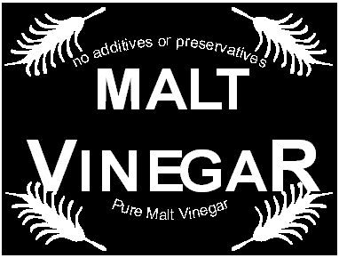
Vinegar is used for seasoning foods. It is a solution of ethanoic acid in water.
In an experiment, it was found that the ethanoic acid present in a 15.000 cm³ sample of vinegar was neutralised by 45.000 cm³ of sodium hydroxide solution, of concentration 0.20 moles per cubic decimetre (moles per litre).
The equation which represents this reaction is
CH₃COOH + NaOH → CH₃COONa + H₂O
Calculate the concentration of the ethanoic acid in this vinegar:
(i) in moles per cubic decimetre (moles per litre);
______________________________________________________________
______________________________________________________________
______________________________________________________________
______________________________________________________________
Concentration =__________________ moles per cubic decimetre
(2)
(ii) in grams per cubic decimetre (grams per litre).
Relative atomic masses: H = 1; C = 12; O = 16.
______________________________________________________________
______________________________________________________________
______________________________________________________________
Concentration = _________________ grams per cubic decimetre
(2)

