Year 7
Weeks 4 Independent learning Pack

Week 4 – Kingdoms
Q1. The drawings below show a stoat, a weasel and an American mink. The stoat and weasel are British wild animals. Mink are from America.

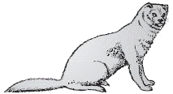
stoat weasel

American mink
(a) They all hunt and eat rabbits.1 000 American mink were set free into the British countryside in 1998.
(i) What happened to the numbers of rabbits in the countryside?
...............................................................................................................
1 mark
Give a reason for your answer.
.................................................................................................................................................................
1 mark
(ii) How did this affect the stoats and weasels that lived in the countryside?
.................................................................................................................................................................
1 mark
(b) Stoats, weasels and American mink all hunt and eat rabbits Complete the sentence below.
The stoats, weasels and American mink are all predators and the rabbits are their ............................
1 mark
(c) (i) Give the name of one other wild animal in Britain that hunts for small
animals such as rabbits.
...............................................................................................................
1 mark
(ii) The American mink were not hunted by other animals in the British
countryside, but many of the mink died.
Suggest two different reasons why the mink died.
1. ............................................................................................................
1 mark
2. ............................................................................................................
1 mark
(d) Stoats, weasels and mink are all mammals.
Give one way you tell from the drawings that they are mammals.
......................................................................................................................... (1)
Q2. The drawing shows eight living things.

Eight living things are drawn.
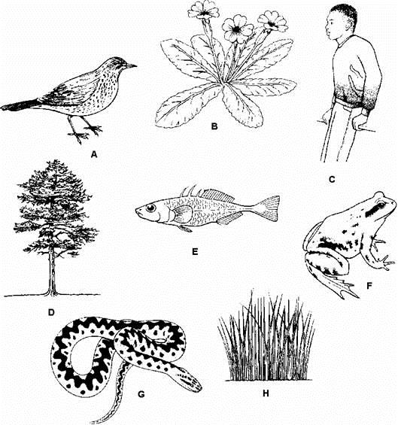
Give the letters of:
(a) one living thing which uses gills to take in oxygen;
1 mark
(b) one living thing which produces seeds;
1 mark
(c) one living thing which uses lungs to breathe;
1 mark
(d) two living things which lay eggs in water;
......................… and ......................…
2 marks
(e) two living things which are covered in scales.
......................… and ......................…
2 marks

Extension
Q3. The chart shows a way to group living things.
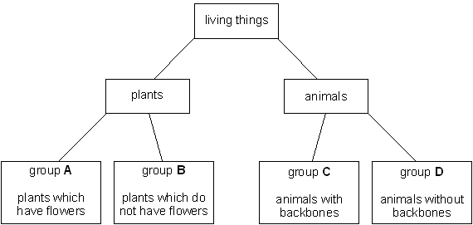
To which group, A, B, C or D, do the following living things belong?
Each letter may be used once, more than once or not at all.
earthworm ..................................
rabbit ..................................
rose bush ..................................
human ..................................
4 marks

Total
/15

With Extension
/19

Week 3 – Food Webs
A food web starts with the plants at the bottom plants are called _________ because they produce food by ____________. The animals that eat the plants are called the _________.Because the food web shows how _____ moves through the ecosystem you just them with an __________that points towards/away from the animal that does the eating (5)
- Where does all of the energy in a food chain come from?
_______________________________________________________________ (1)
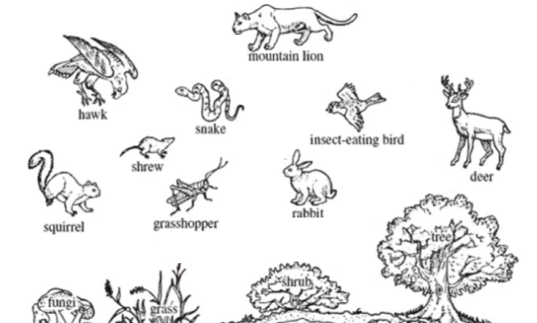
- Draw a food web for the following animals (5)

- Name the producers ___________________________________________(2)
- Name the primary consumers _____________________ ______________(2)
- Name the herbivores _____________________________ _____________ (2)
- Name the carnivores __________________________________________ (2)
Extension Q1.
The diagram below shows part of a grassland food web.
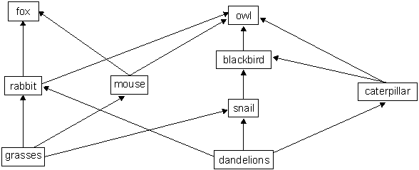

(a) One year the snail population increased in the grassland area.
How could an increase in the number of snails cause the caterpillar population to increase?
................................................................................................................................................(1)(b) Snail poison can be used to control the number of snails. After some time, each owl contains more poison than each snail. Explain why each owl contains more poison than each snail.
....................................................................................................................................................................................................................................................................................................(2)
(c) A scientist wants to record the number of dandelion plants in the grassland area.
Describe how they could use a 1m² quadrat to estimate the number of dandelions growing in the grassland area.
....................................................................................................................................................................................................................................................................................................(2)
(d) The table below shows the population numbers for one food chain from the food web.

organism | number
dandelions | 200
rabbits | 20
foxes | 4
Complete the pyramid of numbers on the graph paper below to represent this food chain. Label the pyramid to show each animal.
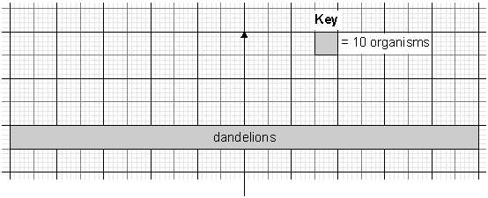 (2)
Total /19
With Extension /26

