**Year 7**

**Weeks 5 and 6 Independent learning Pack**

**Week 5 – Cells**

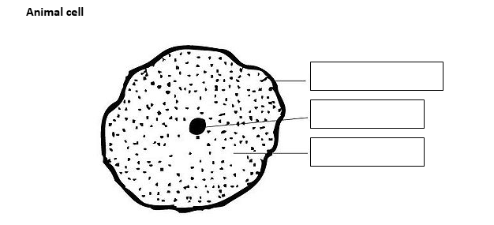Label the plant and animal cells **(9)**

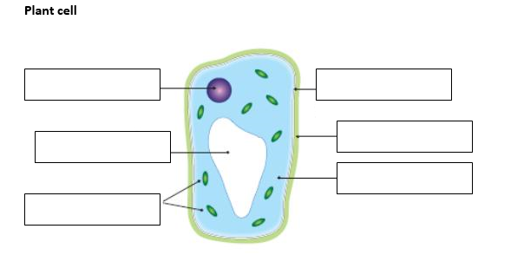

Activity 1: Which bit is it?

*Which part …*

1. …of an animal cell controls the cell’s activities? ………………………….
2. …of an animal forms a thin layer around the outside? …………………….
3. …is a liquid found inside animal cells? ……………………………………………..
4. …is a green structure found inside plant cells? ………………………………..
5. …is a store of liquid found inside plant cells? ……………………………………..

Activity 2: True or False?

*Read each statement and decide whether it is true or false:*

1. Almost all cells have a nucleus. ………………..
2. All plant cells contain chloroplasts. ……………….
3. The cell membrane controls what goes in and out of the cell. …………….
4. Animal cells have cell membranes. ………………
5. Animal cells have cell walls. …………………
6. All cells contains some cytoplasm. ……………….

Activity 3: Specialised Cells

*Answer the questions about specialised cells using the diagrams to help you!*

1. Give the letters of 2 plant cells ………. & …………..
2. Which one of the plant cells contains chloroplasts? ……..
3. Give the function of chloroplasts……………………………..
4. Give the letter of the ciliated cell ……………..
5. What is the function of this ciliated cell? …………………….
6. Give the letter of the cell that transfers genetic information from father to offspring? …………………………………
7. Name 2 ways a red blood cell (d) is specialised …………… ………………………………………………………………….

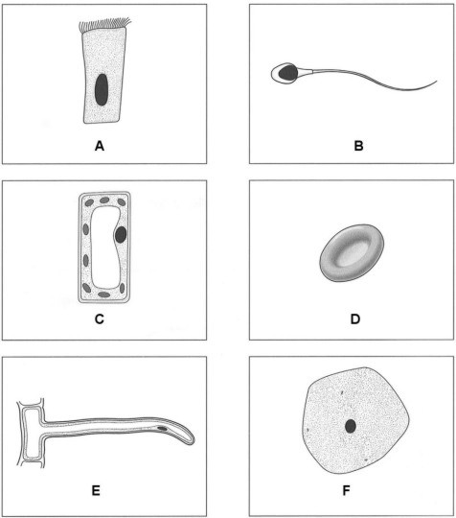

Total /20

Extension /29

**Week 5 – Microscopes**

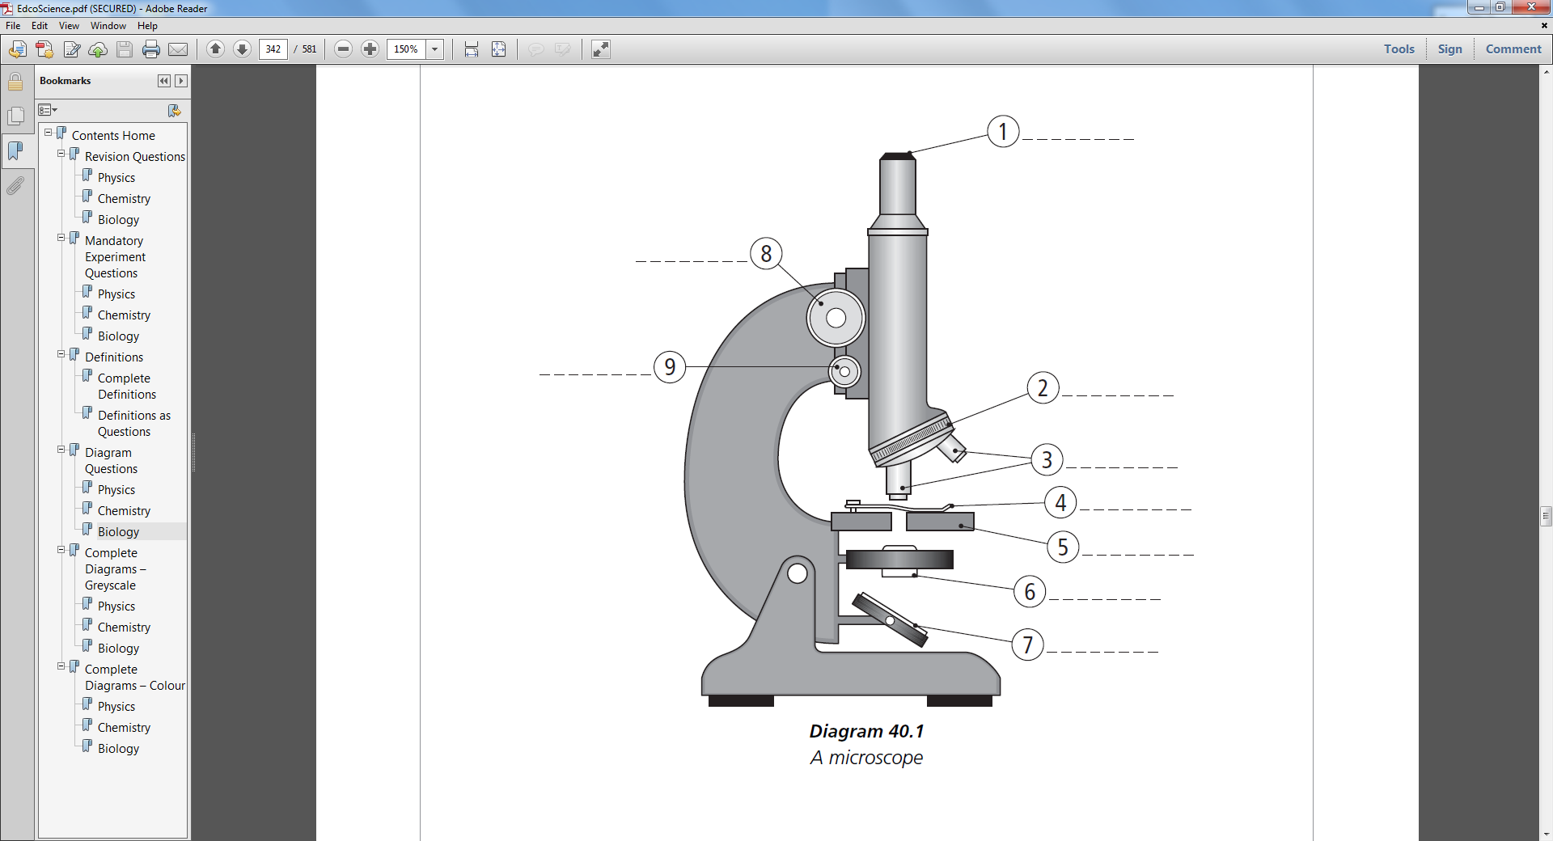Label the diagram (9)

Match the part of the microscope to the function (9)

|  |  |  |
| --- | --- | --- |
| **Part** |  | **Function** |
| **Eyepiece Lens** |  | Controls the amount of light that goes onto the microscope slide. |
| **Objective Lens** | This is the lens closest to your eye. It usually has a magnification of x10 |
| **Stage** | This is used to focus the image so it is very sharp and clear. |
| **Diaphragm** | This is used to focus the image so that you can see it clearly. |
| **Light** | This holds the eyepiece lens above the stage. |
| **Base** | There are three lenses of different strengths which can be used to magnify the image more clearly. |
| **Arm** | This is the place where you put a microscope slide. Clips hold the slide in place |
| **Fine Focus Knob** | The light source projects light onto the microscope slide. It can be a mirror or an electric bulb. |
| **Coarse Focus Knob** | This is very heavy to keep the microscope from falling over |

Extension

Complete the missing boxes using the equation (4)

Total magnification = objective magnification eyepiece magnification

|  |  |  |
| --- | --- | --- |
| **Eyepiece Magnification** | **Objective Magnification** | **Total Magnification** |
| 10x | 4x | 40x |
| 10x | 5x |  |
| 5x |  | 200x |
|  | 120x | 600x |
| 5x | 100x |  |
| 10x |  | 1250x |

Total /19

With extension /23

**Week 6 – Topic Review**

1. What will happen to the number of predators if the number of prey increases? (1)

_____________________________________________________________________________________

1. State three things that organisms depend on each other for (1)

_____________________________________________________________________________________

1. State the type of organism that all food chains start with (1)

_____________________________________________________________________________________

1. Name the diagram that is used to classify organisms (1)

_____________________________________________________________________________________

1. Define "herbivore" (1)

_____________________________________________________________________________________

1. Name the five kingdoms (1)

_____________________________________________________________________________________

1. Define "omnivore" (1)

_____________________________________________________________________________________

1. State three things that animals compete with each other for (1)

_____________________________________________________________________________________

1. What will happen to the number of prey if the number of predators increases? (1)

_____________________________________________________________________________________

1. What does the arrow in a food chain represent? (1)

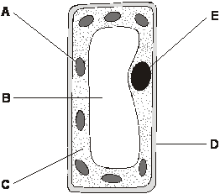_____________________________________________________________________________________

**Q11.**

The diagram shows a plant cell.

(a)     Give the name of part A.______________________

          Give the function of part A.

_____________________________________________________________________(2)

(b)     Give the name of part E.________________________________

          Give the function of part E.

_____________________________________________________________________(2)

(c)     Give the letters of **two** parts that are present in plant cells but **not** in animal cells.

.................. and .................. (1)

(d)     How can you tell that the cell in the diagram is from a leaf and **not** from a root?

................................................................................................................ (1)

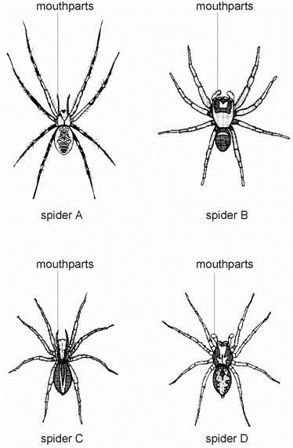**Q12.** The drawings show four different kinds of spider.

          Look at the drawings of the spiders.  
Use the key to find the name of each spider. Start at 1.  
Write your answers in the table below the key.

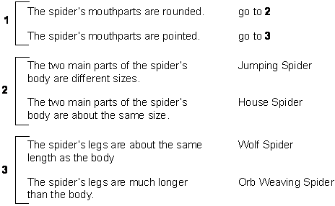

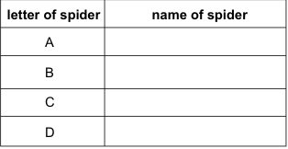(4)

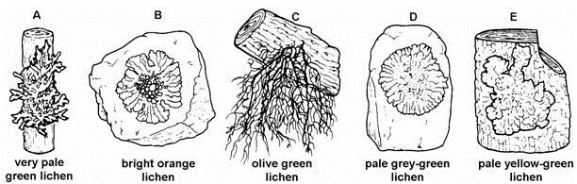Extension

The drawings show five different lichens which grow on rocks or trees.

Identify lichens A, C and D using the key below.

1.      The lichens grow on tree bark...............        Go to 2  
The lichens grow on rocks ...................        Go to 4

2.      They grow flat against the surface .......           *Parmelia subrudecta*They have branches which  
grow away from the surface..................        Go to 3

3.      They have long dangling branches ......            *Usnea*They have short branches ...................         *Evernia*

4.      They are bright orange ........................          *Xanthoria*They are pale grey-green ....................          *Parmelia saxatilis*

         The name of Lichen A is ......................................................................

         The name of Lichen C is ......................................................................

         The name of Lichen D is ......................................................................

(3)

Total /20

With Extension /23