Year 8 Summer 1
Independent learning pack Week 3

Week 3 - Food Groups and Diet

- Fill in the missing gaps in the table below:

Nutrient | Why do you need it? | Foods where it is found (sources) | What happens if you don’t get enough? (deficiency)
Protein | Nutrient your body uses to build new tissue for growth and repair. | Meat, fish, eggs, dairy products, beans, nuts and seeds.
 |  | Oils, butter
Carbohydrates | The body’s main source of energy. There are two types: simple (sugars) and complex (starch).
Vitamins e.g. Vitamin C | Helps bind cells together. |  | You can get scurvy (bleeding gums, bruising, tender skin)
Minerals e.g. iron |  | Needed to make red blood cells
Minerals e.g. calcium |  | Milk, cheese, green vegetables
Fibre | Parts of plants that cannot be digested, which helps the body eliminate waste. |  | You get constipated – are unable to go to the loo.

Maximum 11 marks

2. Use the table above to help state which nutrient the following people are deficient in and what foods they need to eat to improve their health:
a) A group of sailors are suffering from scurvy, the appearance of red dots on their skin, bleeding and swelling of the gums. Their teeth are even falling out! (2)
………………………………………………………………………………………………………………………………………………………………………………………..
b) A child is taken to hospital with a shortness of breath, lack of energy and pale complexion due to anaemia. (2)
…………………………………………………………………………………………………………………………………………………………………………………………………………………………………………………………
Use the table above to help explain why:
b) Young children should drink a pint of milk a day. (2)
…………………………………………………………………………………………………………………………………………………………………………………………………………………………………………………………
c) Bruce the body-builder choices to eat large portions of chicken, fish and lentils every day. (2)
…………………………………………………………………………………………………………………………………………………………………………………………………………………………………………………………
d) Why pregnant woman need more carbohydrates. (2)
…………………………………………………………………………………………………………………………………………………………………………………………………………………………………………………………
Maximum 10 marks
Q3.
(a) Green beans contain vitamin C.
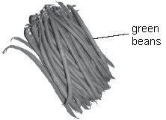
Which other food is a good source of vitamin C?
Tick the correct box.
cheese chicken eggs oranges
1 mark
(b) The amount of vitamin C changes in the beans and in the water as the beans are cooked. The shading shows how it changes.
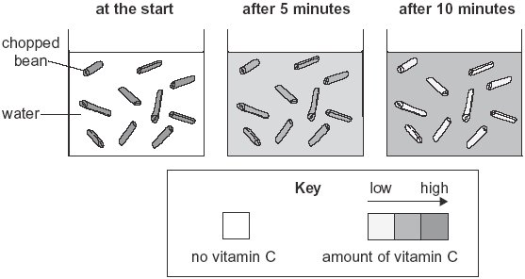
Use the diagram. How does the amount of vitamin C in the beans and in the water change as the beans are cooked? Tick one box in each row.

amount of vitamin C | increases | decreases | stays the same
in the beans
in the water
1 mark
(c) Cheese is a source of calcium.
Why do we need calcium?
........................................................................................................................ 1 mark
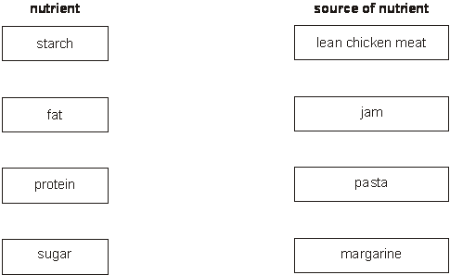
(d) Draw a line from each nutrient to a good source of that nutrient in our diet.
2 marks
maximum 5 marks
Total Marks = / 25
Red = < 8
Yellow = 9 – 15
Green = 16 - 25

Extension
Q1.
Table 1 gives information about 100 g of five different foods.

food | energy per 100 g | nutrients per 100 g of each food
 | of food  (kJ) | protein  (g) | fat  (g) | carbohydrate  (g) | calcium  (mg)
banana | 403 | 1.2 | 0.3 | 23.2 | 6
wholemeal  bread | 914 | 9.2 | 2.5 | 41.6 | 54
butter | 3031 | 0.5 | 81.7 | 0 | 15
cheese | 1708 | 22.5 | 34.4 | 0.1 | 720
milk | 275 | 3.2 | 3.9 | 4.8 | 115
(a) Look at table 1.
(i) Which of the four nutrients, protein, fat, carbohydrate or calcium, provides
most of the energy in the cheese?
................................................................................................................
(ii) Which of the four nutrients provides most of the energy in the wholemeal
bread?
................................................................................................................
(iii) Which of the four nutrients is needed for growth and repair?
................................................................................................................ 3 marks
(b) The recommended daily amount of protein for a woman is 45 g. Look at table 1.
How many grams of cheese would provide 45 g of protein? Tick the correct box.
50 g 100 g 150 g 200 g 1 mark
(c) Not all the types of nutrients needed for a balanced diet are shown in table 1.
Give the name of one of the missing types of nutrient.
............................................................. 1 mark
(d) Table 2 shows the recommended daily amount of calcium for a person in four
stages of the human life cycle.
We need calcium for healthy teeth and bones.

person | recommended daily amount of calcium (mg)
a baby aged 6 months | 600
a woman before she is pregnant | 500
a pregnant woman | 1200
a breast-feeding woman

(i) Use information in table 2 to estimate how much calcium a breast-feeding
woman should have each day.
............. mg
(ii) Explain why she would need this amount of calcium.
................................................................................................................
................................................................................................................ 2 marks
maximum 7 marks
Total Marks = / 32
Red = < 15
Yellow = 16 – 23
Green = 24 - 32

Knowledge Quiz
Topic: |  | Food
1 | Name the 7 food groups | Carbohydrates, proteins, fats, fibre, vitamins, minerals, water
2 | State 2 examples of food rich in carbohydrates | Rice and pasta
3 | State 3 examples of food rich in protein | Fish, meat and eggs
4 | State 3 examples of food rich in fat | Butter, cheese and chocolate
5 | State 3 examples of food rich in minerals and vitamins | Fruit and vegetables
6 | State 2 examples of food rich in fibre | Brown bread and cereal
7 | Define "balanced diet" | Eating a variety of foods in the correct proportions
8 | State three diseases associated with an unbalanced diet | Obesity, anorexia and Type 2 diabetes
9 | Define "anorexia" | Refusing to eat to lose weight
10 | Give three reasons why someone may need to consume more calories than normal | 1) very active, 2) growing, 3) pregnant

