Year 8 Summer 1
Independent learning pack Week 5-6
Knowledge Quiz

 | Topic: | Digestion (B.15)
1 | State the 7 main organs in the digestive system | Mouth, oesophagus, stomach, pancreas, liver, small intestine, large intestine
2 | Which enzyme helps us to digest carbohydrates? | Amylase
3 | Which enzyme helps us to digest proteins? | Protease
4 | Which enzyme helps us to digest fats? | Lipase
5 | Where is amylase produced? | Salivary glands and small intestine
6 | Where is protease produced? | Stomach, pancreas and small intestine
7 | Where is lipase produced? | Pancreas and small intestine
8 | Where is bile produced? | The liver
9 | What is absorbed from the small intestine? | Nutrients
10 | What is absorbed from the large intestine? | Water

Week 5 - Photosynthesis
- a)
Fill in the Gaps...
Leaves help to make ___________ for a plant. They contain a green substance called ________________. The leaves take in a gas called ________ _________. The roots take in ____________ and other substances from the ground.
____________ energy from the Sun helps the chlorophyll change the water and carbon dioxide into the food that the plant needs. This food is a kind of sugar called ________. This whole process of ma1)king food is called _____________________. While this is happening, the leaves give off a gas called _________

Words to use: oxygen, carbon dioxide, photosynthesis, water, food, chlorophyll, glucose, light
Maximum 9 marks

b)
Complete the word equation for photosynthesis

sunlight
____________ + _____________ ____________ + _________ (1)

Complete the balanced symbol equation for photosynthesis

sunlight
____________ + _____________ ____________ + _________ (2)

2) Photosynthesis true or false
Write true or false for each of the statements below:

1. Plants get food from the soil. ____________
2. Plants make food in their green leaves. ____________
3. Water gives the plant the food it needs. _____________
4. It is the green chemical in leaves that helps make the food. ____________
5. To make food a plant needs oxygen. _____________
6. Chlorophyll is green. _______________
7. Photosynthesis makes chlorophyll. _______________
8. Photosynthesis is when the plants make food in its leaves. ___________
9. A plant needs water to make food. ______________
10. The plant gets food from the sun. _______________
11. Sunlight is needed for photosynthesis. ______________
12. The speed of photosynthesis is always the same in a leaf. ___________
13. The speed of photosynthesis depends on the temperature. ___________
14. It needs to be warm for photosynthesis to take place quickly. __________
(14)
3) Tick one box in each row to show whether the statement is true for
photosynthesis or for respiration.

statement | photosynthesis | respiration
carbon dioxide is produced
light is needed
it occurs in plants and animals
oxygen is produced
2 marks

Extension
Total Marks = / 28
Red = < 9
Yellow = 10 – 19
Green = 20 - 28
Q1.
The diagram below shows a plant cell.
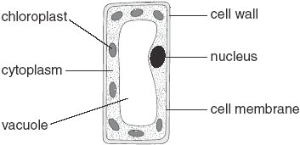
(a) In which part of a plant would you find this type of cell?
........................................................ 1 mark
(b) (i) Give the function of the nucleus.
...............................................................................................................
............................................................................................................... 1 mark
(ii) Give the function of the chloroplasts.
...............................................................................................................
............................................................................................................... 1 mark
(iii) Give the function of the cell wall.
...............................................................................................................
............................................................................................................... 1 mark
(c) Give the names of two labelled parts that are not present in animal cells.
1. .............................................................
2. ............................................................. 2 marks
maximum 6 marks

(d) Describe an investigation you could do to show how the amount of sunlight a plant receives affects plant growth over a six week period.
In your answer, you must clearly identify:
• the independent variable (IV)
• the dependent variable (DV)
• the variables to control (CV)
• how you will calculate the end result.
.............................................................................................................
.............................................................................................................
.............................................................................................................
.............................................................................................................
.............................................................................................................
.............................................................................................................
.............................................................................................................
.............................................................................................................
4 marks
(b) What process do plants carry out in the light and in the dark to release energy?
Tick the correct box.

photosynthesis |  | respiration
absorption |  | dispersal
1 mark
Total Marks = / 39
Red = < 15
Yellow = 16 – 24
Green = 26 - 39
maximum 5 marks

Knowledge Quiz

 | Topic: | Photosynthesis 1 (B.16)
1 | What is the word equation for photosynthesis? | Water + carbon dioxide -> glucose + oxygen
2 | What is the word equation for photosynthesis? | 6H2O + 6CO2 -> 6O2 + C6H12O6
3 | Name the three organs in a plant | Roots, stem, leaf
4 | What is the function of the palisade cells? | To absorb light for photosynthesis
5 | What is the function of the waxy cuticle? | To protect the leaf
6 | What is the function of the spongy layer? | Creates spaces to allow CO2 to diffuse into the leaf
7 | State three ways that a leaf is adapted for gas exchange | Large surface area, thin, stomata
8 | Give an example of diffusion occurring in a plant | Gas exchange (oxygen and carbon dioxide)
9 | Where is osmosis used within a plant? | Water moving into the root
10 | Where is active transport used within a plant? | To move minerals into the root

Homework 4 – Leaf Adaptations

- The ends of roots are normally covered in tiny root hair cells. What is their function? (2)
______________________________________________________________
______________________________________________________________
______________________________________________________________

2) What is the purpose of the small holes on the underside of the leaves? ___________________________________________ (1)

3) Why do the palisade cells, at the top of the leaves, have so many chloroplasts? (1)
_______________________________________________________________________________________________

4) Label the diagram of the plant cell below with the following terms: (6)
cell wall nucleus vacuole cytoplasm chloroplasts cell membrane

Starch granules

5) How is a leaf designed for photosynthesis? (3)
i) _______________________________________________ (1)
ii) ______________________________________________ (1)
iii) ______________________________________________ (1)

- Draw lines to match the sentence beginnings with their correct endings.
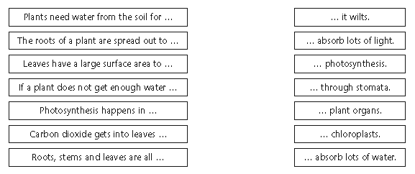

Testing for starch
Number these sentences to explain how to test a leaf for starch.
Cover the leaf with iodine – the areas with starch in will stain black
Take the leaf out of the ethanol carefully as it will be brittle – then wash it in the water bath to soften it.
Place the leaf in boiling water for 1 minute to stop it photosynthesising
Spread the leaf out on a white tile
Place a test tube full of ethanol into the hot water and place the leaf into the ethanol – this will remove the chlorophyll

Total Marks = / 25
Red = < 9
Yellow = 10 – 16
Green = 26 - 25

Extension
Q1.
Plants lose water vapour from their leaves. Most of this water vapour is lost through the stomata.
(a) Draw a ring around the correct answer to complete the sentence.

 | distillation.
Plants lose water vapour by | filtration.
 | transpiration.
(1)
(b) A class of students investigated the number of stomata per mm² on the upper surface and on the lower surface of the leaves of three species of plant, P, Q and R.
The students placed samples of the surface cells onto a grid on a microscope.
Student X counted the stomata on the lower surface of a leaf from one of the plant species.
The diagram shows part of the grid that student X saw under the microscope.
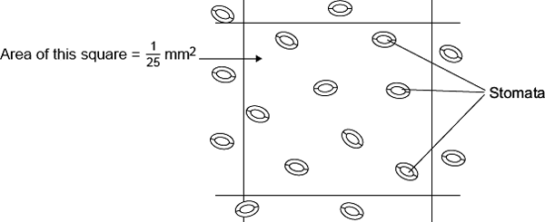
(i) Complete the calculation to estimate the number of stomata per mm² on the lower surface of this leaf.
Number of stomata in mm² = .........................................................
Number of stomata in 1 mm² = ............................................................ (2)
The table shows the mean results for the class.

Plant species | Mean number of stomata per mm² of leaf
 | Upper surface of leaf | Lower surface of leaf
P | 40 | 304
Q | 0 | 11
R | 85 | 195
(ii) Student X had counted the stomata on the lower surface of a leaf from one of the plant species.
Use your answer to part (b)(i), and information in the table, to help you to answer this question.
From which plant species, P, Q or R, was student X’s leaf most likely to have
been taken?
(1)
(iii) Species Q is normally found growing in hot, dry conditions.
Explain one way in which species Q is adapted for living in hot, dry conditions.
Use information from the table.
...............................................................................................................
...............................................................................................................
...............................................................................................................
...............................................................................................................
(2)
Total Marks = / 44
Red = < 13
Yellow = 14 – 21
Green = 22 - 31
(Total 6 marks)

Knowledge Quiz

 | Topic: | Photosynthesis 2 (B.17)
1 | Define "transpiration" | Evaporation of water from a leaf
2 | Define "translocation" | Movement of sugars through a plant
3 | Which substance is used to test for the presence of starch? | Iodine solution
4 | What is the colour of iodine solution if starch is present? | Blue/black
5 | What is the colour of iodine solution if starch is not present? | Orange/brown
6 | State one hazard associated with using iodine solution | Harmful
7 | Why is a leaf boiled in ethanol before being tested for starch? | To break down the cell walls
8 | State one hazard associated with using ethanol | It is flammable
9 | What is starch? | An insoluble store of glucose
10 | How is starch formed in a plant? | During photosynthesis

Week 6 Plant reproduction + Transpiration
Plant Reproduction

Q1
- Label the parts of the flower:
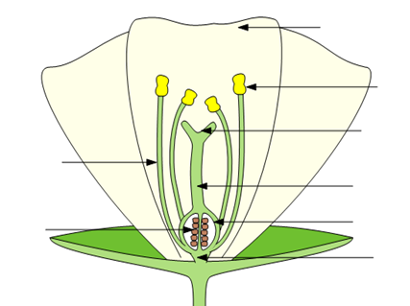
Words to use
Anther Filament
Ovary Ovule
Petal Sepal
Style Stigma

- What is pollination?______________________________________________________________________ (1)

- What part of the flower produces pollen? __________________ (1)

- What part of the flower becomes the seed? _________________ (1)

- Which are the names of the male and female sex cells in plants (gametes).

Male: ____________________________________________ (1)
Female: __________________________________________ (1)

Q2.
The diagrams show two plant cells.
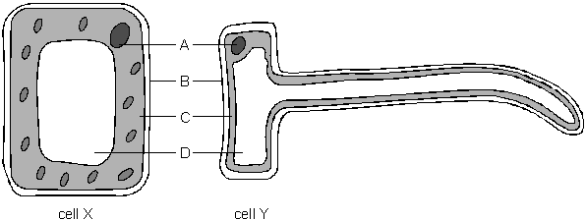
not to scale
(a) In which part of a plant would these cells be found?
cell X ………………………… 1 mark
cell Y ………………………… 1 mark
(b) Give the name of part B.
…………………………………… 1 mark
(c) (i) Give the letter which labels the nucleus.
…………… 1 mark
(ii) What is the function of the nucleus?
…………………………………………………………………………………
………………………………………………………………………………… 1 mark
(d) (i) How can you tell from the diagram that photosynthesis cannot take place
in cell Y?
…………………………………………………………………………………
………………………………………………………………………………… 1 mark
(ii) Which process takes place in both cell X and cell Y?
Tick the correct box.
egestion
Total Marks = / 20
Red = < 9
Yellow = 9 – 15
Green = 16 - 20
fertilisation
pollination
respiration
1 mark
Maximum 7 marks
Extension
Q1.
The diagram shows the reproductive parts of a flower.

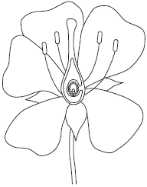
(a) Draw one line from each function to the correct structure.

Function |  | Structure
 |  | anthers
where female gametes are formed
 |  | ovules
where pollen grains are produced
 |  | stigma
where pollen grains land during pollination
 |  | style
(3)
(b) Suggest one way in which flowers attract pollinating insects.
........................................................................................................................
........................................................................................................................ (1)
(c) The pollen grains land on the female part of the flower.
Describe the next stages in the process which results in seed formation.
........................................................................................................................
........................................................................................................................
........................................................................................................................
........................................................................................................................
Total Marks = / 28
Red = < 11
Yellow = 12 – 19
Green = 20 - 28
........................................................................................................................
........................................................................................................................
........................................................................................................................
........................................................................................................................
........................................................................................................................
........................................................................................................................
(4)
(Total 8 marks)

