Year 9 Independent learning
Week 4
Cell Cycle and Reproduction
- Are the following statements related to sexual or asexual reproduction
  - Fusion of gametes
  - Pollen is the male gametes in plants
  - One parent involved
  - Happens in plants but not animals
  - Egg cell (ovum) is the female gametes in animals
  - Fungi can reproduce by spores
  - Leads to mix of genetic information
  - Offspring are identical
  - Involves mitosis
  - Involves meiosis

- Which type of reproduction leads to most variation?
- Can all organisms reproduce sexually and asexually? Explain your answer with examples
Yes/No (circle)
Explanation:
____________________________________________________________________________________________________________________________________________________________________________________________________________________________________________________________________________________________________________________
- What is difference in the amount of genetic information in a gamete compared other cells in the body?
__________________________________________________________________________________________________________________________________________________________
- Name one difference and one similarity between mitosis and meiosis
Difference:
__________________________________________________________________________________________________________________________________________________________
Similarity:
__________________________________________________________________________________________________________________________________________________________
- What is a stem cell?
____________________________________________________________________________________________________________________________________________________________________________________________________________________________________________________________________________________________________________________
- Where can stem cells be found in the human body?
_______________________________________________________________________________________________________________________________________________________________________________________________________________________________________

Extension Questions: Compulsory for A & B

- Name two advantage and two disadvantage of sexual reproduction
Advantage 1:
________________________________________________________________________________________________________________________________________________________________
Advantage 2:
________________________________________________________________________________________________________________________________________________________________
Disadvantage 1:
________________________________________________________________________________________________________________________________________________________________
Disadvantage 2:
________________________________________________________________________________________________________________________________________________________________

Q1.This question is about stem cells.
(a) Give one place in a plant where stem cells are found.
___________________________________________________________________
___________________________________________________________________
(1)
(b) What is one economic use of plant stem cells?
Tick one box.

To create genetically modified crops
To create new species of plants
To increase variation in plants
To produce large numbers of identical plants
(1)
(f) Figure 2 shows how embryonic stem cells are produced in therapeutic cloning for use in patients.
Figure 2
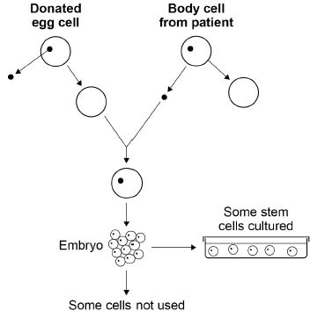
Give two advantages and two disadvantages of therapeutic cloning in medical treatments.
Use Figure 2 to help you.
Advantage 1 ________________________________________________________
___________________________________________________________________
Advantage 2 ________________________________________________________
___________________________________________________________________
Disadvantage 1 ______________________________________________________
___________________________________________________________________
Disadvantage 2 ______________________________________________________
___________________________________________________________________
(4)
Q2.The diagram shows how cells from human embryos can be used to grow ‘replacement body parts’ for humans.
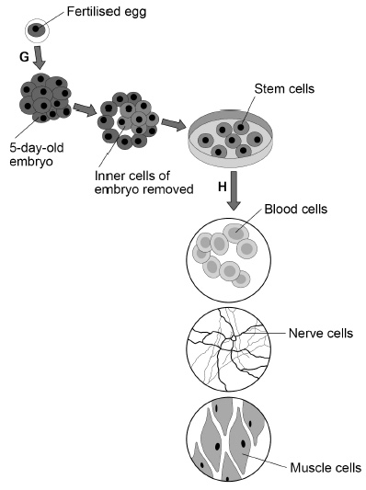
(a) How many chromosomes are in a fertilised human egg?
Tick one box.

12 |  | 23 |  | 46 |  | 92
(1)
(b) What is the process labelled G?
Tick one box.

Fertilisation
Inheritance
Meiosis
Mitosis
(1)
(c) When the embryo is three days old, it contains eight cells.
How many times has the fertilised egg cell divided by day three?
Tick one box.

2 |  | 3 |  | 4 |  | 8
(1)
(d) Stem cells become specialised in the process labelled H in the diagram.
What is the process labelled H?
Tick one box.

Differentiation
Evolution
Genetic modification
Selective breeding
(1)
(e) Which two parts would be found in all the cells in the diagram.
Tick two boxes.

Cell membrane
Cell wall
Chloroplasts
Cytoplasm
Plasmids
(2)
(f) Why might stem cells from human embryos be more useful than stem cells from adults?
___________________________________________________________________
___________________________________________________________________
(1)
(g) Some parents have stem cells from the umbilical cord of their baby collected and stored.
These stem cells can be used to treat diseases in the child later in life.
Why might stem cells from their own umbilical cord be used rather than stem cells from another embryo?
Tick one box.

Less risk of rejection of umbilical cord stem cells.
Stem cells from another embryo can treat more diseases.
Umbilical cord stem cells are older.
(1)
(h) Some medical uses of stem cells are still experimental.
Why do some scientists have concerns about the use of stem cells?
___________________________________________________________________
___________________________________________________________________
(1)
(i) Some people object to the use of embryonic stem cells because of religious beliefs.
Give one other ethical concern about the use of embryonic stem cells?
___________________________________________________________________
___________________________________________________________________
(1)
(Total 10 marks)

