Name: Class: Mark:

Image |  | Tool | Use
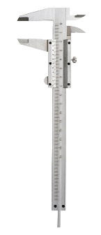 |  | Cutting  mat | Safe anti-slip, self-healing matt to protect work surfaces
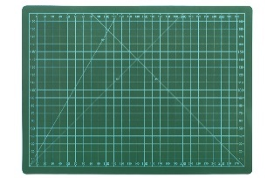 |  | Craft  knife

Vernier
callipers
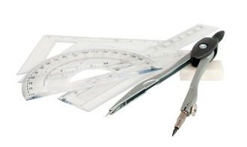 |  | Glue  gun
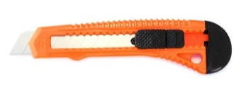 |  | Drawing  aids
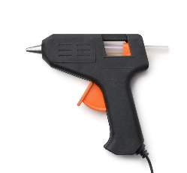 |  | Safety  rule

1. Match the following modelling tools to the correct name and explain how they
are used. An example has been done for you. [10]

[Total 10 marks]

