A-level Chemistry
Video ideas:

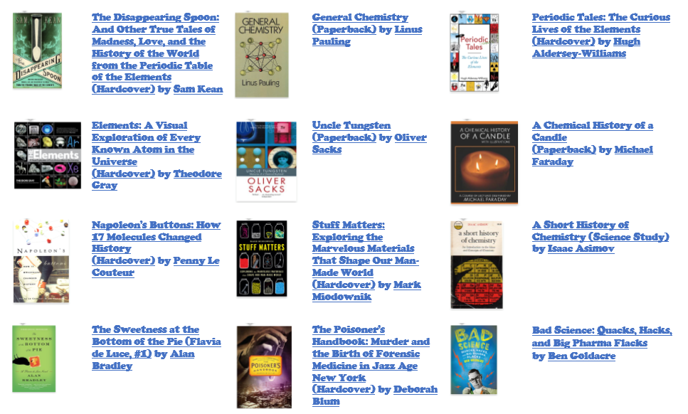
Reading ideas:

Other good ideas:

- https://www.senecalearning.com/ - AQA A level Chemistry
- https://www.youtube.com/playlist?list=PL8dPuuaLjXtPHzzYuWy6fYEaX9mQQ8oGr – chemistry Crash Course
- https://www.youtube.com/watch?v=zvWLMUR4TjM&list=PLi6oabjl6coxUlfu8syK3K0iFXQIjwDUM – MAChemGuy Preparation for A level chemistry video lessons
- https://www.youtube.com/watch?v=qZ3INba16v0&list=PLkocNW0BSuEFvnpnhj8fKN-KFUOlnKiT0 – SNAP revise – online video lessons
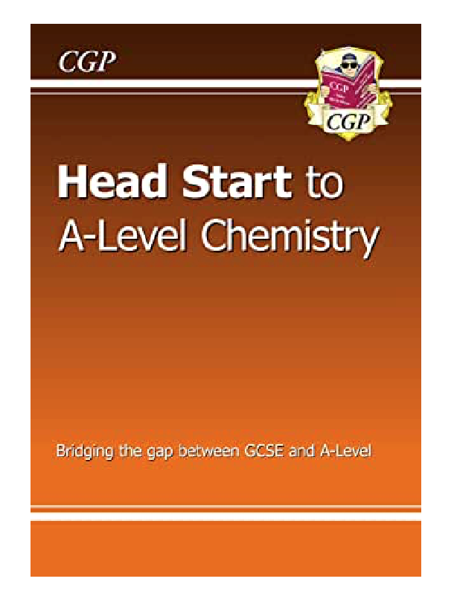
- Get the CGP Head start to A-Level chemistry for free on the amazon Kindle app

GCSE to A-Level Chemistry – Transition Work
Atomic Structure

GCSE questions
Q1. This question is about the structure of the atom.
(a) Complete the sentences. Choose answers from the box. Each word may be used once, more than once, or not at all.
electron |  | ion |  | neutron
 | nucleus |  | proton
The centre of the atom is the _______________________ .
The two types of particle in the centre of the atom are the proton and the _______________________ .
James Chadwick proved the existence of the _______________________ .
Niels Bohr suggested particles orbit the centre of the atom. This type of particle is the ________________ .
The two types of particle with the same mass are the neutron and the _______________________ . (5)
The table below shows information about two isotopes of element X.

 | Mass number | Percentage (%) abundance
Isotope 1 | 63 | 70
Isotope 2 | 65 | 30
(b) Calculate the relative atomic mass (A_{r}) of element X using the equation:
Use the table above. Give your answer to 1 decimal place.
__________________________________________________________________________________________________________________________________________________A_{r} = _________________ (2)
(c) Suggest the identity of element X. Use the periodic table.
Element X is _________________________________________________________________________(1)
(d) The radius of an atom of element X is 1.2 × 10⁻¹⁰ m
The radius of the centre of the atom is 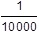 the radius of the atom.
Calculate the radius of the centre of an atom of element X. Give your answer in standard form.
_______________________________________________________________________________________________________________________________________________________________________________________________________________________________Radius = ___________________ m (2)
Q2. The diagram below represents different models of the atom.
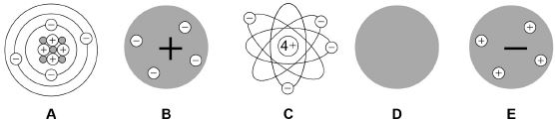
(a) Which diagram shows the plum pudding model of the atom? Tick one box.
(1)
(b) Which diagram shows the model of the atom developed from the alpha particle scattering experiment? Tick one box.
(1)
(c) Which diagram shows the model of the atom resulting from Bohr’s work? Tick one box.
(1)
(d) Define the mass number of an atom.
________________________________________________________________________________________________________________________________________________________________________(1)
(e) Element X has two isotopes. Their mass numbers are 69 and 71
The percentage abundance of each isotope is:
• 60% of ⁶⁹X
• 40% of ⁷¹X
Estimate the relative atomic mass of element X. Tick one box.
< 69.5
Between 69.5 and 70.0
Between 69.5 and 70.0
Between 70.0 and 70.5
> 70.5
(1)
A-Level question to give a go!
Q1. Which of these correctly shows the numbers of sub-atomic particles in a ⁴¹K⁺ ion?
 | Number of electrons | Number of protons | Number of neutrons
A | 19 | 19 | 20
B | 18 | 20 | 21
C | 18 | 19 | 22
D | 19 | 18 | 23
(Total 1 mark)
Q2. Magnesium exists as three isotopes: ²⁴Mg, ²⁵Mg and ²⁶Mg
(a) In terms of sub-atomic particles, state the difference between the three isotopes of magnesium.
________________________________________________________________________________________________________________________________________________________________________(1)
(b) State how, if at all, the chemical properties of these isotopes differ.
Give a reason for your answer.
Chemical properties ______________________________________________________________________
Reason ________________________________________________________________________________________________________________________________________________________________________(2)

Amount of Substance

GCSE questions
Q3. A student investigated the reactions of copper carbonate and copper oxide with dilute hydrochloric acid. In both reactions one of the products is copper chloride.
(a) A student wanted to make 11.0 g of copper chloride.
The equation for the reaction is:
CuCO₃ + 2HCl → CuCl₂ + H₂O + CO₂
Relative atomic masses, A_{r}: H = 1; C = 12; O = 16; Cl = 35.5; Cu = 63.5
Calculate the mass of copper carbonate the student should react with dilute hydrochloric acid to make 11.0 g of copper chloride.
___________________________________________________________________________________________________________________________________________________________________________________________________________Mass of copper carbonate = _________________________ g (4)
(b) The percentage yield of copper chloride was 79.1 %. Calculate the mass of copper chloride the student actually produced.

______________________________________________________________________________________________________________________Actual mass of copper chloride produced = ____________ g (2)

(c) Look at the equations for the two reactions:
Reaction 1 CuCO₃(s) + 2HCl(aq) → CuCl₂(aq) + H₂O(l) + CO₂(g)
Reaction 2 CuO(s) + 2HCl(aq) → CuCl₂(aq) + H₂O(l)
Reactive formula masses: CuO = 79.5; HCl = 36.5; CuCl₂ = 134.5; H₂O = 18
The percentage atom economy for a reaction is calculated using:
Calculate the percentage atom economy for Reaction 2.
______________________________________________________________________________________________________________________________________________________________________________________________________________Percentage atom economy = ________________________ % (3)

(d) The atom economy for Reaction 1 is 68.45 %. Compare the atom economies of the two reactions for making copper chloride. Give a reason for the difference.
__________________________________________________________________________________(1)

A-Level question to give a go!
Q3. Ethanol can be made from glucose by fermentation.
C₆H₁₂O₆ → 2C₂H₅OH + 2CO₂

In an experiment, 268 g of ethanol (M_{r} = 46.0) were made from 1.44 kg of glucose (M_{r} = 180.0).
What is the percentage yield?
A | 18.6%
B | 36.4%
C | 51.1%
D | 72.8%
(Total 1 mark)
Q4. A gas cylinder contains 5.0 kg of propane.
How many propane molecules are in the cylinder?
The Avogadro constant, L = 6.022 × 10²³ mol^{–1}
A | 6.8 × 10²²
B | 7.2 × 10²²
C | 6.8 × 10²⁵
D | 7.2 × 10²⁵
(Total 1 mark)
Bonding

GCSE questions
Q4. Figure 1 shows the structure of five substances.
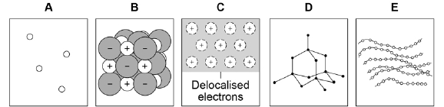
(a) Which diagram shows a gas? Tick (✔) one box.
A |  |  | B |  |  | C |  |  | D |  |  | E
(1)
(b) Which diagram shows the structure of diamond? Tick (✔) one box.
A |  |  | B |  |  | C |  |  | D |  |  | E
(1)
(c) Which diagram shows a metallic structure? Tick (✔) one box.
A |  |  | B |  |  | C |  |  | D |  |  | E
(1)
(d) Which diagram shows a polymer? Tick (✔) one box.
A |  |  | B |  |  | C |  |  | D |  |  | E
(1)

(e) A chlorine atom has 7 electrons in the outer shell.
Two chlorine atoms covalently bond to form a chlorine molecule, Cl₂

Figure 2 is a dot and cross diagram showing the outer shells and some electrons in a chlorine molecule.

Complete the dot and cross diagram. Show only the electrons in the outer shell.
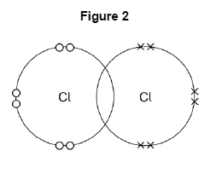
(1)
(f) What is the reason for chlorine’s low boiling point? Tick (✔) one box.
Strong covalent bonds
Strong forces between molecules
Weak covalent bonds
Weak forces between molecules
(1)
Figure 3 represents the structure of manganese oxide. Manganese oxide is an ionic compound.
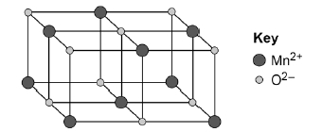
(g) Determine the empirical formula of manganese oxide. Use Figure 3.
_________________________________________________________________________________________________________________________________Empirical formula = ______________________ (1)
(h) Why does manganese oxide conduct electricity as a liquid? Tick (✔) one box.
Atoms move around in the liquid
Electrons move around in the liquid
Ions move around in the liquid
Molecules move around in the liquid
(1)
Q5. This question is about structure and bonding.

(a) Complete the dot and cross diagram to show the covalent bonding in a nitrogen molecule, N₂
Show only the electrons in the outer shell.
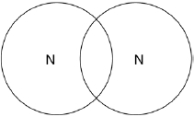
(2)
(b) Explain why nitrogen is a gas at room temperature. Answer in terms of nitrogen’s structure.
_________________________________________________________________________________________________________________________________________________________________________________________________________________________________________________________________________________________________________________________________________________(3)

(c) Graphite and fullerenes are forms of carbon. Graphite is soft and is a good conductor of electricity.
Explain why graphite has these properties. Answer in terms of structure and bonding.
________________________________________________________________________________________________________________________________________________________________________________________________________________________________________________________________________________________________________________________________________________________________________________________________________________________________________________(4)

A-Level question to give a go!
Q5. Which is the correct crystal structure for the substance named?
 | Substance | Structure
A | Iodine | Simple molecular
B | Diamond | Ionic
C | Sodium chloride | Giant covalent
D | Graphite | Metallic
(Total 1 mark)
Q6. What is the formula of calcium nitrate(V)?
A | CaNO₃
B | Ca(NO₃)₂
C | Ca₂NO₂
D | Ca(NO₂)₂
(Total 1 mark)
Q7. The table shows some data about the elements bromine and magnesium.

Element | Melting point / K | Boiling point / K
Bromine | 266 | 332
Magnesium | 923 | 1383
In terms of structure and bonding explain why the boiling point of bromine is different from that of magnesium. Suggest why magnesium is a liquid over a much greater temperature range compared to bromine.
____________________________________________________________________________________________________________________________________________________________________________________________________________________________________________________________________________________________________________________________________________________________________________________________________________________________________________________________________________________________________________________________________________________________________________________________________________________________________________________________________________________________________________________________________________________________________________________________________________________________________________________________________________________________________________________________________________________________________________________________(Total 5 marks)

Energetics
GCSE questions
Q6. Methane (CH₄) is used as a fuel.
(a) Methane burns in oxygen.
(i) The diagram below shows the energy level diagram for the complete combustion of methane.

Draw and label arrows on the diagram to show:
• the activation energy
• the enthalpy change, ΔH.
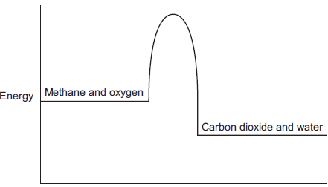
(2)
(ii) Complete and balance the symbol equation for the complete combustion of methane.
CH₄ + _____ CO₂ + _____ (2)
(ii) Explain why, in terms of the energy involved in bond breaking and bond making, the combustion of methane is exothermic.
_________________________________________________________________________________________________________________________________________________________________________________________________________________________________________________________________________________________________________________________________________________(3)
(b) Methane reacts with chlorine in the presence of sunlight. The equation for this reaction is:
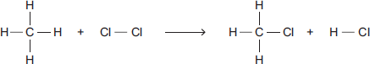
Some bond dissociation energies are given in the table.

Bond | Bond dissociation energy  in kJ per mole
C−H | 413
C−Cl | 327
Cl−Cl | 243
H−Cl | 432
(i) Show that the enthalpy change, ΔH, for this reaction is −103 kJ per mole.
_________________________________________________________________________________________________________________________________________________________________________________________________________________________________________________________________________________________________________________________________________________(3)
(ii) Methane also reacts with bromine in the presence of sunlight.
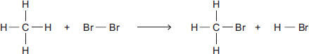
This reaction is less exothermic than the reaction between methane and chlorine.
The enthalpy change, ΔH, is −45 kJ per mole.
What is a possible reason for this? Tick () one box.
CH₃Br has a lower boiling point than CH₃Cl
The C−Br bond is weaker than the C−Cl bond.
The H−Cl bond is weaker than the H−Br bond.
Chlorine is more reactive than bromine.
(1)
A-Level question to give a go!
Q8. Calculate the enthalpy change, in kJ, for this dissociation of mole of propan-1-ol.
C₃H₇OH(g) ⟶ 3C(g) + 8H(g) + O(g)

Mean bond dissociation enthalpy / kJ mol⁻¹ |  |  |  | 412 | 348 | 360 | 463
A | −4751
B | −4403
C | +4403
D | +4751
(Total 1 mark)
Q9. Hydrogen is produced by the reaction of methane with steam. The reaction mixture reaches a state of dynamic equilibrium.
CH₄(g) + H₂O(g) ⇌ CO(g) + 3H₂(g) ∆H = +206 kJ mol⁻¹
Some enthalpy data is given in the table.

Bond | C–H | O–H | H–H | C≡H
Bond enthalpy /  kJ mol⁻¹ | 413 | 463 | 436 | To be calculated
Use the information in the table and the stated enthalpy change to calculate the missing bond enthalpy.
A | 234
B | 1064
C | 1476
D | 1936
(Total 1 mark)

Kinetics

GCSE questions
Q7. When sodium thiosulfate solution reacts with dilute hydrochloric acid, the solution becomes cloudy.
The equation for the reaction is:
Na₂S₂O₃(aq) + 2 HCl(aq) ⟶ 2 NaCl(aq) + SO₂(g) + H₂O(l) + S(s)
Some students used this reaction to investigate the effect of concentration on rate of reaction. The table shows the students’ results.
Concentration of sodium thiosulfate solution in mol / dm³ | Time for cross to become no longer visible in s
0.020 | 170
0.040 | 90
0.060 | 82
0.080 | 42
0.100 | 34
0.120 | 30
0.140 | 28
(a) Plot the data from the table above on the graph below. Draw a line of best fit.
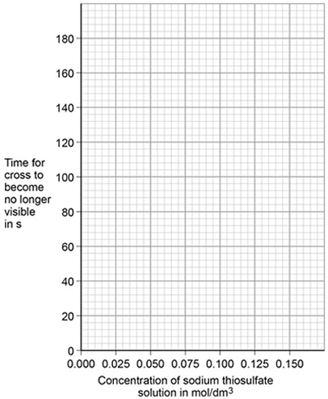
(3)
The students repeated the investigation two more times. They obtained similar results each time.

(b) The students analysed their results to give a conclusion and an explanation for their investigation.

Conclusion: ‘The higher the concentration, the lower the rate of reaction.’

Explanation: ‘At higher concentrations, the particles have more energy, so they are moving faster. Therefore the collisions are more energetic.’

The students are not correct.
Give a correct conclusion and explanation for the results of the investigation.

Conclusion __________________________________________________________________________ ____________________________________________________________________________________

Explanation ___________________________________________________________________________ ____________________________________________________________________________________________________________________________________________________________________________________________________________________________________________________________(3)

(c) A solution containing 0.18 g of sodium thiosulfate reacts with dilute hydrochloric acid in 2 minutes.
Calculate the mean rate of reaction in g / s. Give your answer in standard form.
_______________________________________________________________________________________________________________________________________________________________________________________________________________________Mean rate of reaction = _____________ g / s (3)

A-Level question to give a go!
Q10. Line X in the diagram represents the volume (V) of gas formed with time (t) in a reaction between an excess of magnesium and aqueous sulfuric acid.
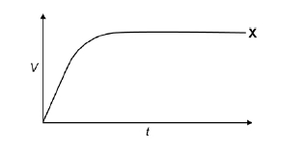
Which line represents the volume of hydrogen formed, at the same temperature and pressure, when the concentration of sulfuric acid has been halved?
A | 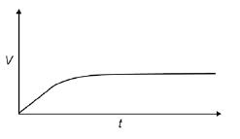
B | 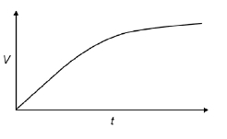
C | 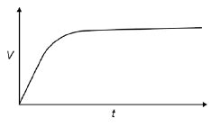
D | 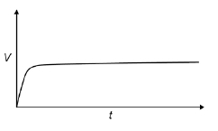
(Total 1 mark)
Q11. The gas-phase reaction between hydrogen and chlorine is very slow at room temperature.
H₂(g) + Cl₂(g) → 2HCl(g)
(a) Define the term activation energy.
________________________________________________________________________________________________________________________________________________________________________(2)
(b) Give one reason why the reaction between hydrogen and chlorine is very slow at room temperature.
________________________________________________________________________________________________________________________________________________________________________ (1)
(c) Explain why an increase in pressure, at constant temperature, increases the rate of reaction between hydrogen and chlorine.
________________________________________________________________________________________________________________________________________________________________________(2)
(d) Explain why a small increase in temperature can lead to a large increase in the rate of reaction between hydrogen and chlorine.
________________________________________________________________________________________________________________________________________________________________________(2)
(e) Give the meaning of the term catalyst.
________________________________________________________________________________________________________________________________________________________________________(1)
(f) Suggest one reason why a solid catalyst for a gas-phase reaction is often in the form of a powder.
___________________________________________________________________________________(1)

Chemical Equilibria, Le Chatelier’s Principle and K_{c}
GCSE questions
Q8. In industry ethanol is produced by the reaction of ethene and steam at 300°C and 60 atmospheres pressure using a catalyst.
The equation for the reaction is: C₂H₄ (g) + H₂O (g) C₂H₅OH (g)
(a) The forward reaction is exothermic.
Use Le Chatelier’s Principle to predict the effect of increasing temperature on the amount of ethanol produced at equilibrium. Give a reason for your prediction.
________________________________________________________________________________________________________________________________________________________________________(2)
(b) Explain how increasing the pressure of the reactants will affect the amount of ethanol produced at equilibrium.
________________________________________________________________________________________________________________________________________________________________________(2)

A-Level question to give a go!
Q12. Which statement is not correct about the industrial preparation of ethanol by the hydration of ethene at 300 °C?
C₂H₄(g) + H₂O(g) ⇌ C₂H₅OH(g) ∆H = –46 kJ mol^{–1}

A | The reaction is catalysed by an acid.
B | The higher the pressure, the higher the equilibrium yield of ethanol.
C | The higher the temperature, the higher the equilibrium yield of ethanol.
D | A low equilibrium yield of ethanol is acceptable because unreacted ethene is recycled.
(Total 1 mark)
Q13. The forward reaction in this equilibrium is endothermic
COCl₂ (g) ⇌ CO(g) + Cl₂ (g)
Which statement is correct?

A | If the total pressure is increased at constant temperature, the proportion of COCl₂ in the equilibrium mixture will decrease
B | Use of a catalyst will increase the proportion of COCl₂ in the equilibrium mixture at constant temperature and pressure
C | Reducing the equilibrium concentration of CO will increase the value of the equilibrium constant
D | Raising the temperature from 373 K to 473 K will increase the value of the equilibrium constant
Oxidation, Reduction and Redox equations

GCSE questions
Q9. This question is about halogens and their compounds.
(a) What is the ionic equation for the reaction of chlorine with potassium iodide? Tick one box.
Cl₂ + 2K → 2KCl
2I⁻ + Cl₂ → I₂ + 2Cl⁻
I⁻ + Cl → I + Cl⁻
I⁻ + K⁺ → KI
(1)
Q10. Titanium is a transition metal.
Titanium is extracted from titanium dioxide in a two-stage industrial process.
Stage 1 TiO₂ + 2 C + 2 Cl₂ ⟶ TiCl₄ + 2 CO
Stage 2 TiCl₄ + 4 Na ⟶ Ti + 4 NaCl
In Stage 2, sodium displaces titanium from titanium chloride.
(a) Sodium atoms are oxidised to sodium ions in this reaction. Why is this an oxidation reaction?
___________________________________________________________________________________(1)
(b) Complete the half equation for the oxidation reaction.
Na ⟶ ____________ + ____________ (1)

A-Level question to give a go!
Q14. In which reaction is the metal oxidised?
A | 2Cu²⁺ + 4I– 2CuI + I₂
B | [Fe(H₂O)₆]³⁺ + Cl– [Fe(H₂O)₅(Cl)]²⁺ + H₂O
C | [CoCl₄]^{2–} + 6H₂O [Co(H₂O)₆]²⁺ + 4Cl–
D | Mg + S MgS
(Total 1 mark)

Periodicity

GCSE questions
Q11. This question is about metals.
(a) Which unreactive metal is found in the Earth as the metal itself? Tick () one box
aluminium
gold
magnesium
(1)
(b) Complete the sentence.
Aluminium is an element because aluminium is made of only one type of _________________________ .
(1)
(c) Figure 1 shows the electronic structure of an aluminium atom.
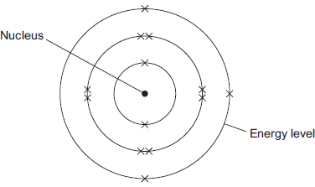
(i) Use the correct words from the box to complete the sentence.

electrons | ions | protons | neutrons | shells
The nucleus of an aluminium atom contains _______________ and _______________ . (2)
(ii) Complete the sentence.
In the periodic table, aluminium is in Group ___________________ (1)

(d) Aluminium is used for kitchen foil. Figure 2 shows a symbol on a box of kitchen foil.
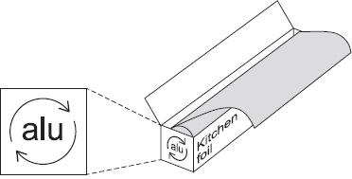
The symbol means that aluminium can be recycled. It does not show the correct chemical symbol for aluminium.
(i) What is the correct chemical symbol for aluminium? ___________________________ . (1)
(ii) Give two reasons why aluminium should be recycled.
________________________________________________________________________________________________________________________________________________________________________(2)

(e) Aluminium has a low density, conducts electricity and is resistant to corrosion.
Which one of these properties makes aluminium suitable to use as kitchen foil? Give a reason for your answer.
__________________________________________________________________________________________________________________________________________________________________________________________________________________________________________________________(2)

A-Level question to give a go!
Q15. Which of the following is a correct statement about the trend in atomic radius across Period 3 of the Periodic Table?
A | radius increases because the atoms have more electrons
B | radius decreases because nuclear charge increases
C | radius increases because shielding (screening) increases
D | radius decreases because shielding (screening) decreases
(Total 1 mark)

Group 2 – The Alkaline Earth Metals

GCSE questions
Q12. This question is about compounds.
(a) The table gives information about the solubility of some compounds.
Soluble compounds
All potassium and sodium salts
All nitrates
Chlorides, bromides and iodides, except those of silver and lead
Use information from the table to answer these questions.
(i) Name a soluble compound that contains silver ions.
___________________________________________________________________________________(1)
(ii) Name a soluble compound that contains carbonate ions.
___________________________________________________________________________________(1)
(b) Metal oxides react with acids to make salts. What type of compound is a metal oxide?
___________________________________________________________________________________(1)
(c) Lead nitrate solution is produced by reacting lead oxide with nitric acid.
(i) State how solid lead nitrate can be obtained from lead nitrate solution.
________________________________________________________________________________________________________________________________________________________________________(1)
(ii) Balance the equation for the reaction.
PbO + HNO₃ Pb(NO₃)₂ + H₂O
(1)
(iii) Give the total number of atoms in the formula Pb(NO₃)₂
___________________________________________________________________________________(1)

A-Level question to give a go!
Q16. (a) Nickel is a metal with a high melting point.
(i) Explain, in terms of its structure and bonding, why nickel has a high melting point.
__________________________________________________________________________________________________________________________________________________________________________________________________________________________________________________________________________________________________________________________________________________(2)
(ii) Draw a labelled diagram to show the arrangement of particles in a crystal of nickel.
In your answer, include at least six particles of each type.

(2)
(iii) Explain why nickel is ductile (can be stretched into wires).
________________________________________________________________________________________________________________________________________________________________________(1)

Group 7 – The Halogens
GCSE questions
Q13. The halogens are elements in Group 7.
(a) Bromine is in Group 7.
Give the number of electrons in the outer shell of a bromine atom. _______________________________(1)

(b) Bromine reacts with hydrogen. The gas hydrogen bromide is produced.
What is the structure of hydrogen bromide? Tick one box.
Giant covalent
Ionic lattice
Metallic structure
Small molecule
(1)
(c) What is the formula for fluorine gas? Tick one box.
F
F₂
F²
2F
(1)
A student mixes solutions of halogens with solutions of their salts.
The table below shows the student’s observations.
 |  | Potassium chloride (colourless) | Potassium bromide (colourless) | Potassium iodide (colourless)
Chlorine (colourless) |  |  | Solution turns orange | Solution turns brown
Bromine (orange) |  | No change |  | Solution turns brown
Iodine (brown) |  | No change | No change
(d) Explain how the reactivity of the halogens changes going down Group 7. Use the results in the table above.
_____________________________________________________________________________________________________________________________________________________________________________________________________________________________________________________________________________________________________________________________________________ (3)
A-Level question to give a go!
Q17. An aqueous solution of a white solid gives a yellow precipitate with aqueous silver nitrate. The formula of the white solid could be
A AgBr
B AgI
C NaBr
D NaI
(Total 1 mark)
Q18. What will you see when a solution of silver nitrate is added to a solution containing bromide ions, and concentrated aqueous ammonia is added to the resulting mixture?
A a white precipitate soluble in concentrated aqueous ammonia
B a white precipitate insoluble in concentrated aqueous ammonia
C a cream precipitate soluble in concentrated aqueous ammonia
D a yellow precipitate insoluble in concentrated aqueous ammonia
(Total 1 mark)
Introduction to Organic Chemistry

GCSE questions
Q14. Scientists found that a compound contained:
22.8% sodium; 21.8% boron; and 55.4% oxygen.
Use the percentages to calculate the empirical formula of the compound.
Relative atomic masses (A _{r}): B = 11; O = 16; Na = 23
To gain full marks you must show all your working.
________________________________________________________________________________________________________________________________________________________________________________________________________________________________________________________________________________________________________________________________________________________________________________________________________________________________________________________________________________________________________________________________________________________________________________________________________________________________________________________________________________________________________________________________________________________________________________________________________________________________Empirical formula = ________________________________(Total 5 marks)

A-Level question to give a go!
Q19. An organic compound is found to contain 40.0% carbon, 6.7% hydrogen and 53.3% oxygen.
Which of the following compounds could this be?
A | Ethanol
B | Ethanoic acid
C | Methanol
D | Methanoic acid
(Total 1 mark)

Alkanes

GCSE questions
Q15. This question is about hydrocarbons.
The table gives information about four hydrocarbons. The hydrocarbons are four successive members of a homologous series.
Hydrocarbon | Formula | Boiling point in °C
A | C₄H₁₀ | 0
B |  | 36
C | C₆H₁₄ | 69
D | C₇H₁₆ | 98
(a) What is the formula of hydrocarbon B? Tick (✔) one box.
C₄H₁₂
C₅H₁₂
C₅H₁₂
C₆H₁₂
(1)

(b) What is the simplest ratio of carbon : hydrogen atoms in a molecule of hydrocarbon A?
Ratio = 2 : _______ (1)
(c) Which hydrocarbon is a gas at room temperature (25 °C)? Tick (✔) one box.
A |  |  | B |  |  | C |  |  | D
(1)
(d) Which hydrocarbon is most flammable? Tick (✔) one box.
A |  |  | B |  |  | C |  |  | D
(1)
(e) Which two substances are produced when a hydrocarbon completely combusts in air? Tick (✔) two boxes.
Carbon
Carbon dioxide
Hydrogen
Sulfur dioxide
Water
(2)
The diagram shows the displayed structure of a hydrocarbon molecule.
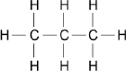
(f) What is the name of the hydrocarbon in the diagram above? Tick (✔) one box.

Butane
Ethane
Methane
Propane
(1)
Q16. This question is about hydrocarbons.
(a) The names and formulae of three hydrocarbons in the same homologous series are:
Ethane C₂H₆
Propane C₃H₈
Butane C₄H₁₀
The next member in the series is pentane. What is the formula of pentane?
_________________________________________________________________________________(1)
(b) Which homologous series contains ethane, propane and butane? Tick one box.
Alcohols
Alkanes
Alkenes
Carboxylic acids
(1)
(c) Propane (C₃H₈) is used as a fuel. Complete the equation for the complete combustion of propane.
C₃H₈ + 5O₂ → 3 _______________ + 4 _________________
(2)
(d) Octane (C₈H₁₈) is a hydrocarbon found in petrol. Explain why octane is a hydrocarbon.
________________________________________________________________________________________________________________________________________________________________________(2)

(e) The table below gives information about the pollutants produced by cars using diesel or petrol as a fuel.

Fuel | Relative amounts of pollutants
 | Oxides of Nitrogen | Particulate matter | Carbon dioxide
Diesel | 31 | 100 | 85
Petrol | 23 | 0 | 100
Compare the pollutants from cars using diesel with those from cars using petrol.
______________________________________________________________________________________________________________________________________________________________________________________________________________________________________________________________________________________________________________________________________________________________________________________________________________________________________ (3)
(f) Pollutants cause environmental impacts. Draw one line from each pollutant to the environmental impact caused by the pollutant.
Pollutant |  |  |  |  |  | Environmental impact caused by the pollutant
 |  |  |  |  |  |  | Acid rain
 | Oxides of nitrogen |  |  |  |  |  | Flooding
 |  |  |  |  |  |  | Global dimming
 | Particulate matter |  |  |  |  |  | Global warming
 |  |  |  |  |  |  | Photosynthesis
(2)
A-Level question to give a go!
Q20. Which correctly represents an incomplete combustion of pentane?
A | C₅H₁₂ + 8O₂ ⟶ 5CO₂ + 6H₂O
B | C₅H₁₂ + 8O₂ ⟶ 4CO + CO₂ + 6H₂O
C | C₅H₁₂ + 6O₂ ⟶ 4CO + CO₂ + 6H₂O
D | C₅H₁₂ + 5O₂ ⟶ 4CO + CO₂ + 4H₂O + 2H₂
(Total 1 mark)
Q21. Tetradecane (C₁₄H₃₀) is an alkane found in crude oil. When tetradecane is heated to a high temperature, one molecule of tetradecane decomposes to form one molecule of hexane and three more molecules.

Which of the following could represent this reaction?
A | C₁₄H₃₀ → C₆H₁₄ + C₄H₈ + 2C₂H₄
B | C₁₄H₃₀ → C₆H₁₄ + C₆H₁₂ + C₂H₄
C | C₁₄H₃₀ → C₅H₁₂ + 3C₃H₆
D | C₁₄H₃₀ → C₆H₁₄ + C₂H₆ + 2C₃H₆
(Total 1 mark)
Q22. Petrol contains saturated hydrocarbons. Some of the molecules in petrol have the molecular formula C₈H₁₈ and are referred to as octanes. These octanes can be obtained from crude oil by fractional distillation and by cracking suitable heavier fractions.

Petrol burns completely in a plentiful supply of air but can undergo incomplete combustion in a car engine.

(a) State the meaning of both the words saturated and hydrocarbon as applied to the term saturated hydrocarbon. Name the homologous series to which C₈H₁₈ belongs.

_______________________________________________________________________________________________________________________________________________________________________________________________________________________________________________________________________________________________________________________________________________________________________________________________________________________________________ (3)
(b) Outline the essential features of the fractional distillation of crude oil that enable the crude oil to be separated into fractions.
___________________________________________________________________________________________________________________________________________________________________________________________________________________________________________________________________________________________________________________________________________________________________________________________________________________________________________________________________________________________________________________________ (4)

Alkenes

GCSE questions
Q18. This question is about organic compounds. Hydrocarbons can be cracked to produce smaller molecules.
The equation shows the reaction for a hydrocarbon, C₁₈H₃₈
C₁₈H₃₈ → C₆H₁₄ + C₄H₈ + 2 C₃H₆ + C₂H₄
(a) Which product of the reaction shown is an alkane? Tick one box.
C₂H₄
C₃H₆
C₄H₈
C₆H₁₄
(1)

(b) The table below shows the boiling point, flammability and viscosity of C₁₈H₃₈ compared with the other hydrocarbons shown in the equation.

 | Boiling point | Flammability | Viscosity
A | highest | lowest | highest
B | highest | lowest | lowest
C | lowest | highest | highest
D | lowest | highest | lowest
Which letter, A, B, C or D, shows how the properties of C₁₈H₃₈ compare with the properties of C₂H₄, C₃H₆, C₄H₈ and C₆H₁₄? Tick one box.
A
B
C
D
(1)
(c) The hydrocarbon C₄H₈ was burnt in air. Incomplete combustion occurred.
Which equation, A, B, C or D, correctly represents the incomplete combustion reaction?
A C₄H₈ + 4O → 4CO + 4H₂
B C₄H₈ + 4O₂ → 4CO + 4H₂O
C C₄H₈ + 6O₂ → 4CO₂ + 4H₂O
D C₄H₈ + 8O → 4CO₂ + 4H₂

Tick one box.
A
B
C
D
(1)
(d) Propanoic acid is a carboxylic acid. Which structure, A, B, C or D, shows propanoic acid?
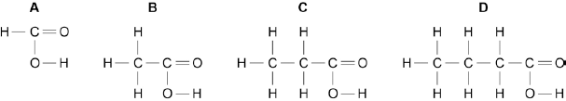
Tick one box.
A
B
C
D
(1)
(e) Propanoic acid is formed by the oxidation of which organic compound? Tick one box.
Propane
Propene
Propanol
Polyester
(1)
Q19. A molecule of ethene (C₂H₄) is represented as:
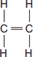
(a) A sample of ethene is shaken with bromine water. Complete the sentence.
The bromine water turns from orange to _____________________________________________________(1)

(b) Most ethene is produced by the process of cracking.
(i) Decane (C₁₀H₂₂) can be cracked to produce ethene (C₂H₄) and one other product.
Complete the equation to show the formula of the other product.
C₁₀H₂₂ C₂H₄ + _____________ (1)

(c) Many molecules of ethene join together to produce poly(ethene).
(i) Complete the structure of the polymer in the equation.
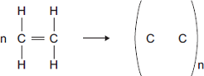
(2)
(ii) Some carrier bags are made from poly(ethene). Some carrier bags are made from cornstarch.
Suggest two benefits of using cornstarch instead of poly(ethene) to make carrier bags.

____________________________________________________________________________________________________________________________________________________________________________________________________________________________________________________________(2)
A-Level question to give a go!
Q23. Consider the following reactions.
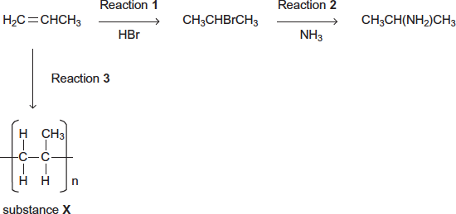
(a) State the type of reaction in Reaction 3. Give the name of substance X.
________________________________________________________________________________________________________________________________________________________________________(2)

Alcohols
GCSE questions
Q20. The diagrams represent two compounds, A and B.
Compound A Compound B
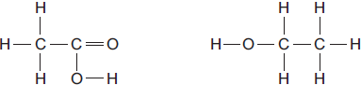
(a) (i) Compound B is an alcohol. Name compound B.
____________________________________________________________________________________(1
(ii) Use the correct answer from the box to complete the sentence.
burned | decomposed | oxidised
To form compound A, compound B is ____________________________________________________(1)
(iii) Compounds A and B are both colourless liquids.
A test tube contains a colourless liquid, which could be either compound A or compound B. Describe a simple chemical test to show which compound, A or B, is in the test tube.
______________________________________________________________________________________________________________________________________________________________________________________________________________________________________________________________________________________________________________________________________________(2)
A-Level question to give a go!
Q24. A group of students wanted to produce a biofuel to power the central heating system in their school. They collected scraps of fruits and vegetables from the kitchens and fermented them with yeast, in the absence of air, in order to produce ethanol.
The aqueous mixture was filtered to remove the remaining solids.
The students then set up the apparatus shown in the diagram below and placed the aqueous mixture in the round bottomed flask.
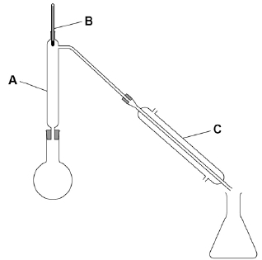
(a) Describe how the students would use this apparatus to collect a sample of ethanol. Include in your answer the functions of the parts of the apparatus labelled A, B and C.
___________________________________________________________________________________________________________________________________________________________________________________________________________________________________________________________________________________________________________________________________________________________________________________________________________________________________________________________________________________________________________________________________________________________________________________________________________________________________________________________________________________________________________________________________________________________________________________________ (6)

Organic Analysis

GCSE questions
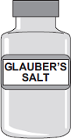
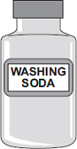
Q21. Four bottles of chemicals made in the 1880s were found recently in a cupboard during a Health and Safety inspection at Lovell Laboratories.
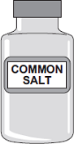
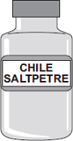

Sodium carbonate sodium chloride sodium nitrate sodium sulfate

The chemical names are shown below each bottle.

(a) You are provided with the following reagents:
• aluminium powder
• barium chloride solution acidified with dilute hydrochloric acid
• dilute hydrochloric acid
• silver nitrate solution acidified with dilute nitric acid
• sodium hydroxide solution.
• limewater
• red litmus paper
(i) Describe tests that you could use to show that these chemicals are correctly named.
In each case give the reagent(s) you would use and state the result.
Test and result for carbonate ions:
________________________________________________________________________________________________________________________________________________________________________
Test and result for chloride ions:
_______________________________________________________________________________________________________________________________________________________________________
Test and result for nitrate ions:
________________________________________________________________________________________________________________________________________________________________________
Test and result for sulfate ions:
______________________________________________________________________________________________________________________________________________________________________(4)
(ii) Suggest why a flame test would not distinguish between these four chemicals.
__________________________________________________________________________________(1)
(b) Instrumental methods of analysis linked to computers can be used to identify chemicals. Give two advantages of using instrumental methods of analysis.
__________________________________________________________________________________________________________________________________________________________________________________________________________________________________________________________(2)

A-Level question to give a go!
Q25. Consider the following scheme of reactions.
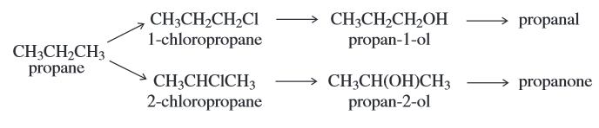
(a) High resolution mass spectrometry of a sample of propane indicated that it was contaminated with traces of carbon dioxide.
Use the data in the table to show how precise M_{r} values can be used to prove that the sample contains both of these gases.
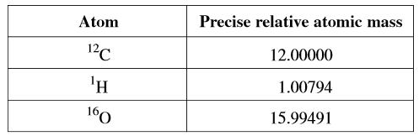
________________________________________________________________________________________________________________________________________________________________________(2)

GCSE to A-Level Chemistry – Skills Transition
Balancing Equations

Use this method to help you https://www.youtube.com/watch?v=ab0gYBdHU-k
GCSE questions
Q1. (a) Balance these chemical equations.
(i) H₂ + O₂ → H₂O (1)
(ii) Al + O₂ → Al₂O₃ (1)
(b) Briefly explain why an unbalanced chemical equation cannot fully describe a reaction.
_____________________________________________________________________________________________________________________________________________________________________________________________________________________________________________________________(2
Q2. The following passage was taken from a chemistry textbook.
Germanium is a white, shiny, brittle element. It is used in the electronics industry because it is able to conduct a small amount of electricity.

It is made from germanium oxide obtained from flue dusts of zinc and lead smelters.
The impure germanium oxide from the flue dusts is changed into germanium by the process outlined below.

STEP 1 The germanium oxide is reacted with hydrochloric acid to make germanium tetrachloride. This is a volatile liquid in which the germanium and chlorine atoms are joined by covalent bonds.
STEP 2 The germanium tetrachloride is distilled off from the mixture.
STEP 3 The germanium tetrachloride is added to an excess of water to produce germanium oxide and hydrochloric acid.
STEPS 1 to 3 are repeated several times.
STEP 4 The pure germanium oxide is reduced by hydrogen to form germanium.

(a) Balance the equation below which represents the reaction in step 1.
GeO₂ + ______ HCl → GeCl₄ + ______ H₂O (1)
(b) Write a word equation for the reaction in step 3.
___________________________________________________________________________________(1)

Q3. (a) Cola drinks contain phosphoric acid, H3PO4. The two equations show how phosphoric acid can be made from phosphorus.

Balance these two equations.
(i) P₄ + ____ O₂ → P₄O₁₀ (1)
(ii) P₄O₁₀ + ________ H₂O → 4H₃PO₄ (1)

Some more practice
4) Mg + O2 → MgO

5) H2 + O2 → H2O

6) Fe + HCl → FeCl2 + H2

7) CuO + HNO3→ Cu(NO3)2 + H2O

8) Ca(OH)2 + HCl → CaCl2 + H2O

9) KHCO3 + H2SO4 → K2SO4 + CO2 + H2O

10) Al + Cl2 → AlCl3

Even more practice - Balancing Equations Game

A-Level question to give a go!
Q11. Copper can be produced from rock that contains CuFeS₂
(a) Balance the equations for the two stages in this process.
.....CuFeS₂ + .....O₂ + .....SiO₂ ⟶ .....Cu₂S + .....Cu₂O + .....SO₂ + .....FeSiO₃
.....Cu₂S + .....Cu₂O ⟶ .....Cu + .....SO₂ (2)

Formula Literacy

For each of the following compounds;
- Identify the number of atoms of each element
- The formula of the ions it consists of
- Name it
- Challenge yourself: calculate its RFM
e.g. the first one is done for you:
1. NaNO₃
1 x sodium atom, 1 x nitrogen atom, 3 x oxygen atoms
Na+ and NO₃-
Sodium nitrate
Challenge: (1 x 23) + (1 x 14) + (3 x 16) = 85

2. Na₂O

3. K₃PO₄

4. CaBr₂

5. Al₂O₃

6. NH₄OH

7. (NH₄)₂SO₄

SI units

To reduce confusion and to help with conversion between different units, there is a standard system of units called the SI units which are used for most scientific purposes.

These units have all been defined by experiment so that the size of, say, a metre in the UK is the same as a metre in China. The seven SI base units are:

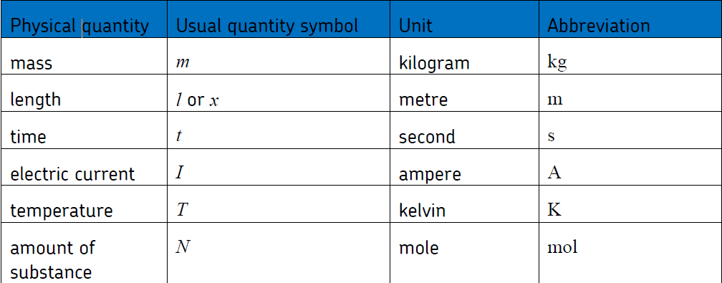

All other units can be derived from the SI base units.

For example, area is measured in square metres (written as m²) and speed is measured in metres per second (written as ms^{–1}).

It is not always appropriate to use a full unit. For example, measuring the width of a hair or the distance from Manchester to London in metres would cause the numbers to be difficult to work with.

Prefixes are used to multiply each of the units. You will be familiar with centi (meaning 1/100), kilo (1000) and milli (1/1000) from centimetres, kilometres and millimetres.

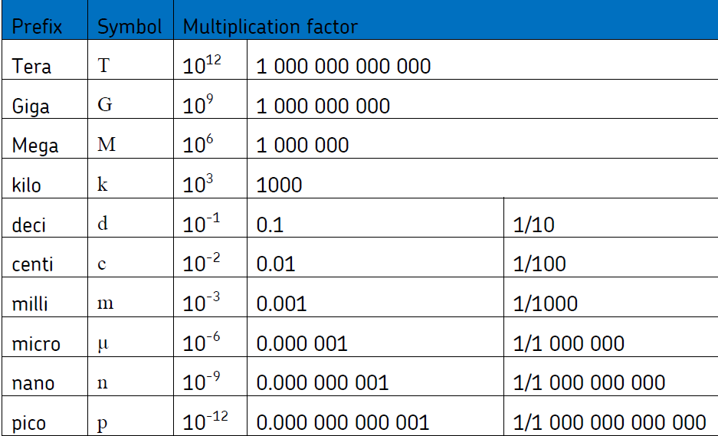
There is a wide range of prefixes. The majority of quantities in scientific contexts will be quoted using the prefixes that are multiples of 1000. For example, a distance of 33 000 m would be quoted as 33 km.

For the following quantities, which SI unit and most appropriate prefix would you use?

1. The mass of water in a test tube.

2. The time taken for a solution to change colour.

3. The radius of a gold atom.

4. The volume of water in a burette.

5. The amount of substance in a beaker of sugar.

6. The temperature of the blue flame from a Bunsen burner.

Rewrite the following quantities.
7. 0.00122 metres in millimetres

8. 104 micrograms in grams

9. 1.1202 kilometres in metres

10. 70 decilitres in millilitres

11. 70 decilitres in litres

12. 10 cm³ in litres

Transition from GCSE to A Level
Moving from GCSE Science to A Level can be a daunting leap. You’ll be expected to remember a lot more facts, equations, and definitions, and you will need to learn new maths skills and develop confidence in applying what you already know to unfamiliar situations.
This worksheet aims to give you a head start by helping you:
- to pre-learn some useful knowledge from the first chapters of your A Level course
- understand and practise of some of the maths skills you’ll need.

Learning objectives
After completing the worksheet you should be able to:
- define practical science key terms
- recall the answers to the retrieval questions
- perform maths skills including:
  - converting between units and standard form and decimals o balancing chemical equations o rearranging equations o calculating moles and masses
  - calculating percentage yield and percentage error o interpreting graphs of reactions.

Retrieval questions
You need to be confident about the definitions of terms that describe measurements and results in A Level Chemistry.
Learn the answers to the questions below then cover the answers column with a piece of paper and write as many answers as you can. Check and repeat.

Practical science key terms
When is a measurement valid? | when it measures what it is supposed to be measuring
When is a result accurate? | when it is close to the true value
What are precise results? | when repeat measurements are consistent/agree closely with each other
What is repeatability? | how precise repeated measurements are when they are taken by the same person, using the same equipment, under the same conditions
What is reproducibility? | how precise repeated measurements are when they are taken by different people, using different equipment
What is the uncertainty of a measurement? | the interval within which the true value is expected to lie
Define measurement error | the difference between a measured value and the true value
What type of error is caused by results varying around the true value in an unpredictable way? | random error
What is a systematic error? | a consistent difference between the measured values and true values
What does zero error mean? | a measuring instrument gives a false reading when the true value should be zero
Which variable is changed or selected by the  investigator? | independent variable
What is a dependent variable? | a variable that is measured every time the independent variable is changed
Define a fair test | a test in which only the independent variable is allowed to affect the dependent variable
What are control variables? | variables that should be kept constant to avoid them affecting the dependent variable

Atomic structure
Learn the answers to the questions below then cover the answers column with a piece of paper and write as many answers as you can. Check and repeat.
What does an atom consist of? | a nucleus containing protons and neutrons, surrounded by electrons
What are the relative masses of a proton,  neutron, and electron? | 1, 1, and 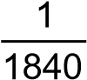 respectively
What are the relative charges of a proton,  neutron, and electron? | +1, 0, and -1 respectively
How do the number of protons and electrons  differ in an atom? | they are the same because atoms have neutral charge
What force holds an atomic nucleus together? | strong nuclear force
What is the atomic number of an element? | the number of protons in the nucleus of a single atom of an element
What is the mass number of an element? | number of protons + number of neutrons
What is an isotope? | an atom with the same number of protons but different number of neutrons
What is an ion? | an atom, or group of atoms, with a charge
What is the function of a mass spectrometer? | it accurately determines the mass and abundance of separate atoms or molecules, to help us identify them
What is a mass spectrum? | the output from a mass spectrometer that shows the different isotopes that make up an element
What is the total number of electrons that each electron shell (main energy level) can contain? | 2n² electrons, where n is the number of the shell
How many electrons can the first three electron  shells hold each? | 2 electrons (first shell), 8 electrons (second shell), 18 electrons (third shell)
What are the first four electron sub-shells (orbitals) called? | s, p, d, and f (in order)
How many electrons can each orbital hold? | a maximum of 2 electrons
Define the term ionisation energy, and give its  unit | the energy it takes to remove a mole of electrons from a mole of atoms in the gaseous state, unit = kJ mol⁻¹
What is the equation for relative atomic mass (A_{r})? | average mass of 1 atom  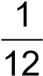  relative atomic mass = th  mass of 1 atom of ¹²C
What is the equation for relative molecular mass (M_{r})? | average mass of 1 molecule  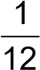  relative molecular mass = th  mass of 1 atom of ¹²C

Maths skills

1 Core mathematical skills
A practical chemist must be proficient in standard form, significant figures, decimal places, SI units, and unit conversion.

1.1 Standard form
In science, very large and very small numbers are usually written in standard form. Standard form is writing a number in the format A × 10^{x} where A is a number from 1 to 10 and x is the number of places you move the decimal place.
For example, to express a large number such as 50 000 mol dm⁻³ in standard form, A = 5 and x = 4 as there are four numbers after the initial 5.
Therefore, it would be written as 5×10⁴ mol dm⁻³.
To give a small number such as 0.000 02 Nm² in standard form, A = 2 and there are five numbers before it so x = −5.
So it is written as 2×10⁻⁵ Nm².

Practice questions
- Change the following values to standard form. a boiling point of sodium chloride: 1413 °C b largest nanoparticles: 0.0 001×10⁻³ m c number of atoms in 1 mol of water: 1806×10²¹
- Change the following values to ordinary numbers.
a 5.5×10⁻⁶ b 2.9×10² c 1.115×10⁴ d 1.412×10⁻³ e 7.2×10¹

1.2 Significant figures and decimal places
In chemistry, you are often asked to express numbers to either three or four significant figures. The word significant means to ‘have meaning’. A number that is expressed in significant figures will only have digits that are important to the number’s precision.
It is important to record your data and your answers to calculations to a reasonable number of significant figures. Too many and your answer is claiming an accuracy that it does not have, too few and you are not showing the precision and care required in scientific analysis.
For example, 6.9301 becomes 6.93 if written to three significant figures.
Likewise, 0.000 434 56 is 0.000 435 to three significant figures.
Notice that the zeros before the figure are not significant – they just show you how large the number is by the position of the decimal point. Here, a 5 follows the last significant digit, so just as with decimals, it must be rounded up.
Any zeros between the other significant figures are significant. For example, 0.003 018 is 0.003 02 to three significant figures.
Sometimes numbers are expressed to a number of decimal places. The decimal point is a place holder and the number of digits afterwards is the number of decimal places.
For example, the mathematical number pi is 3 to zero decimal places, 3.1 to one decimal place, 3.14 to two decimal places, and 3.142 to three decimal places.

Practice questions
3 Give the following values in the stated number of significant figures (s.f.).
a 36.937 (3 s.f.) b 258 (2 s.f.) c 0.043 19 (2 s.f.) d 7 999 032 (1 s.f.) 4 Use the equation: number of molecules = number of moles × 6.02 × 10²³ molecules per mole to calculate the number of molecules in 0.5 moles of oxygen. Write your answer in standard form to 3 s.f.
5 Give the following values in the stated number of decimal places (d.p.). a 4.763 (1 d.p.) b 0.543 (2 d.p.) c 1.005 (2 d.p.) d 1.9996 (3 d.p.)

1.3 Converting units
Units are defined so that, for example, every scientist who measures a mass in kilograms uses the same size for the kilogram and gets the same value for the mass. Scientific measurement depends on standard units – most are Système International (SI) units.
If you convert between units and round numbers properly it allows quoted measurements to be understood within the scale of the observations.
Multiplication factor | Prefix | Symbol
10⁹ | giga | G
10⁶ | mega | M
10³ | kilo | k
10–2 | centi | c
10^{–3} | milli | m
10^{–6} | micro | µ
10^{–9} | nano | n
Unit conversions are common. For instance, you could be converting an enthalpy change of 488 889 J mol⁻¹ into kJ mol⁻¹. A kilo is 10³ so you need to divide by this number or move the decimal point three places to the left.
488 889 ÷ 10³ kJ mol⁻¹ = 488.889 kJ mol⁻¹
Converting from mJ mol⁻¹ to kJ mol⁻¹, you need to go from 10³ to 10⁻³, or move the decimal point six places to the left.
333 mJ mol⁻¹ is 0.000 333 kJ mol⁻¹
If you want to convert from 333 mJ mol⁻¹ to nJ mol⁻¹, you would have to go from 10⁻⁹ to 10⁻³, or move the decimal point six places to the right.
333 mJ mol⁻¹ is 333 000 000 nJ mol⁻¹

Practice questions
6 Calculate the following unit conversions.
a 300 µm to m b 5 MJ to mJ c 10 GW to kW

2 Balancing chemical equations

2.1 Conservation of mass
When new substances are made during chemical reactions, atoms are not created or destroyed – they just become rearranged in new ways. So, there is always the same number of each type of atom before and after the reaction, and the total mass before the reaction is the same as the total mass after the reaction. This is known as the conservation of mass.
You need to be able to use the principle of conservation of mass to write formulae, and balanced chemical equations and half equations.

2.2 Balancing an equation
The equation below shows the correct formulae but it is not balanced.
H₂ + O₂ → H₂O
While there are two hydrogen atoms on both sides of the equation, there is only one oxygen atom on the right-hand side of the equation against two oxygen atoms on the left-hand side. Therefore, a two must be placed before the H₂O.
H₂ + O₂ → 2H₂O
Now the oxygen atoms are balanced but the hydrogen atoms are no longer balanced. A two must be placed in front of the H₂.
2H₂ + O₂ → 2H₂O
The number of hydrogen and oxygen atoms is the same on both sides, so the equation is balanced.

Practice questions
1 Balance the following equations.
a C + O₂ → CO b N₂ + H₂ → NH₃ c C₂H₄ + O₂ → H₂O + CO₂

2.3 Balancing an equation with fractions
To balance the equation below:
C₂H₆ + O₂ → CO₂ + H₂O
- Place a two before the CO₂ to balance the carbon atoms.
- Place a three in front of the H₂O to balance the hydrogen atoms. C₂H₆ + O₂ → 2CO₂ + 3H₂O
There are now four oxygen atoms in the carbon dioxide molecules plus three oxygen atoms in the water molecules, giving a total of seven oxygen atoms on the product side.
- To balance the equation, place three and a half in front of the O₂. C₂H₆ + 3½O₂ → 2CO₂ + 3H₂O
- Finally, multiply the equation by 2 to get whole numbers.
2C₂H₆ + 7O₂ → 4CO₂ + 6H₂O

Practice questions
2 Balance the equations below. a C₆H₁₄ + O₂ → CO₂ + H₂O b NH₂CH₂COOH + O₂ → CO₂ + H₂O + N₂

2.4 Balancing an equation with brackets
Ca(OH)₂ + HCl → CaCl₂ + H₂O
Here the brackets around the hydroxide (OH⁻) group show that the Ca(OH)₂ unit contains one calcium atom, two oxygen atoms, and two hydrogen atoms.
To balance the equation, place a two before the HCl and another before the H₂O.
Ca(OH)₂ + 2HCl → CaCl₂ + 2H₂O

Practice questions
3 Balance the equations below.
a Mg(OH)₂ + HNO₃ → Mg(NO₃)₂ + H₂O b Fe(NO₃)₂ + Na₃PO₄ → Fe₃(PO₄)₂ + NaNO₃

3 Rearranging equations and calculating concentrations

3.1 Rearranging equations
In chemistry, you sometimes need to rearrange an equation to find the desired values.
For example, you may know the amount of a substance (n) and the mass of it you have (m), and need to find its molar mass (M).
The amount of substance (n) is equal to the mass you have (m) divided by the molar mass (M):
m
n=
M
You need to rearrange the equation to make the molar mass (M) the subject.
Multiply both sides by the molar mass (M):
M × n = m
Then divide both sides by the amount of substance (n):
m
m=
N

Practice questions
n
- Rearrange the equation c= to make: V
  - n the subject of the equation b V the subject of the equation.
- Rearrange the equation PV = nRT to make:
  - n the subject of the equation
  - T the subject of the equation.

3.2 Calculating concentration
The concentration of a solution (a solute dissolved in a solvent) is a way of saying how much solute, in moles, is dissolved in 1 dm³ or 1 litre of solution.
Concentration is usually measured using units of mol dm⁻³. (It can also be measured in g dm³.)
The concentration of the amount of substance dissolved in a given volume of a solution is given by the equation:
n
c=
V
where n is the amount of substance in moles, c is the concentration, and V is the volume in dm³.
The equation can be rearranged to calculate:
- the amount of substance n, in moles, from a known volume and concentration of solution
- the volume V of a solution from a known amount of substance, in moles, and the concentration of the solution.

Practice questions
- Calculate the concentration, in mol dm⁻³, of a solution formed when 0.2 moles of a solute is dissolved in 50 cm³ of solution.
- Calculate the concentration, in mol dm⁻³, of a solution formed when 0.05 moles of a solute is dissolved in 2.0 dm³ of solution.
- Calculate the number of moles of NaOH in an aqueous solution of 36 cm³ of 0.1 mol dm⁻³.

4 Molar calculations

4.1 Calculating masses and gas volumes
The balanced equation for a reaction shows how many moles of each reactant and product are involved in a chemical reaction.
If the amount, in moles, of one of the reactants or products is known, the number of moles of any other reactants or products can be calculated.
The number of moles (n), the mass of the substance (m), and the molar mass (M) are linked by:
m
n=
M
Note: The molar mass of a substance is the mass per mole of the substance. For CaCO₃, for example, the atomic mass of calcium is 40.1, carbon is 12, and oxygen is 16. So the molar mass of CaCO₃ is:
40.1 + 12 + (16 × 3) = 100.1. The units are g mol⁻¹.
Look at this worked example. A student heated 2.50 g of calcium carbonate, which decomposed as shown in the equation:
CaCO₃(s) → CaO(s) + CO₂(g)
The molar mass of calcium carbonate is 100.1 g mol⁻¹.
- Calculate the amount, in moles, of calcium carbonate that decomposes.
m
n= = 2.50/100.1 = 0.025 mol
M
- Calculate the amount, in moles, of carbon dioxide that forms.
From the balanced equation, the number of moles of calcium carbonate = number of moles of carbon dioxide = 0.025 mol

Practice questions
- In a reaction, 0.486 g of magnesium was added to oxygen to produce magnesium oxide.
2Mg(s) + O₂(g) → 2MgO(s) a Calculate the amount, in moles, of magnesium that reacted. b Calculate the amount, in moles, of magnesium oxide made.
c Calculate the mass, in grams, of magnesium oxide made.
- Oscar heated 4.25 g of sodium nitrate. The equation for the decomposition of sodium nitrate is:
2NaNO₃(s) → 2NaNO₂(s) + O₂(g) a Calculate the amount, in moles, of sodium nitrate that reacted.
b Calculate the amount, in moles, of oxygen made.
- 0.500 kg of magnesium carbonate decomposes on heating to form magnesium oxide and carbon dioxide. Give your answers to 3 significant figures. MgCO₃(s) → MgO(s) + CO₂(g) a Calculate the amount, in moles, of magnesium carbonate used. b Calculate the amount, in moles, of carbon dioxide produced.

5 Percentage yields and percentage errors

5.1 Calculating percentage yield
Chemists often find that an experiment makes a smaller amount of product than expected. They can predict the amount of product made in a reaction by calculating the percentage yield.
The percentage yield links the actual amount of product made, in moles, and the theoretical yield, in moles:
actual amount (in moles) of product
percentage yield = ×100
theoretical amount (in moles) of product
Look at this worked example. A student added ethanol to propanoic acid to make the ester, ethyl propanoate, and water.
C₂H₅OH + C₂H₅COOH → C₂H₅COOC₂H₅ + H₂O
The experiment has a theoretical yield of 5.00 g.
The actual yield is 4.50 g.
The molar mass of C₂H₅COOC₂H₅ = 102.0 g mol⁻¹ Calculate the percentage yield of the reaction.
m
Actual amount of ethyl propanoate: n= = 4.5/102 = 0.0441 mol
M
m
Theoretical amount of ethyl propanoate: n= = 5.0/102 = 0.0490 mol
M
percentage yield = (0.0441/0.0490) × 100% = 90%

Practice questions
- Calculate the percentage yield of a reaction with a theoretical yield of 4.75 moles of product and an actual yield of 3.19 moles of product. Give your answer to 3 significant figures.
- Calculate the percentage yield of a reaction with a theoretical yield of 12.00 moles of product and an actual yield of 6.25 moles of product. Give your answer to 3 significant figures.

5.2 Calculating percentage error in apparatus
The percentage error of a measurement is calculated from the maximum error for the piece of apparatus being used and the value measured:
maximum error
percentage error = × 100%
measured value
Look at this worked example. In an experiment to measure temperature changes, an excess of zinc powder was added to 50 cm³ of copper(II) sulfate solution to produce zinc sulfate and copper.
Zn(s) + CuSO₄(aq) → ZnSO₄(aq) + Cu(s)
The measuring cylinder used to measure the copper(II) sulfate solution has a maximum error of ±2 cm³.
a Calculate the percentage error.
percentage error = (2/50) × 100% = 4% b A thermometer has a maximum error of ±0.05 °C.
Calculate the percentage error when the thermometer is used to record a temperature rise of 3.9 °C. Give your answer to 3 significant figures. percentage error = (2 × 0.05)/3.9 × 100% = 2.56%
(Notice that two measurements of temperature are required to calculate the temperature change so the maximum error is doubled.)

Practice questions
- A gas syringe has a maximum error of ±0.5 cm³. Calculate the maximum percentage error when recording these values. Give your answers to 3 significant figures.
  - 21.0 cm³ b 43.0 cm³
- A thermometer has a maximum error of ±0.5 °C. Calculate the maximum percentage error when recording these temperature rises. Give your answers to 3 significant figures.
  - 12.0 °C b 37.6 °C

6 Graphs and tangents

6.1 Deducing reaction rates
To investigate the reaction rate during a reaction, you can measure the volume of the product formed, such as a gas, or the colour change to work out the concentration of a reactant during the experiment. By measuring this concentration at repeated intervals, you can plot a concentration–time graph.
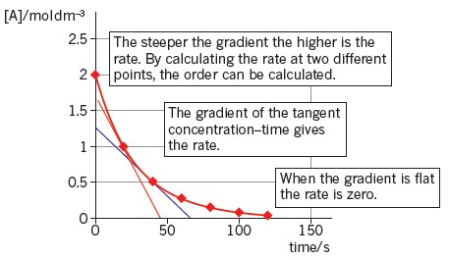
Note: When a chemical is listed in square brackets, it just means ‘the concentration of’ that chemical. For example, [O₂] is just shorthand for the concentration of oxygen molecules.
By measuring the gradient (slope) of the graph, you can calculate the rate of the reaction. In the graph above, you can see that the gradient changes as the graph is a curve. If you want to know the rate of reaction when the graph is curved, you need to determine the gradient of the curve. So, you need to plot a tangent.
The tangent is the straight line that just touches the curve. The gradient of the tangent is the gradient of the curve at the point where it touches the curve.
Looking at the graph above. When the concentration of A has halved to 1.0 mol dm⁻³, the tangent intercepts the y-axis at 1.75 and the x-axis at 48.
The gradient is 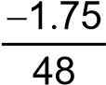 = −0.0365 (3 s.f.).
So the rate is 0.0365 mol dm⁻³ s⁻¹.

Practice questions
1 Using the graph above, calculate the rate of reaction when the concentration of A halves again to 0.5 mol dm⁻³.

6.2 Deducing the half-life of a reactant
In chemistry, half-life can also be used to describe the decrease in concentration of a reactant in a reaction. In other words, the half-life of a reactant is the time taken for the concentration of the reactant to fall by half.

Practice questions
2 The table below shows the change in concentration of bromine during the course of a reaction.
Time / s | [Br₂] / mol dm⁻³
0 | 0.0100
60 | 0.0090
120 | 0.0066
180 | 0.0053
240 | 0.0044
360 | 0.0028
a Plot a concentration–time graph for the data in the table. b Calculate the rate of decrease of Br₂ concentration by drawing tangents. c Find the half-life at two points and deduce the order of the reaction.

Answers to maths skills practice questions

1 Core mathematics
- a 1.413 × 10³ °C b 1.0 × 10⁻⁷ m c 1.806 × 10²¹ atoms
- a 0.000 0055 b 290 c 11150 d 0.001 412 e 72
- a 36.9 b 260 c 0.043 d 8 000 000
- Number of molecules = 0.5 moles × 6.022 × 10²³ = 3.011 × 10²³ = 3.01 × 10²³
- a 4.8 b 0.54 c 1.01 d 2.000
- a 0.0003 m b 5 × 10⁹ mJ c 1 × 10⁷ kW

2 Balancing chemical equations
- a 2C + O₂ → 2CO b N₂ + 3H₂ → 2NH₃ c C₂H₄ + 3O₂ → 2H₂O + 2CO₂
- a C₆H₁₄ + 9O₂ → 6CO₂ + 7H₂O or 2C₆H₁₄ + 19O₂ → 12CO₂ + 14H₂O b 2NH₂CH₂COOH +4O₂ → 4CO₂ + 5H₂O + N₂ or 4NH₂CH₂COOH +9O₂ → 8CO₂ + 10H₂O + 2N₂
- a Mg(OH)₂ + 2HNO₃ → Mg(NO₃)₂ + 2H₂O b 3Fe(NO₃)₂ + 2Na₃PO₄ → Fe₃(PO₄)₂ + 6NaNO₃

3 Rearranging equations and calculating concentrations
n
1 a n = cv b v =
c
PV PV 2 a n= b T =
RT nR
0.2
- = 4.0 mol dm₋₃
0.050
0.05
- =0.025 mol dm₋₃
2
- 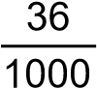× 0.1= 3.6 × 10⁻³ mol

4 Molar calculations
0.486
- a = 0.02 mol b 0.02 mol
24.3
c 0.02 × 40.3 = 0.806 g
4.25 0.05
- a = 0.05 mol b = 0.025 mol
85 2
- a 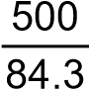 = 5.93 mol b 5.93 mol

5 Percentage yields and percentage errors
- 3.19/4.75 × 100 = 67.2%
- 6.25/12.00 × 100 = 52.1%
- a 0.5/21 × 100 = 2.38% b 0.5/43 × 100 = 1.16%
- a 0.5 × (2/12) × 100 = 8.33% b 0.5 × (2/37.6) × 100 = 2.66%

6 Graphs and tangents
- 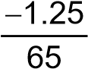=−0.0192
- a
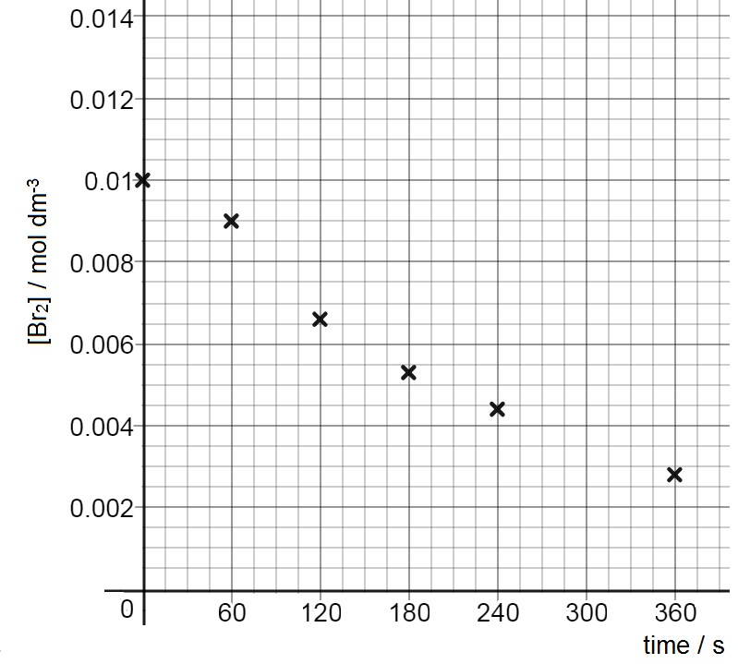
b Half-life is approximately 180 seconds c The reaction is first order

