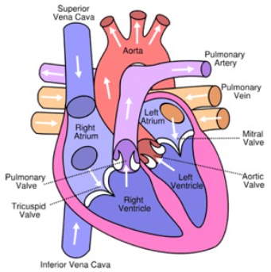
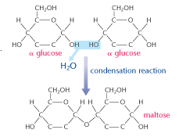
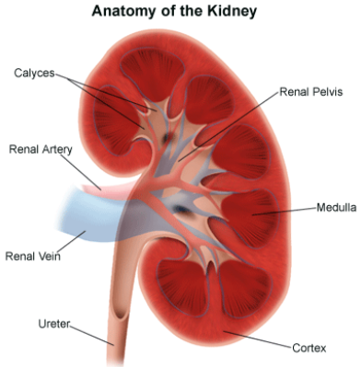
This booklet will provide you with a recap of GCSE content and extend you onto A level content.
Starting with a bit of fun: some books and films that will introduce you to some scientific ideas we will cover in A level biology.
There is a lot of work here. Pace yourself, you don’t need to complete it all in one week. Set yourself a schedule and work your way through it. If you have any problems email me (david.jones@oasisisleofsheppey.org) and I can help.
Best of luck!

Getting a head start on A Level Biology
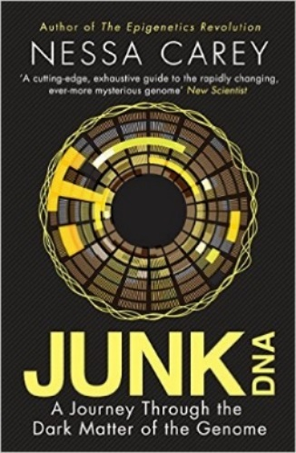
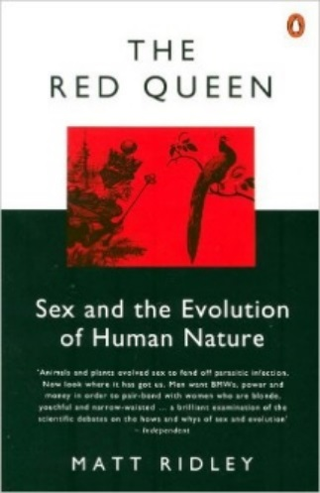
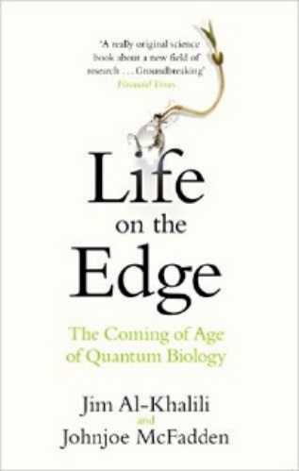
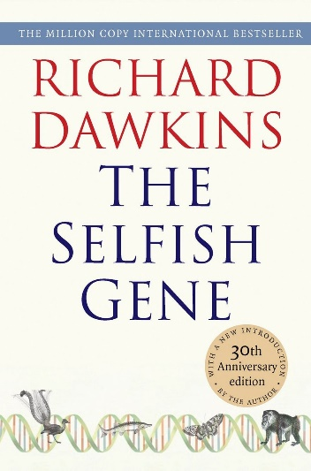
Kick back this summer with a good read. The books below are all popular science books and great for extending your understanding of Biology
Junk DNA
Our DNA is so much more complex than you probably realize, this book will really deepen your understanding of all the work you will do on Genetics. Available at amazon.co.uk
The Red Queen
Its all about sex. Or sexual selection at least. This book will really help your understanding of evolution and particularly the fascinating role of sex in evolution. Available at amazon.co.uk
The Selfish Gene
The most famous and arguably most important Biologist since Darwin. Every wondered what the point of life is? Ever wondered what the point of evolution is if it doesn’t actually help an individual. Here’s Dawkins take on all that
Available at amazon.co.uk
A Short History of Nearly Everything
A whistle-stop tour through many aspects of history from the Big Bang to now. This is a really accessible read that will re-familiarise you with common concepts and introduce you to some of the more colourful characters from the history of science! Available at amazon.co.uk
An easy read..
Frankenstein’s cat
Discover how glow in the dark fish are made and more great Biotechnology breakthroughs. Available at amazon.co.uk
Book Recommendations
Movie Recommendations
Everyone loves a good story and everyone loves some great science. Here are some of the picks of the best films based on science.
Inherit The Wind (1960)
Great if you can find it. Based on a real life trial of a teacher accused of the crime of teaching Darwinian evolution in school in America. Does the debate rumble on today?
The Martian (2015)
A biologist/ astronaut (Matt Damon) is stranded on Mars after a freak accident. How can biology help him survive?
Jurassic park and Jurassic World
Just because we’ve got the technology to clone organisms including bring back the dinosaurs, it doesn’t mean we should.
Gorillas in the Mist (1988)
An absolute classic that retells the true story of the life and work of Dian Fossey and her work studying and protecting mountain gorillas from poachers and habitat loss. A tear jerker.
Andromeda Strain (1971)
Science fiction by the great thriller writer Michael Cricthon (he of Jurassic Park fame). Humans begin dying when an alien microbe arrives on Earth.
There are some great TV series and box sets available too, you might want to check out: Anything by David Attenborough: Blue Planet, Planet Earth, The Ascent of Man, Catastrophe, Frozen Planet, Life Story, The Hunt and Monsoon.
Eukaryotes and prokaryotes;
Prokaryotes are singled celled organisms such as bacteria.
Usually much smaller than eukaryotic cells (1/10th the size), do not contain a nucleus, chloroplasts or mitochondria, DNA can be found floating free in the cytoplasm or in loops called Plasmids, some have flagellum for movement.

Eukaryotic cells are more complex and can be single cellular or multi cellular organisms.

Microscopes;
The Light microscope allows you to view animal cells. It can magnify up to 1500 times. Some organelles such as mitochondria, chloroplasts, vacuoles, cell walls, cell membranes and nuclei are visible. Staining makes these organelles visible.
Label and annotate the diagram

The electron microscope; invented in 1950s it allows a much higher magnification (500 000x) and better resolution, allowing greater detail to be seen.
Electron microscopes allowed detailed ultrastructure of the cell to be seen, such as ribosomes and the inside of mitochondria and chloroplasts. The image is called an ELECTRON MICROGRAPH.

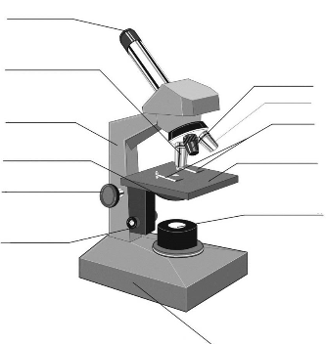
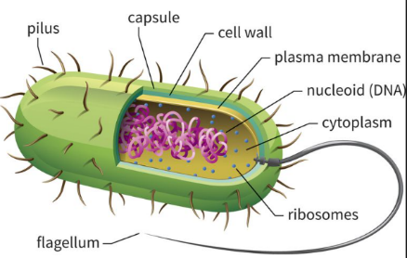

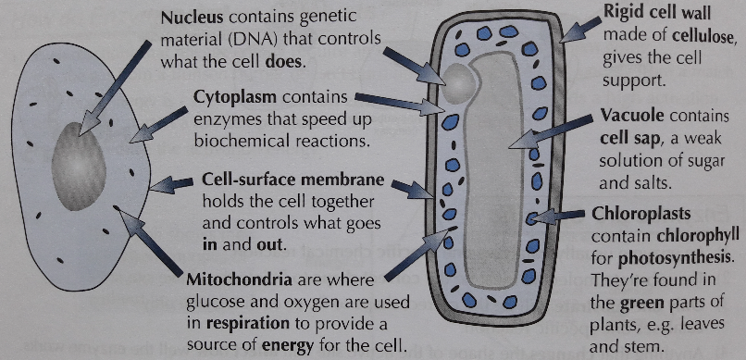

Questions;
Name 3 things visible with a light microscope in both animal and plant cells.___________________________________________________________________________________________________________________________________
Name 4 organelles that both plant and an animal cell have. ________________________________________________________________________________________________________________________________________________
What is the calculation used to calculate the magnification of an object? _____________________________________________________________________________________________________________________________________
What is the function of the mitochondria? ______________________________________________________________

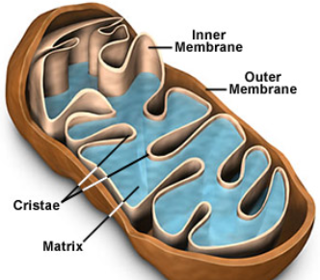
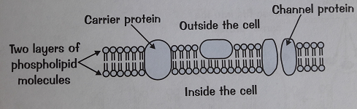
Questions;
Name 2 molecules that make up the cell membrane. _________________________________________
Describe the membranes of the mitochondria. ________________________________________
What is the name of the molecule that provide energy to the cell? _______________________________________
What term is used to describe water concentration? ________________________________________
Cell structure;
Nuclei: controls the cell function, containing the DNA which is the coded information for the production of proteins.
During cell division the chromosomes become shorter and thicker and can be seen with a light microscope. The chromosomes will then make a copy of themselves, one copy for each cell produced during cytokinesis.
Nuclei have a double membrane called the nuclear envelope.
Mitochondria: can be seen with a light microscope, however, greater internal detail can be seen using an electron microscope. The mitochondria’s function is to carry out aerobic respiration. The energy released is used to form molecules of ATP. ATP is used in the cells to provide energy for muscular contractions, active transport as well as anabolic and catabolic reactions.

Cell wall: the plant cell wall is made up of cellulose Molecules laid side by side to form microfibrils. These provides rigidity and support for the cell.

Cell structure;
Cell surface membrane: Found around every cell, it allows the movement of substances into and out of the cell. It is a partially permeable membrane and will prevent certain substances from entering.

It is made up of a double layer called the PHOSPHOLIPID BILAYER. These are molecules closely packed together in a mosaic pattern. Within the bilayer are large proteins which are also responsible for transport and for cell recognition.
Transport into and out of cells
There are 4 modes of transport you need to be aware of;
Diffusion; can be gas or liquid particles. They move from an area of high concentration to an area of low concentration down a concentration gradient. Small molecules such as oxygen, water and carbon dioxide can pass through the phospholipid bilayer.
Osmosis; occurs only with water. The water particles move from an area of high water concentration to an area of low water concentration, down a concentration gradient, across a partially permeable membrane. NO ENERGY IS REQUIRED. You will be required to refer to water potential in AS level not water concentration.
Facilitated diffusion; Some particles are too large to fit through the phospholipid bilayer and therefore require a carrier protein to assist. The protein carriers are within the bilayer and they change shape when they come into contact with a specific molecule (i.e. Glucose). NO ENERGY IS REQUIRED.
Active transport; This moves substances for an area of low concentration to an area of high concentration against a concentration gradient. ENERGY IS NEEDED for this to occur. Specific carrier proteins are also required these can be called ‘pumps’.

Enzymes; Help to speed up biochemical reactions.
Metabolism is the sum of all the biochemical reactions that occur per second and a single chain of these reactions is called a metabolic pathway.
Enzymes are biological catalysts and increase the rate of reactions.
Reactions that release energy
need an input energy to start.
The input energy is called the
ACTIVATION ENERGY. Enzymes reduce the activation energy.
Enzymes are proteins; enzymes are globular proteins with a specific order of amino acids that determines what the enzyme does.
Enzymes can be catabolic (break substrates down) or anabolic (build substrates up). Enzymes have a specific site into which the substrates can attach itself, this attachment site is called the active site. The active site is complementary to the shape of the substrate. Once they attach together they form the enzyme substrate complex. The substrate then breaks bonds or makes bonds (depending on the type of enzyme) and the product leaves the active site. The active site is now able to accept another substrate.

Denaturing enzymes; Enzymes have a specific tertiary shape held in place by weak hydrogen bonds and stronger disulphide bonds. These bonds can be broken by an increase in temperature (kinetic energy) or a change in pH (H⁺ in acid or OH⁻ in alkali disrupt the bonds).
Useful enzymes; Digestive enzymes are catabolic, breaking down food into smaller molecules. Enzymes are also needed in DNA replication, building up molecules (DNA polymerase).
Proteins;
Proteins are made of long chains of amino acids, up to several hundred long. There are only 20 different amino acids and the combination of these 20 produce a wide range of complex proteins. Protein structures are held together with strong bonds called PEPTIDE bonds. The order of the amino acids determines the structure and how it works.
All amino acids have the same structure with one variation on the R group.
Contains; Hydrogen, oxygen,
Nitrogen and carbon.
Proteins structure;
The order of the amino acids forms the PRIMARY STRUCTURE. The protein chain can then coil or fold into pleats which are held together by weak hydrogen bonds to for the SECONDARY STRUCTURE.
Enzymes have a further folding held together with stronger disulphide bonds. This is the TERTIARY STRUCTURE. If the structure is almost spherical it is called a globular protein.

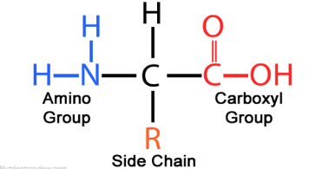
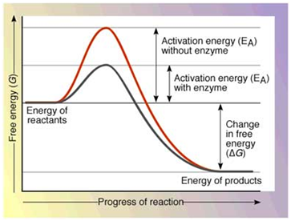
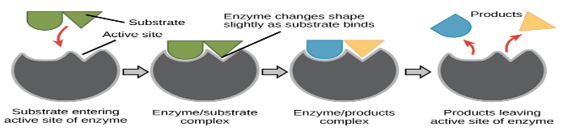
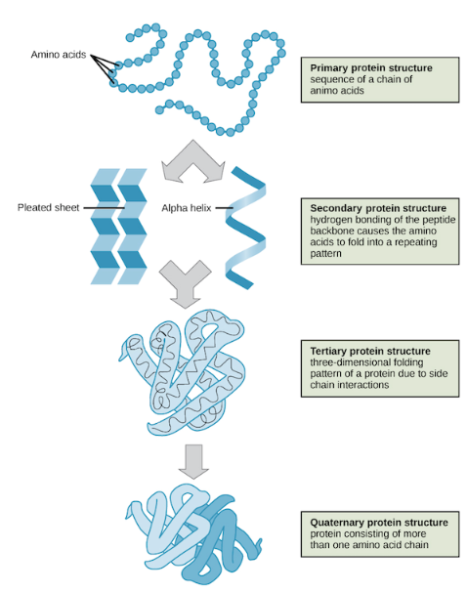
Questions;
What types of bond hold together the secondary structure? ________________ The tertiary structure? ______________________ How many amino acids are there and what elements are found in them? _______________________________________________ Explain why denatured enzymes will not function. ____________________________________________________________________________________________________________________________________________________________________________
What is activation energy? ____________________________________________________________________________________
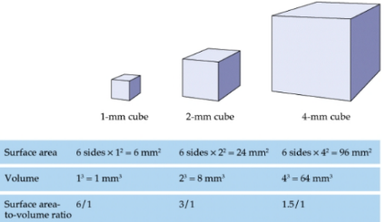
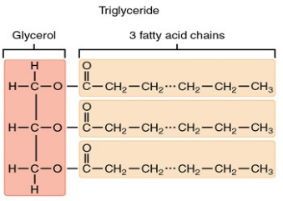
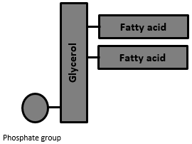
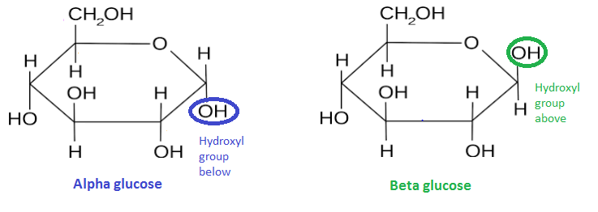
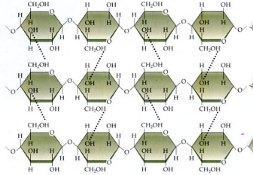
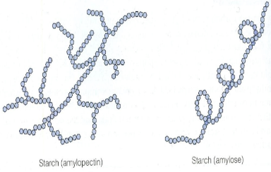
Exchange surfaces;
All good exchange surfaces require adaptations to make the exchange efficient. The smaller the object the quicker exchange is able to occur due to it having a large surface area to volume ration, however larger, more complex organisms have a much smaller surface area to volume ratio.
The larger the object the lower the surface area to volume ratio.

To overcome this, multicellular organisms have highly adapted exchange organs. Adaptations include;
- Folded to increase the surface area to volume ratio for a faster exchange.
- A good blood supply to maintain the concentration gradient.
- One cell thick (thin) to reduce diffusion distance.
Materials that need to be exchanged between the cell and he environment include; heat, oxygen, water, carbon dioxide, nutrients and other waste products such as urea. The adaptations allow MORE substances to be exchanged at a faster rate.

Lipids;
Three elements make up the lipid molecule – carbon, hydrogen and oxygen. Lipids are fats and oils, predominantly made up of a group of lipids called triglycerides. These contain a molecule of GLYCEROL with 3 fatty acids.
The fatty acid is a long chain of carbon atoms with an acid (-COOH) group. Hydrogen atoms are attached to the carbons by single bond. A single bond forms a saturated lipid. If there is a double bond then the lipid is unsaturated, many double bonds forms a polyunsaturated lipid.
Cell membranes are formed from phospholipid. They do not have 3 fatty acid chains but 2 fatty acid chains and a phosphate group.
Questions;
Describe the difference between a triglyceride and a phospholipid. ___________________________________ ______________________________________________
Describe the difference between Starch and cellulose. ____________________________________________________________________________________________
What bonds hold Cellulose microfibrils together? ______
Carbohydrates;
Three elements make up the carbohydrate molecule – carbon, hydrogen and oxygen.
There are several types of carbohydrates;
Sugars; Small, sweet, water soluble molecules. Can be monosaccharides or disaccharides. Monosaccharides are single units from which disaccharides are built. Glucose and Fructose are monosaccharides and join together to form the disaccharide sucrose. The joining together of 2 monosaccharides occurs to release a molecule of water this is called a condensation reaction.
Glucose occurs in 2 forms alpha (α) glucose and beta (β) glucose.

Starch; A POLYSACCHARIDE (a large molecule –polymer, made up of monomers). Two different polysaccharides of glucose are used to make starch- amylose and amylopectin. Starch is insoluble so it is a good storage molecule in plants.
Cellulose; a polymer of glucose. Bonding is different in cellulose, molecules are bonded in a long straight line with hydrogen bonds between the strands. It forms microfibrils to provide strength to plant cell walls.
Cellulose Amylopectin Amylose
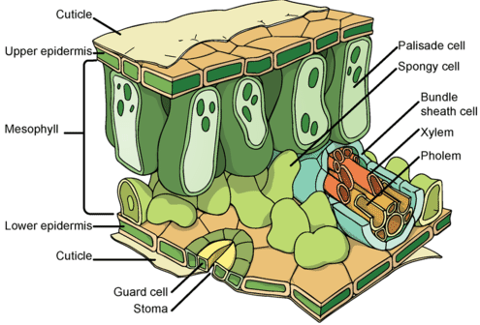
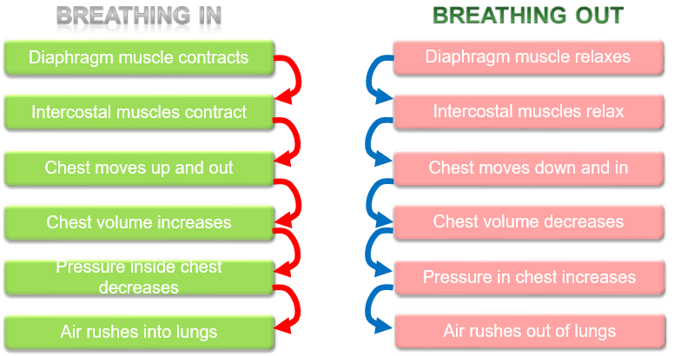
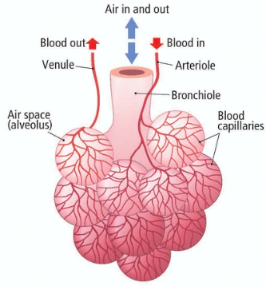
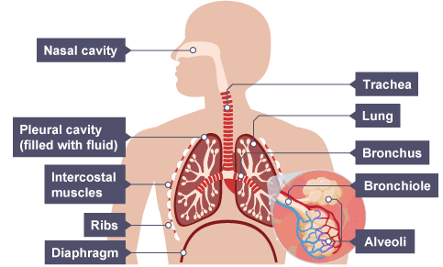
Gas exchange in animals;
Lungs; Multi cellular organisms have evolved a complex blood supply system and a large gas exchange system (lungs). The lungs contain millions of tiny air sacs called ALVEOLI which are then folded to further increase the surface area of the lung.

The alveoli are further adapted by having a single flattened layer of epithelial squamous cells which reduces the diffusion distance increasing the speed of diffusion. Alveoli have a dense network of capillaries to move the blood away quickly, maintaining a steep diffusion gradient. The walls of the alveoli are fully permeable to dissolved oxygen and carbon dioxide.
Breathing/ventilation; The process of maintaining a high concentration of oxygen inside the lungs and getting rid of the waste product carbon dioxide. Ventilation increases he rate of diffusion.
Lungs are suspended in the airtight Thorax and any change in volume will affect the pressure in the thorax.

Gas exchange in plants;

Plants also have adaptations to allow gas exchange. The leaf is an organ that is adapted to allow the movement of water from the leaf and the diffusion of carbon dioxide into the leaf. The upper mesophyll layer contains Palisade cells which are packed with chloroplasts to absorb as much energy from the sun as possible for photosynthesis. The lower part of the mesophyll layer is the spongy mesophyll which contains air spaces to facilitated the diffusion of gases into the cells and out of the cells.
The upper epidermis is covered by a waxy cuticle to prevent water loss. The lower epidermis has a specialised pair of cells called the GUARD CELLS. The guard cells have an uneven thickening in the cell wall which causes the cell to bend and open up a hole in the lower epidermis called the STOMA. The stoma allows the water vapour to move out of the leaf into the environment (transpiration) and carbon dioxide to move into the leaf.
Transpiration; The movement of water from the root and out of the leaf is called the transpiration stream. Water passes into the root by osmosis and then moves through the root by 3 different processes;
- The symplast pathway; water moves from root cell to root cell through the cytoplasm.
- The apoplast pathway; water moves through the cell wall, not passing over the cell membrane, carrying minerals with it through a process called MASS FLOW.
- The vacuolar pathway; water moves from root cell to root cell via the cytoplasm and the vacuole.
Water moves out of the leaf by diffusion into the environment. The water moves from root to leaf through a specialised tube called the xylem. Water is pulled up the xylem due to an attraction force between the water particles causing a tension in the xylem (Cohesion tension) and the attraction between the water particles and the sides of the xylem vessel (adhesion).
The second vessel in the plant is the phloem and this is responsible for translocation, the mass flow of substances from the leaf to the rest of the plant.
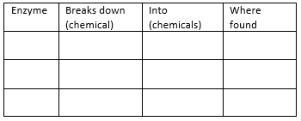
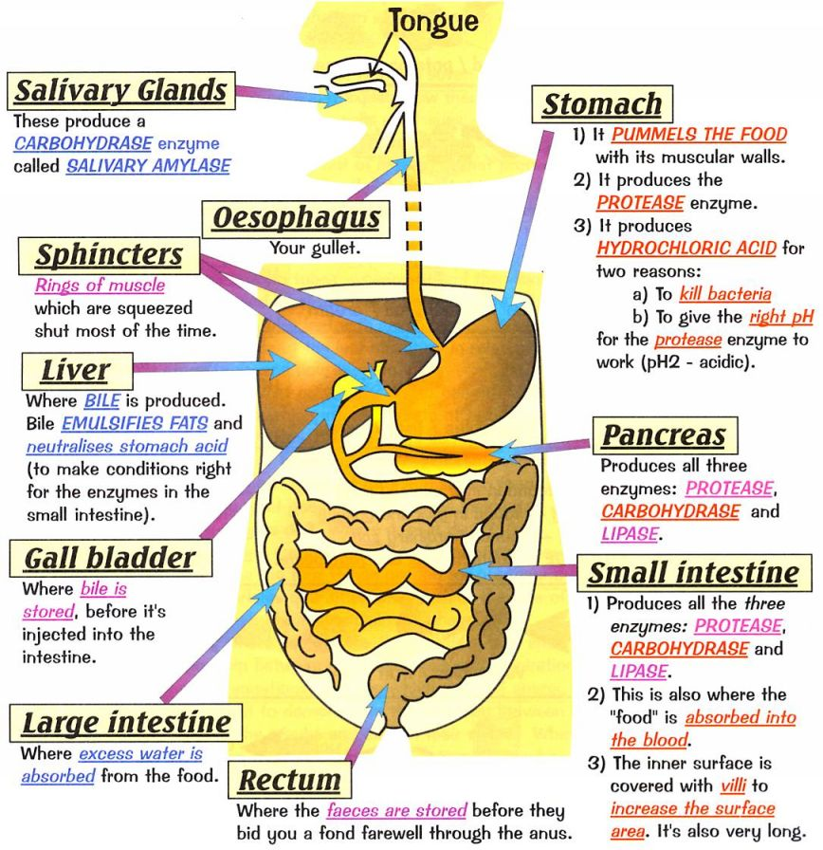
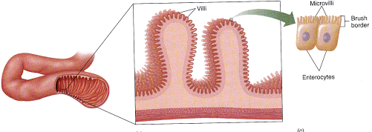
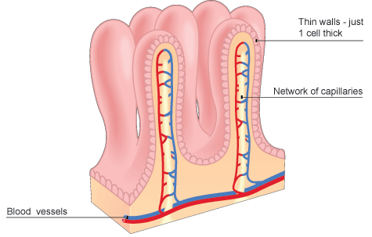
Questions; What are the 3 ways water moved through the root? ___________________________________________________________________________________________________________________
What are the 3 digestive enzymes, what do they break down and where are they found?

What is the role of Bile? ______________________________________________________________________________________
How is the small intestine adapted to increase the rate of diffusion of digested food products? _________________________________________________________________________________________________________________________________
Questions; What are the features that makes a surface better adapted for exchange? __________________________________________ What is transpiration? ________________________________
What is translocation? ________________________________
Other exchange surfaces:
All of the digested food is now small enough to pass through the wall of the small intestine into the blood stream.

As an exchange surface it displays the same characteristic adaptations as the lung; Large surface area to volume ratio, good blood supply and one cell thick.
Microvilli; the walls of the small intestine are highly folded into villi, to increase the SA:Vol. ratio. However, this can be increase further by each individual cell having further folds called microvilli.
Other exchange surfaces;
Digestion; The human digestive system has 3 main functions;
- Mechanical breakdown of food
- Chemical breakdown of food
- Absorption of digested food particles into the blood stream.

The digestive system contains 3 types of enzyme;
- Carbohydrase enzymes for breaking down complex carbohydrates into simple sugars. These are found in the mouth (amylase enzyme), the pancreas and the small intestine.
- Protease enzymes break down proteins into amino acids. These are found in the stomach (protease enzyme requires a pH 2 which is provided by the hydrochloric acid), the pancreas and the small intestine.
- Lipase enzymes breaks down lipids into fatty acids and glycerol. These are found in the pancreas and the small intestine.
Bile is an important chemical in digestion. Bile is made in the liver and stored in the gall bladder. It has 2 roles;
- Makes the digested food, leaving the stomach, slightly alkali for enzymes to work in.
- It emulsifies the lipids, breaking them up into small droplets to increase the surface area for lipase to digest.
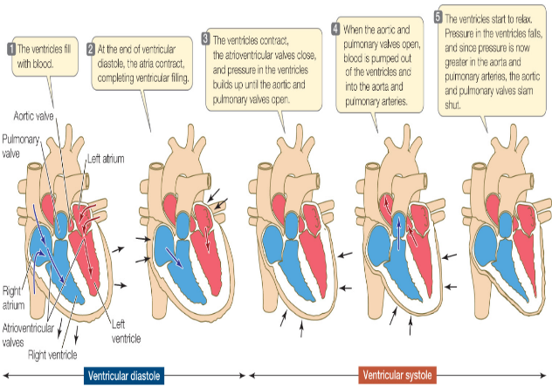
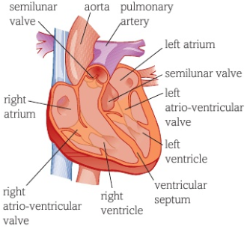
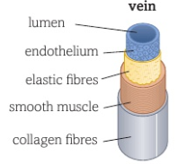
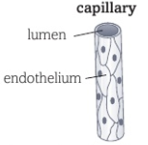
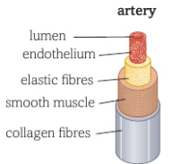
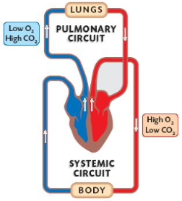
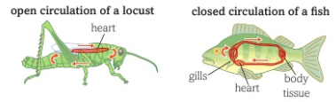
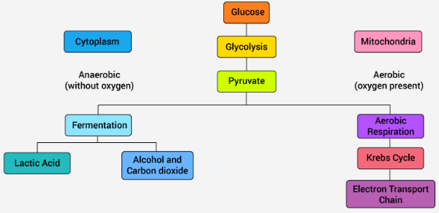
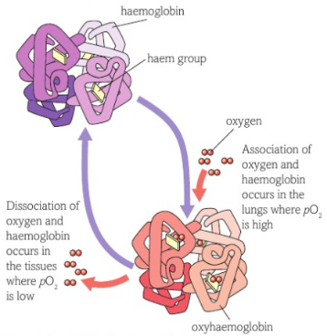
Questions;
What is the name of the system that sends blood to body organs? _____________________________________________________ Which blood vessels contain valves? _______________________ Which blood vessel has the thickest smooth muscle and what is its function? ___________________________________________ Which Valves close when the ventricles contract? _____________ Which side of the heart is the thickest and why? ______________
The circulatory system and blood vessels;
Large multicellular organisms have a small surface area to volume ratio and have evolved a complex circulatory system to transport chemicals around the body, this is called the CIRCULATORY SYSTEM.
Some organisms such as flat worms can diffuse oxygen and glucose across their surface. Less active organisms such as insects may have a much more simplified circulatory system.

Fish have a more complex system were by the blood enters the heart once before being transported to the systemic system this is called a single circulatory system. Mammals have evolved a double circulatory system with a pulmonary and a systemic circuit.
The heart pumps the deoxygenated blood to the lungs (pulmonary system) to pick up oxygen and removes carbon dioxide. The oxygenated blood is then returned to the heart to be pumped out to the organs (systemic system).

The blood travels through 3 main types of blood vessels; 1) The Arteries; carry blood away from the heart. They have a thick layer of elastic tissue and smooth muscle. The elastic walls stretch when the heart contracts and the elastic tissue recoils to maintain the pressure. 2) Capillaries; These consist of a single layer of endothelial cells. The arteries subdivide arterioles which further divide into thousands of capillaries. The capillaries come into close contact with body cells providing a huge surface area to volume ratio and a short diffusion distance for the exchange of oxygen, glucose, carbon dioxide, urea and other substances. 3) Veins; The capillaries start to come back together forming venules and then veins. Veins carry blood back towards the heart. Blood is at a lower pressure and therefore do not need such a thick layer of elastic tissue or smooth muscle. The veins contain valves to prevent the blood flowing backwards.

The heart;

The heart has two separate pumps. The right side of the heart pumps blood to the lungs and the left side pumps blood to the body. Valves within the heart keep the blood flowing in the correct direction. Valves open and close in response to the changes of pressure inside the chambers.
The heart is made up of 4 chambers; the right atria, the right ventricle, the left atria and the left ventricle. The left side of the heart has a thicker muscular wall to create enough pressure to force the blood around the whole body.
The hearts contractions are initiated by a cluster of specialised cells called the SINO-ATRIAL NODE or the PACEMAKER. These cells send out electrical impulses at regular intervals.
The coronary arteries supply the muscle in the heart with blood.
The cardiac cycle; This is the sequence of events that occur in a single heartbeat.

Questions continued….
11) Define the term anaerobic respiration _____________________________________________________________________
12) Write a word equation for;
a) anaerobic respiration in plants and yeast _______________________________________________
b) anaerobic respiration in mammals ________________________________________________
13) What is the oxygen debt? ______________________________________________________________________________
14) Why can a person not anaerobically respire for a long time? _______________________________________________________________________________________________________
Questions;
1)What substance is picked up by the blood in the lungs? ____________________________________________________
2) What is the name of the protein found in the erythrocyte? ____________________________________________________
3) What metal ion is present in the protein? ________________
4) What does it mean if the blood is said to be ‘fully saturated’? ________________________________________________________________________________________________________
5) Which gas affects the oxygen binding properties of haemoglobin? ________________________________________
6) What is the term used to describe oxygen leaving the haemoglobin protein? _________________________________
7) What is the name of the stage of respiration that is common to aerobic and anaerobic respiration? _____________________
8) What are the products of the first stage of respiration? ____________________________________________________
9) Name the remaining 3 stages of aerobic respiration. ________________________________________________________________________________________________________
10) Name the molecule that is produced and will supply energy to other parts of the body. ______________________________
The blood;
Blood is made up of 4 different components
1) Plasma; the liquid part of blood that transports the cells, dissolved substances and thermal energy.
2) Platelets; cell fragments responsible for clotting of the blood.
3) White blood cells; there are many different white blood cells all responsible for protecting the body from pathogens.
4) Red blood cells AKA erythrocytes; these are responsible for transporting oxygen to body cells. Erythrocytes contain a complex protein called HAEMOGLOBIN. Haemoglobin contains four iron ions each will bind to one oxygen. One haemoglobin can carry 4 molecules of oxygen (100% saturated) and becomes OXYHAEMOGLOBIN. Due to the low availability of oxygen in the tissue and the high concentration of carbon dioxide, the oxygen will dissociate from the haemoglobin. The carbon dioxide from the respiring tissues makes the haemoglobin less able to ‘hold on’ to the oxygen so increases the rate at which the oxygen dissociates.

Respiration;
Aerobic respiration; This occurs in the mitochondria of cells. It requires a number of small stages to break down glucose (C₆H₁₂O₆) to release a large amount of energy; adenosine triphosphate (ATP). The first stage is a stage called GLYCOLYSIS, this occurs in the cytoplasm and converts glucose into two 3 carbon molecules called PYRUVATE. Pyruvate is formed in both aerobic and anaerobic respiration, however in aerobic respiration the pyruvate passes into the matrix of the Mitochondria. Pyruvate then goes into the link reaction to form acetyl CoA which then passes into to the Kreb cycle with the oxidise products passing into oxidative phosphorylation to form ATP and waste products carbon dioxide and water.

Anaerobic respiration; Respiration without oxygen. This form of respiration occurs without oxygen. Glucose is converted into pyruvate, through the process of GLYCOLYSIS, in the cytoplasm and is unable to pass into the mitochondria. The process of glycolysis releases small amounts of energy and over a short period of time it can keep the muscles working.
Anaerobic respiration in plants and yeast forms carbon dioxide and alcohol. Anaerobic respiration in animals forms lactic acid. The build-up of lactic acid in muscles must be broken down as the formation of the acid alters the pH and affects enzymes in the cells, slowing down reactions. As the lactate ions build up in the muscles this causes pain called fatigue. The oxygen required to convert the lactate ions back to pyruvate is called the oxygen debt.
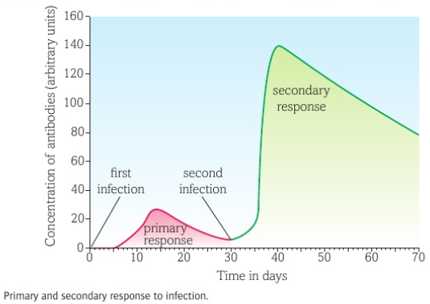
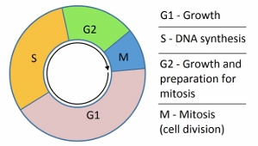
Questions;
What is a pathogen? ______________________________________________
Give 3 examples of non-communicable disease. ____________________________________________________________________________________________ How do bacteria make us ill? ______________________________________________
How do viruses make us ill? ______________________________________________
What do monocytes do? _______________________________________________________________________________________________________________________________
What do macrophages do? ___________________________________________________________________________
What are the 2 main types of lymphocytes? ______________________________________________
What do memory cells do? ____________________________________________________________________________
Look at the graph. Describe the different between the primary and secondary response. __________________________________________________________________________________________________________________________________________________________________________________________________________________________
Risk factors;
A risk factor is something that will increase the chance of becoming ill. Risk factors do not always lead to the disease, just increase the risk. Some risk factors are unavoidable such as genetic risk factors; genetic predisposition to producing high quantities of cholesterol, having high blood pressure or carrying the BRCA gene which increase the risk of breast cancer.
Other risk factors are avoidable such as; smoking, drinking alcohol, unprotected sex, high fat or high salt diet. Some risk factors (carcinogens) can cause DNA to mutate and cause cells to go into uncontrolled cell growth.
Disease;
Disease can be communicable and non-communicable.
♦ Non-communicable disease are disease’s which cannot be directly passed for person to person. These include cancer, heart disease, diabetes and Alzheimer’s. ♦ Communicable disease are disease which can be transmitted from organism to organism. These are caused by PATHOGENS such as VIRUSES, BACTERIA, FUNGI and PROTISTS.
Bacteria will produce toxins.
Viruses will place their genetic information into a cell and the information replicates and bursts the host cells.
Fungi produce mycelium and exocytose digestive enzymes to digest the tissue it is living on; it then reabsorbs the digestive products. Protists use a host to complete an important part of its life cycle and will damage the hosts cells/organs in the process.
If the first lines of defence do not prevent the pathogen entering the body, then the bodies defence systems will be activated. All cells have a unique protein structure (ANTIGEN) identifying it as not self and activating the immune system. White blood cells will respond in different ways. First the MONOCYTES and MACROPHAGES (types of phagocyte) identify the pathogen as ‘foreign’. These cells will engulf the pathogen and destroy it. Macrophages do not destroy all of the pathogen, it retains the antigen of the pathogen and ‘presents’ it on its own surface. This is now an ANTIGEN PRESENTING CELL and initiates the next round of specific white blood cells. The LYMPHOCYTES now have 3 jobs, track down and destroy the pathogens (T Lymphocytes), produce antibodies (B Lymphocytes) and make memory cells to produce antibodies quickly if the pathogen enters the body again in the future.
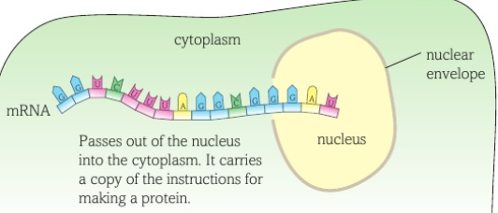
DNA and protein synthesis;
DNA is a complex chemical, found in the nucleus of eukaryotes and in the cytoplasm of prokaryotes. DNA is made up of; pentose sugar, phosphate and nitrogenous bases forming a NUCLEOTIDE. There are 4 different nitrogenous bases; A= Adenine T= Thymine C= Cytosine G= Guanine
Complementary pair; A pairs with T C pairs with G The bases pair up in the formation stated above. They are held together by hydrogen bonds. The two strands run in opposite directions causing the molecule to spiral forming a DOUBLE HELIX.
DNA controls the production of proteins. A section of DNA that codes for a protein is called a gene. Proteins are made up of a string of amino acids, each protein has a different number and order of amino acids. The proteins also have different bonds which holds the molecule in a unique shape which means all proteins have a different function.

Protein synthesis; Protein synthesis occurs in the cytoplasm, carried out by RIBOSOMES. When a protein is required then the gene has to be copied producing a molecule called messengerRNA (mRNA). mRNA is small enough to pass out of the nucleus into the cytoplasm. mRNA is a template, containing nucleotides and bases. The nucleotide on the mRNA will line up with the complementary base. However, on RNA there is no Thymine, RNA will have the base URACIL (U).
The mRNA passes out of the nucleus carrying the code for a protein. Once in the cytoplasm the mRNA binds to a ribosome.
Within the cytoplasm there is another molecule called transfer RNA (tRNA). At one end, the anticodon is complementary to them RNA. At the opposite end there are three unpaired bases which code for an amino acid. The amino acid is brought in to form a peptide bond with the amino acids brought in by the previous tRNA. This forms a polypeptide chain which will form hydrogen and disulfide bonds to form the unique protein.

Mutations: Mutations change the order of bases in the DNA. Some bases may change to a different base (substitution), some bases may be deleted and some bases may be added. Mutations can cause the following;
- Incorrect protein to be produces - No change in protein being made - Causes a harmful proteins/ no protein to be made
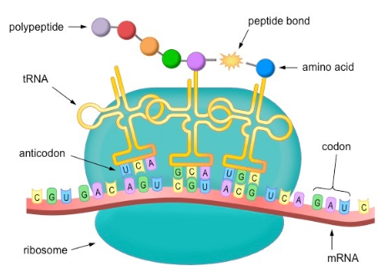
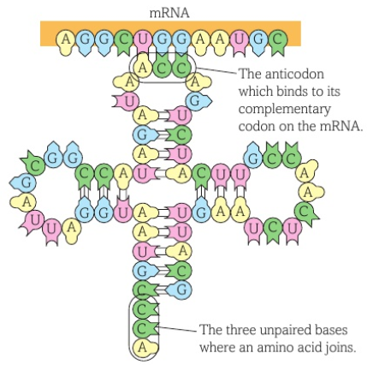
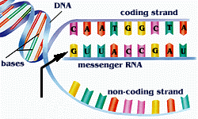
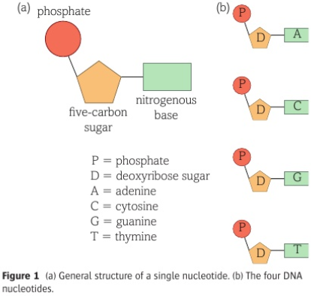
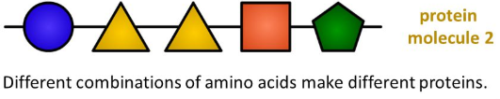
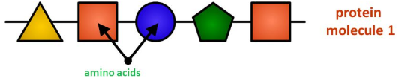
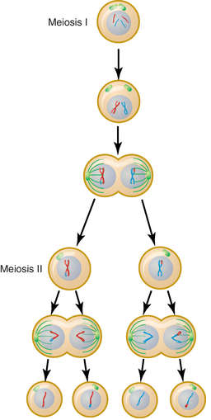
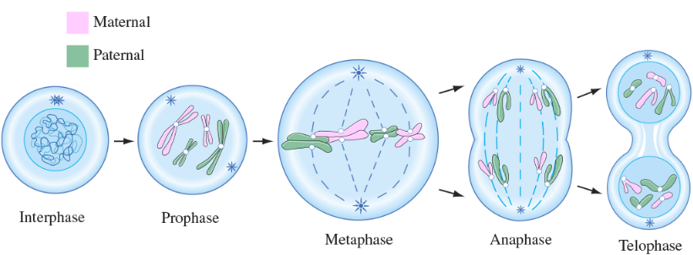
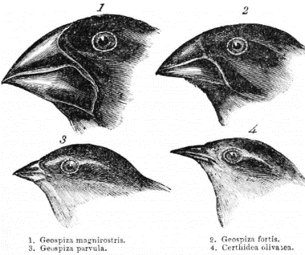
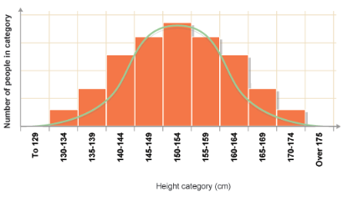
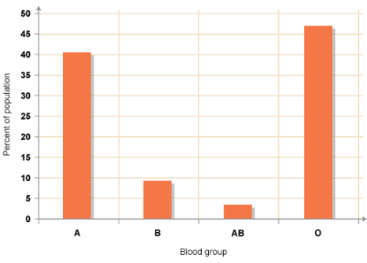
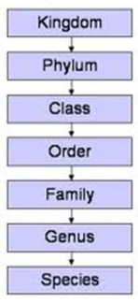
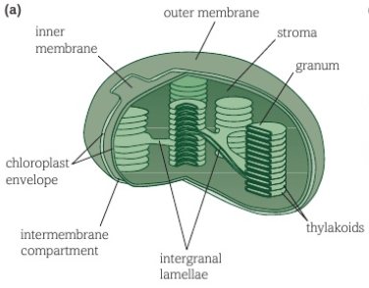
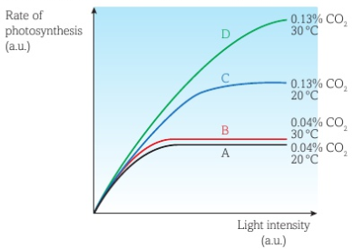
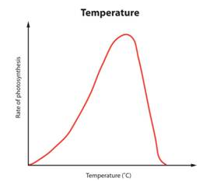
3
Pr
Questions; What are the components of a nucleotide. ________________ ___________________________________________________ What are the names of the 4 nitrogenous bases? ___________________________________________________ What type of bonds hold the 2 strands together? __________ What is the name of a section of DNA that codes for a protein? ___________________________________________ What are proteins made from? _________________________ DNA is too big to leave the nucleus, what is the copy of the gene called that enters the cytoplasm? __________________ What organelle will this molecule attach to? ______________ Which molecule has a complementary anticodon and brings in the correct amino acid? _______________________________
Questions;
Which cell division forms haploid cells? __________________ What happens during prophase? _______________________ __________________________________________________ What do centrioles do? ______________________________ __________________________________________________ Which organs produce haploid cells? ____________________ __________________________________________________What happens in Telophase? __________________________
7) Anaphase 2; The spindle fibres start to drag the chromatids to opposite sides of the cell. 8) Telophase 2; The nuclei’s start to reform and the cytoplasm spits to form 4 haploid cells that are genetically different to the parent cells.
3) Anaphase I; Spindle fibres attach to the centromere and pull the chromosomes to opposites poles. 4)Telophase I; Two nuclear envelopes surround the divided genetic information. Each contains half the number of chromosomes.
5)Prophase 2; New nucleus breaks down and chromosomes coil and condense.
6) Metaphase 2; Spindle fibres attach to the centromeres.
Meiosis; This cell division is responsible for the production of sex cells and introduces genetic variation. It results in the formation of gametes containing half the original genetic information (Haploid number). This ensures, that during fertilisation, the embryo obtains two complete sets of genetic information.
In meiosis the cell undergoes 2 cellular divisions.
2) Metaphase I; The homologous pairs arrange themselves randomly along the equator.
Telophase; A nuclear envelope forms around each set of chromatids and the cytoplasm divides forming 2 genetically identical cells.
Anaphase; The spindle fibres pull the centromere apart and the chromatids separate and are dragged to the poles of the cell.
Metaphase; the nuclear membrane breaks down, the chromosomes line up along the equator of the cell and spindle fibres, produced by the centrioles, attach to the chromosomes.
Genetics and cell division;
The DNA molecule contains thousands of genes along its length. The DNA molecule is wound up into a chromosome. Each body cell in a human contains 23 pairs of chromosomes (diploid number), one from mother and one from father. These pair up forming a homologous pair, both the same size and containing the same genes (these genes can be different alleles). A chromosome is often seen as an X shaped molecule. The X shape is actually one chromosome attached to an exact copy of itself (2 CHROMATIDS). They are joined together by an attachment called a centromere. In preparation for cell division the chromosome will make a copy of itself. All damaged tissue and cells are replaced by a process of cell division called MITOSIS. Mitosis is also seen in asexual reproduction, the offspring are genetically identical to the parent.
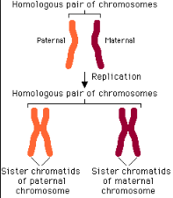

Mitosis cell division;
1) Prophase I; The chromosomes condense and the nuclear envelope breaks down. Homologous chromosomes pair up and can cross over DNA (Recombination).
Prophase; The DNA becomes supercoiled and compact and can now be seen under a light microscope. It has the X shape.
Interphase; DNA molecules are indistinct in the nucleus. They replicate their DNA, attaching at the centromeres.
Questions;
What type of variation can be displayed as a distribution curve? _____________________________________________________ What type of variation can be displayed on a bar chart? _____________________________________________________ Describe Natural selection. _______________________________ ____________________________________________________________________________________________________________________________________________________________________________________________________________________ What are the 3 domains? ________________________________ What method did Linnaeus use to group organisms? __________ _____________________________________________________ What newer methods are now used? ______________________ _____________________________________________________ Define species. ________________________________________
Variation and evolution;
Due to the mechanisms used to produce haploid cells through meiosis, genetic variation occurs. Organisms of the same species show some variation due to alleles. There are 2 types of variation;
- Genetic variation; passed from parent to child (blood group, eye colour).
- Environmental variation; caused by the environment (scars, accents, freckles)
Some variation can be due to a combination of both genetic variation and environmental variation (intelligence, height and weight). Some characteristics fall into the category of continuous variation whereby there is a large range in variations (height and weight).

Other characteristics fall into a distinct categories such as blood type, colour, tongue rolling; this is called discontinuous variation.
Sometimes a variation may lead to a characteristic that helps the organism to survive and be better adapted to its environment. The variation may be that the animal is slightly fast or better camouflaged. This slight difference within the species will allow the individual to compete better, survive, breed and potentially pass on the genetic variation to it’s offspring. This is called Natural selection. Evolution can occur through natural selection. Gradual changes over millions of years can ultimately lead to the formation of a new species.

as antibiotic-resistant bacteria. Darwin noticed that the finches - songbirds - on the different islands in the Galápagos were fundamentally similar to each other, but showed wide variations in their size, beaks and claws from island to island. For example, their beaks were different depending on the local food source. Darwin concluded that, because the islands are so distant from the mainland, the finches that had arrived there in the past had changed over time.
King Prawn Curry Or Fat Greasy Sausages.
Classification;
Developed by Carl Linnaeus in the 18th century, it was a method of sorting, grouping and naming different groups of organisms.

A species was classified as a group of organisms that look very similar to each other and can reproduce to form fertile offspring.
Technology has advanced and organisms can now be classified on a genetic level using base sequence, proteins and enzymes in common and growth during embryonic stage.

The Three Domains; Taxonomic ranking was altered in the 1970’s with the introduction of the domains before kingdom. It was further clarified in the 1990’s with better understanding of cellular structure. Archaea are prokaryotic cells, Bacteria (even though bacteria are prokaryotic cells just like Archaea, their cell membranes have a different composition) and Eukarya (eukaryotes).

Organisms were grouped into divisions based on characteristics they had in common. The five kingdoms are; Animalia, Plantae, Fungi, Prokaryotes, Protoctists. The kingdoms then divide into Phylum; in Animalia these are; Cnidaria (invertebrates), Chordata (vertebrates), Arthropods, Molluscs and Echinoderms.
In animals the vertebrate’s phylum further splits into Mammalia (Mammals), Fish, Birds, Amphibians and Reptiles.
Order, Genus and species further classifies the organisms. The Genus and species names are always written in Latin and italics. The genus name has a capital letter and the species is lower case.

Questions;
Define photoautotroph. ________________________________________________________________________________ Where in the chloroplast are the photosynthetic pigments found? _________________________________________________
What reactant of photosynthesis is broken down in the light dependent stage? _______________________________________
What reactant of photosynthesis is used in the light independent stage? ___________________________________________
What effect does increasing temperature have on the rate of photosynthesis? _________________________________________ ________________________________________________________________________________________________________________
Photosynthesis;
Photoautotrophs are organisms that produce their own food with the use of solar energy. They are the source of chemical energy for other organisms within a food chain.

Photosynthesis is and endothermic reaction requiring the energy to initiate it. A special organelle in the plant cell called the CHLOROPLAST contains a chemical called CHLOROPHYLL. The chloroplast has an inner and outer membrane called the envelope.

The photosystems contain different photosynthetic pigments which absorb different wavelengths of light. A fluid filled matrix called the STROMA surrounds the grana and contains enzymes and DNA for protein production within the chloroplast. Photosynthesis occurs in two stages;
- The Light dependent stage (LDS); this uses light energy and water to provide hydrogen ions and electrons, which are moved through electron carriers, to produce oxygen and reduced NADP which can pass into the next phase.
- The light independent stage (LIS) or CALVIN CYCLE; the Calvin cycle uses inorganic carbon dioxide gas to produce organic glucose. A five carbon compound called Ribulose bisphosphate accepts one carbon from the carbon dioxide with the help of an enzyme, RuBisCo. This forms and unstable 6 carbon compound which dissociates into two 3 carbon molecules called glycerate-3-phosphate (GP) which then accepts a hydrogen ion from the reduced NADP (brought in from the light dependent stage) to make 2 molecules of triose phosphate (TP). TP can then be synthesised into other sugars or used to synthesis amino acids, fatty acids and glycerol.
Inside the chloroplast are flattened sacs called GRANA. The grana stack up to form THYLAKOIDS. The chemical, chlorophyll is embedded in the Thylakoid membrane in PHOTOSYSTEMS.
second increase as does the reaction rate. However, these reactions are reliant upon enzymes. Enzymes have a specific structure to allow them to carry out the specific function. As the temperature increases then hydrogen and disulfide bonds, holding the tertiary structure, will break and the enzymes active site changes shape (DENATURES) and the enzyme can no longer catalyse the reaction.
At lower temperatures the rate of reaction is slow due to the molecules and enzymes having less kinetic energy and therefore fewer collisions per second. As the temperature increases, the molecules gain more kinetic energy and collisions per

Without the presence of carbon dioxide then photosynthesis will stop. Ribulose bisphosphate needs a carbon from CO₂ to become the 6 carbon molecule and then the 3 carbon TP. Without TP no glucose is made.
Limiting factors and Photosynthesis;
Factors that can affect the rate of photosynthesis are called limiting factors. These can be the raw materials of photosynthesis (carbon dioxide and water), Light intensity or factors that affect enzymes responsible for photosynthesis (temperature and pH).
Water stress; water does not generally limit photosynthesis since it is required in other cellular reactions the plant, turgidity, transpiration stream and cooling is usually dead before water is at a low enough level to affect photosynthesis.
Carbon dioxide;

Light intensity; Light is required to provide photons of energy in the LDS. Light can also cause the stoma to open in the leaf bringing about transpiration.
Temperature;

pH; Similar to temperature, enzymes work best in particular pH’s. If the pH alters then bonds break and the enzyme denatures.
Biological molecules
Learn the answers to the questions below then cover the answers column with a piece of paper and write as many answers as you can. Check and repeat.
What are monomers? | smaller units from which larger molecules are made
What are polymers? | molecules made from a large number of monomers joined together
What is a condensation reaction? | a reaction that joins two molecules together to form a chemical bond whilst eliminating of a molecule of water
What is a hydrolysis reaction? | a reaction that breaks a chemical bond between two molecules and involves the use of a water molecule
What is a monosaccharide? | monomers from which larger carbohydrates are made
How is a glycosidic bond formed? | a condensation reaction between two monosaccharides
Name the three main examples of polysaccharides | glycogen, starch, cellulose
Describe Benedict’s test for reducing sugars | gently heat a solution of a food sample with an equal volume of Benedict’s solution for five minutes, the solution turns orange/brown if reducing sugar is present
Name the two main groups of lipids | phospholipids, triglycerides (fats and oils)
Give four roles of lipids | source of energy, waterproofing, insulation, protection
What is an ester bond? | a bond formed by a condensation reaction between glycerol and a fatty acid
Describe the emulsion test for lipids | mix the sample with ethanol in a clean test tube, shake the sample, add water, shake the sample again, a cloudy white colour indicates that lipid is present
What are the monomers that make up proteins? | amino acids
Draw the structure of an amino acid | 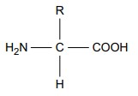
How is a peptide bond formed? | a condensation reaction between two amino acids
What is a polypeptide? | many amino acids joined together
Describe the biuret test for proteins | mix the sample with sodium hydroxide solution at room temperature, add very dilute copper(II) sulfate solution, mix gently, a purple colour indicates that peptide bonds are present
How does an enzyme affect a reaction? | it lowers the activation energy
Give five factors which can affect enzyme action | temperature, pH, enzyme concentration, substrate concentration, inhibitor concentration
What is a competitive inhibitor? | a molecule with a similar shape to the substrate, allowing it to occupy the active site of the enzyme
What is a non-competitive inhibitor? | a molecule that changes the shape of the enzyme by binding somewhere other than the active site.

Basic components of living systems
Learn the answers to the questions below then cover the answers column with a piece of paper and write as many answers as you can. Check and repeat.
What is the formula to calculate magnification? | size of image  magnification = actual size of object
Why are cells stained before being viewed with a light microscope? | staining increases contrast between different cell components, makes them visible, and allows them to be identified
What is an eyepiece graticule? | a glass disc that fits on top of the eyepiece lens that is marked with a fine scale from 1 to 100
What is a stage micrometer? | a microscope slide with a very accurate scale in micrometers (µ) engraved on it
What is a scientific drawing? | a labelled line drawing that is used to highlight particular features and does not include unnecessary detail or shading, it should always have a title and state the magnification
What is magnification? | how many times larger an image is than the actual size of the object being viewed
What is resolution? | the ability to see individual objects as separate entities
What is the function of the nucleus? | controls the metabolic activities of the cell as it contains genetic information in the form of DNA
What is the nucleolus? | area within the nucleus that is responsible for producing ribosomes
What is the function of mitochondria? | site of production of ATP in the final stages of cellular respiration
What are vesicles? | membranous sacs that are used to transport materials in the cell
What are lysosomes? | specialised forms of vesicles with hydrolytic enzymes that break down waste material in cells
What is the role of the cytoskeleton? | controls cell movement, movement of organelles within the cell, and provides mechanical strength to the cell
Name the three types of cytoskeletal filaments | microfilaments, microtubules, and intermediate fibres
Give two types of extension that protrude from some cells | flagella (whip-like protrusions) and cilia (tail-like protrusions)
What is the endoplasmic reticulum (ER)? | a network of membranes enclosing flattened sacs called cisternae
What are the functions of the two types of ER? | smooth ER – lipid and carbohydrate synthesis, and storage rough ER – synthesis and transport of proteins
What is the function of the Golgi apparatus? | plays a part in modifying proteins and packaging them into vesicles

Maths skills

1 Numbers and units

1.1 Units and prefixes
A key criterion for success in biological maths lies in the use of correct units and the management of numbers. The units scientists use are from the Système Internationale – the SI units. In biology, the most commonly used SI base units are metre (m), kilogram (kg), second (s), and mole (mol). Biologists also use SI derived units, such as square metre (m²), cubic metre (m³), degree Celsius (°C), and litre (l).
To accommodate the huge range of dimensions in our measurements they may be further modified using appropriate prefixes. For example, one thousandth of a second is a millisecond (ms). Some of these prefixes are illustrated in the table below.
Multiplication factor | Prefix | Symbol
10⁹ | giga | G
10⁶ | mega | M
10³ | kilo | k
10–2 | centi | c
10^{–3} | milli | m
10^{–6} | micro | µ
10^{–9} | nano | n

Practice questions
- A burger contains 4 500 000 J of energy. Write this in:
a kilojoules b megajoules.
- HIV is a virus with a diameter of between 9.0×10⁻⁸ m and 1.20×10⁻⁷ m.
Write this range in nanometres.

1.2 Powers and indices
Ten squared = 10 × 10 = 100 and can be written as 10². This is also called ‘ten to the power of 2’.
Ten cubed is ‘ten to the power of three’ and can be written as 10³ = 1000.
The power is also called the index.
Fractions have negative indices: one tenth = 10⁻¹ = 1/10 = 0.1 one hundredth = 10⁻² = 1/100 = 0.01
Any number to the power of 0 is equal to 1, for example, 29⁰ = 1.
If the index is 1, the value is unchanged, for example, 17¹ = 17.
When multiplying powers of ten, you must add the indices.
So 100 × 1000 = 100 000 is the same as 10² × 10³ = 10² ⁺ ³ = 10⁵
When dividing powers of ten, you must subtract the indices.
So 100/1000 = 1/10 = 10⁻¹ is the same as 10²/10³ = 10² ⁻ ³ = 10⁻¹
But you can only do this when the numbers with the indices are the same.
So 10² × 2³ = 100 × 8 = 800
And you can’t do this when adding or subtracting.
10² + 10³ = 100 + 1000 = 1100
10² − 10³ = 100 − 1000 = −900
Remember: You can only add and subtract the indices when you are multiplying or dividing the numbers, not adding or subtracting them.

Practice questions
- Calculate the following values. Give your answers using indices. a 10⁸ × 10³ b 10⁷ × 10² × 10³
c 10³ + 10³ d 10² − 10⁻²
- Calculate the following values. Give your answers with and without using indices. a 10⁵ ÷ 10⁴ b 10³ ÷ 10⁶ c 10² ÷ 10⁻⁴ d 100² ÷ 10²

1.3 Converting units
When doing calculations, it is important to express your answer using sensible numbers. For example, an answer of 6230 μm would have been more meaningful expressed as 6.2 mm.
If you convert between units and round numbers properly, it allows quoted measurements to be understood within the scale of the observations.
To convert 488 889 m into km:
A kilo is 10³ so you need to divide by this number, or move the decimal point three places to the left.
488 889 ÷ 10³ = 488.889 km
However, suppose you are converting from mm to km: you need to go from 10³ to 10⁻³, or move the decimal point six places to the left.
333 mm is 0.000 333 km
Alternatively, if you want to convert from 333 mm to nm, you would have to go from 10⁻⁹ to 10⁻³, or move the decimal point six places to the right.
333 mm is 333 000 000 nm

Practice questions
- Calculate the following conversions:
  - 0.004 m into mm b 130 000 ms into s c 31.3 ml into μl d 104 ng into mg
- Give the following values in a different unit so they make more sense to the reader.
Choose the final units yourself. (Hint: make the final number as close in magnitude to zero as you can. For example, you would convert 1000 m into 1 km.)
  - 0.000 057 m b 8 600 000 μl c 68 000 ms d 0.009 cm

2 Decimals, standard form, and significant figures

2.1 Decimal numbers
A decimal number has a decimal point. Each figure before the point is a whole number, and the figures after the point represent fractions.
The number of decimal places is the number of figures after the decimal point. For example, the number 47.38 has 2 decimal places, and 47.380 is the same number to 3 decimal places.
In science, you must write your answer to a sensible number of decimal places.

Practice questions
- New antibiotics are being tested. A student calculates the area of clear zones in Petri dishes in which the antibiotics have been used. List these in order from smallest to largest.
0.0214 cm² 0.03 cm² 0.0218 cm² 0.034 cm²
- A student measures the heights of a number of different plants. List these in order from smallest to largest.
22.003 cm 22.25 cm 12.901 cm 12.03 cm 22 cm

2.2 Standard form
Sometimes biologists need to work with numbers that are very small, such as dimensions of organelles, or very large, such as populations of bacteria. In such cases, the use of scientific notation or standard form is very useful, because it allows the numbers to be written easily.
Standard form is expressing numbers in powers of ten, for example, 1.5×10⁷ microorganisms.
Look at this worked example. The number of cells in the human body is approximately 37 200 000 000 000. To write this in standard form, follow these steps:
Step 1: Write down the smallest number between 1 and 10 that can be derived from the number to be converted. In this case it would be 3.72
Step 2: Write the number of times the decimal place will have to shift to expand this to the original number as powers of ten. On paper this can be done by hopping the decimal over each number like this:
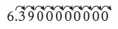
until the end of the number is reached.
In this example that requires 13 shifts, so the standard form should be written as 3.72×10¹³.
For very small numbers the same rules apply, except that the decimal point has to hop backwards. For example, 0.000 000 45 would be written as 4.5×10⁻⁷.

Practice questions
3 Change the following values to standard form.
a 3060 kJ b 140 000 kg c 0.000 18 m  4 Give the following numbers in standard form. | d 0.000 004 m
a 100 b 10 000 c 0.01 | d 21 000 000
5 Give the following as decimals.
a 10⁶ b 4.7×10⁹ c 1.2×10¹² d 7.96×10⁻⁴

2.3 Significant figures
When you use a calculator to work out a numerical answer, you know that this often results in a large number of decimal places and, in most cases, the final few digits are ‘not significant’. It is important to record your data and your answers to calculations to a reasonable number of significant figures. Too many and your answer is claiming an accuracy that it does not have, too few and you are not showing the precision and care required in scientific analysis.
Numbers to 3 significant figures (3 s.f.):
7.88 25.4 741
Bigger and smaller numbers with 3 significant figures:
0.000 147 0.0147 0.245 39 400 96 200 000 (notice that the zeros before the figures and after the figures are not significant – they just show you how large the number is by the position of the decimal point).
Numbers to 3 significant figures where the zeros are significant:
207 4050 1.01 (any zeros between the other significant figures are significant).
Standard form numbers with 3 significant figures:
9.42×10⁻⁵ 1.56×10⁸
If the value you wanted to write to 3.s.f. was 590, then to show the zero was significant you would have to write:
590 (to 3.s.f.) or 5.90 × 10²
Remember: For calculations, use the same number of figures as the data in the question with the lowest number of significant figures. It is not possible for the answer to be more accurate than the data in the question.

3 Working with formulae
It is often necessary to use a mathematical formula to calculate quantities. You may be tested on your ability to substitute numbers into formulae or to rearrange formulae to find specific values.

3.1 Substituting into formulae
Think about the data you are given in the question. Write down the equation and then think about how to get the data to substitute into the equation. Look at this worked example.
A cheek cell has a 0.06 mm diameter. Under a microscope it has a diameter 12 mm. What is the magnification?
I
magnification = image size (mm) ÷ object size (mm) or M =
O
Substitute the values and calculate the answer:
M = 12 mm/0.06 mm = 12/0.06 = 200
Answer: magnification = ×200 (magnification has no units)
Sometimes an equation is more complicated and the steps need to be carried out in a certain order to succeed. A general principle applies here, usually known by the mnemonic BIDMAS. This stands for Brackets, Indices (functions such as squaring or powers), Division, Multiplication, Addition, Subtraction.

Practice questions
- Calculate the magnification of a hair that has a width of 6.6 mm on a photograph. The hair is 165 µm wide.
- Estimate the area of a leaf by treating it as a triangle with base 2 cm and height 9 cm.
- Estimate the area of a cell by treating it as a circle with a diameter of 0.7 µm. Give your answer in µm².
- An Amoeba population starts with 24 cells. Calculate how many Amoeba cells would be present in the culture after 7 days if each cell divides once every 20 hours. Use the equation N_{t} = N₀ × 2^{n} where Nt = number after time t, N0 = initial population, n = number of divisions in the given time t.
- In a quadrat sample, an area was found to contain 96 aphids, 4 ladybirds, 22 grasshoppers,
2
 n 
and 3 ground beetles. Calculate the diversity of the site using the equation D = 1−Σ 
N where n = number of each species, N = grand total of all species, and D = diversity.
Remember: In this equation there is a part that needs to be done several times then summed, shown by the symbol Σ.

3.2 Rearranging formulae
Sometimes you will need to rearrange an equation to calculate the answer to a question. For example, the relationship between magnification, image size, and actual size of specimens in
I
micrographs usually uses the equation M = , where M is magnification, I is size of the image,
O
and O = actual size of the object.
You can use the algebra you have learnt in Maths to rearrange equations.
Cover the quantity you want to find. This leaves you with either a fraction or a multiplication:
M = I ÷ O O = I ÷ M I = M × O
- A fat cell is 0.1 mm in diameter. Calculate the size of the diameter seen through a microscope with a magnification of ×50.
- A Petri dish shows a circular colony of bacteria with a cross-sectional area of 5.3 cm². Calculate the radius of this area.
- In a photograph, a red blood cell is 14.5 mm in diameter. The magnification stated on the image is ×2000. Calculate the real diameter of the red blood cell.
- Rearrange the equation 34 = 2a/135 × 100 and find the value of a.
- The cardiac output of a patient was found to be 2.5 dm³ min⁻¹ and their heart rate was 77 bpm. Calculate the stroke volume of the patient.
Use the equation: cardiac output = stroke volume × heart rate.
biomass transferred
- In a food chain, efficiency = × 100
biomass taken in
A farmer fed 25 kg of grain to his chicken. The chicken gained weight with an efficiency of 0.84. Calculate the weight gained by the chicken.

4 Magnification
To look at small biological specimens you use a microscope to magnify the image that is observed. The microscope was developed in the 17th century. Anton van Leeuwenhoek used a single lens and Robert Hooke used two lenses. The lenses focus light from the specimen onto your retina to produce a magnified virtual image. The magnification at which observations are made depends on the lenses used.

4.1 Calculating the magnifying power of lenses
Lenses each have a magnifying power, defined as the number of times the image is larger than the real object. The magnifying power is written on the lens.
To find the magnification of the virtual image that you are observing, multiply the magnification powers of each lens used. For example, if the eyepiece lens is ×10 and the objective lens is ×40 the total magnification of the virtual image is 10 × 40 = 400.

Practice questions
1 Calculate the magnification of the virtual image produced by the following combinations of lenses:
a objective ×10 and eyepiece ×12 b objective ×40 and eyepiece ×15
4.2 Calculating the magnification of images
Drawings and photographs of biological specimens should always have a magnification factor stated. This indicates how much larger or smaller the image is compared with the real specimen.
The magnification is calculated by comparing the sizes of the image and the real specimen. Look at this worked example.
The image shows a flea which is 1.3 mm long. To calculate the magnification of the image, measure the image (or the scale bar if given) on the paper (in this example, the body length as indicated by the line A–B).
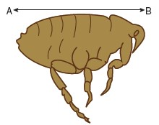
For this image, the length of the image is 42 mm and the length of the real specimen is 1.3 mm.
length of image
magnification = = 42/1.3 = 32.31
length of real specimen
The magnification factor should therefore be written as ×32.31
Remember: Use the same units. A common error is to mix units when performing these calculations. Begin each time by converting measurements to the same units for both the real specimen and the image.

Practice questions
2 Calculate the magnification factor of a mitochondrion that is 1.5 µm long.
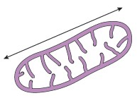

4.3 Calculating real dimensions
Magnification factors on images can be used to calculate the actual size of features shown on drawings and photographs of biological specimens. For example, in a photomicrograph of a cell, individual features can be measured if the magnification is stated. Look at this worked example.
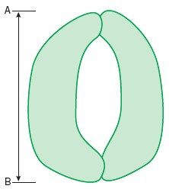
The magnification factor for the image of the open stoma is ×5000.
This can be used to find out the actual size of any part of the cell, for example, the length of one guard cell, measured from A to B.
Step 1: Measure the length of the guard cell as precisely as possible. In this example the image of the guard cell is 52 mm long.
Step 2: Convert this measurement to units appropriate to the image. In this case you should use µm because it is a cell.
So the magnified image is 52 × 1000 = 52 000 µm
Step 3: Rearrange the magnification equation (see Topic 3.2) to get: real size = size of image/magnification = 52 000/5000 = 10.4 So the real length of the guard cell is 10.4 µm.
3 Use the magnification factor to determine the actual size of a bacterial cell.
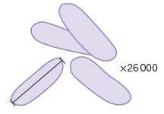

5 Percentages and uncertainty
A percentage is simply a fraction expressed as a decimal. It is important to be able to calculate routinely, but is often incorrectly calculated in exams. These pages should allow you to practise this skill.

5.1 Calculating percentages as proportions
To work out a percentage, you must identify or calculate the total number using the equation:
number you want as a percentage of total number
percentage = × 100%
total number
For example, in a population, the number of people who have brown hair was counted.
The results showed that in the total population of 4600 people, 1800 people had brown hair.
The percentage of people with brown hair is found by calculating:
number of people with brown hair
× 100
total number of people
= 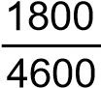 × 100 = 39.1%

Practice questions
- The table below shows some data about energy absorbed by a tree in a year and how some of it is transferred.
Energy absorbed by the tree in a year | 3 600 000 kJ/m²
Energy transferred to primary consumers | 2240 kJ/m²
Energy transferred to secondary consumers | 480 kJ/m²
Calculate the percentage of energy absorbed by the tree that is transferred to a primary consumers b secondary consumers.
- One in 17 people in the UK has diabetes.
Calculate the percentage of the UK population that have diabetes.

5.2 Calculating the percentage change
When you work out an increase or a decrease as a percentage change, you must identify, or calculate, the total original amount:
increase
% increase = × 100
original amount
decrease
% decrease = × 100
original amount
Remember: When you calculate a percentage change, use the total before the increase or decrease, not the final total.

Practice questions
3 Convert the following mass changes as percentage changes.
Sucrose conc. / mol dm⁻³ | Initial mass / g | Final mass / g | Mass change / g | Percentage change in mass
0.9 | 1.79 | 1.06
0.7 | 1.86 | 1.30
0.5 | 1.95 | 1.70
0.3 | 1.63 | 1.76
0.1 | 1.82 | 2.55

5.3 Measurement uncertainties
When you measure something, there will always be a small difference between the measured value and the true value. This may be because of the size of the scale divisions on your measuring equipment, or the difficulty of taking the measurement. This is called an uncertainty.
To estimate the uncertainty of a measurement with an instrument with a marked scale such as a ruler, a good rule of thumb is to let the uncertainty be equal to half the smallest division on the scale being used.
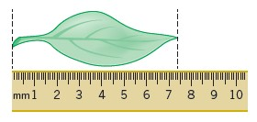
Using a ruler with a mm scale, the length of the leaf seems to be 74 mm. The smallest division is 1 mm, so the uncertainty is 0.5 mm.
The true length is therefore 74 mm +/− 0.5 mm.
4 Give the uncertainty for the following pieces of equipment:
a large measuring cylinder with 2 cm³ divisions b digital stopwatch timer measuring to the nearest hundredth of a second c thermometer with 0.1 °C divisions.

5.4 Calculating percentage uncertainties
The uncertainty is the range of possible error either side of the true value due to the scale being used, so the value recorded for the measurement = closest estimate +/− uncertainty.
The difference between the true value and the maximum or minimum value is called the absolute error.
Once the absolute error has been established for a particular measurement, it is possible to express this as a percentage uncertainty or relative error. The calculation to use is:
absolute error relative error = × 100%
measured value
In the leaf example above, the absolute error is +/−0.5 mm.
The relative error is therefore:
0.5/74 × 100% = 0.7%

Practice questions
5 Complete the table to show the missing values in the last two columns.
Measurement made | Equipment used | Absolute error | Relative error
Length of a fluid column in a respirometer is 6 mm | mm scale | 0.5 mm
Volume of a syringe is 12 cm³ of liquid | 0.5 cm³ divisions
Change in mass of 1.6 g | balance with 2 d.p.

6 Scatter graphs and lines of best fit
The purpose of a scatter graph with a line of best fit is to allow visualisation of a trend in a set of data. The graph can be used to make calculations, such as rates, and also to judge the correlation between variables. It is easy to draw such a graph but also quite easy to make simple mistakes.

6.1 Plotting scatter graphs
The rules when plotting graphs are:
- Ensure that the graph occupies the majority of the space available:
  - In exams, this means more than half the space o Look for the largest number to help you decide the best scale o The scale should be based on 1, 2, or 5, or multiples of those numbers
- Ensure that the dependent variable that you measured is on the y-axis and the independent variable that you varied is on the x-axis
- Mark axes using a ruler and divide them clearly and equidistantly (i.e. 10, 20, 30, 40 not 10, 15, 20, 30, 45)
- Ensure that both axes have full titles and units are clearly labelled
- Plot the points accurately using sharp pencil ‘x’ marks so the exact position of the point is obvious
- Draw a neat best fit line, either a smooth curve or a ruled line. It does not have to pass through all the points. Move the ruler around aiming for:
  - as many points as possible on the line o the same number of points above and below the line
- If the line starts linear and then curves, be careful not to have a sharp corner where the two lines join. Your curve should be smooth
- Confine your line to the range of the points. Never extrapolate the line beyond the range within which you measured
- Add a clear, concise title.
Remember: Take care, use only pencil and check the positions of your points.

Answers to maths skills practice questions

1 Numbers and units
- a 1 kJ = 1000 J, so 4 500 000 J = 4 500 000/1000 kJ = 4500 kJ b 1 MJ = 1000 kJ, so 4500 kJ = 4.5 MJ
- 1 m = 10⁹ nm (there are a billion nanometre in a metre)
9.0 × 10⁻⁸ m = 9.0 × 10⁻⁸ × 10⁹ nm = 9.0 × 10⁻⁸ ⁺ ⁹ nm = 9.0 × 10 nm = 90 nm
1.20 × 10⁻⁷ m = 1.20 × 10⁻⁷ × 10⁹ nm = 1.20 × 10⁻⁷ ⁺ ⁹ nm = 1.20 × 100 nm = 120 nm
Range = 90 nm to 120 nm
- a 10¹¹ b 10¹²
c 1000 + 1000 = 2000 d 100 − 0.01 = 99.99
- a 10¹ or 10 b 10⁻³ or 0.001
c 10⁶ or 1 000 00 d 100² ÷ 100 = 100 or 10²
- a 4 mm b 130 s
c 31 300 µl d 0.000 104 mg
- a 57 µm b 8.6 L or 8.6 dm³ c 68 s d 0.09 mm

2 Decimals, standard form, and significant figures
- 10.0214 cm² 0.0218 cm² 0.03 cm² 0.034 cm²
- 12.03 cm 12.901 cm 22 cm 22.003 cm 22.25 cm
- a 3.06×10³ kJ b 1.4×10⁵ kg c 1.8×10⁻⁴ m d 4×10⁻⁶ m
- a 1×10² b 1×10⁴ c 1×10⁻² d 2.1×10⁷
- Give the following as decimals.
a 1 000 000 b 4 700 000 000 c 1 200 000 000 000 d 0.000 796
- a 7600 g / 7640 g b 28 m / 27.5 m c 4.3 g / 4.33 g d 6.0 × 10² m / 5.00 × 10² m
- 1.2 × 10⁴ g

3 Working with formulae
- M? I = 6.6 mm O = 165 μm
Change to same units: either both mm or both μm or both m: 165 μm = 0.165 mm
M = I/O = 6.6/0.165 = × 40
- Area = 0.5 × 2 cm × 9 cm = 9 cm²
- Area = π r² = π × (0.7 µm)² = π × (0.7 × 10⁻⁶ m) × (0.7 × 10⁻⁶ m) = 1.5 µm²
- N₀ = 24
7 days = 7 × 24 hours = 168 hours so n = 168 ÷ 20 = 8.4
Nt = 24 x 28.4 = 8107 cells
- N = 96 + 4 + 22 + 3 = 125 animals found
2
 n  so D = −1 ∑ 
N
inner brackets: D = −1  96 ² + 4 ² + 22 ² + 3 ²
125 125 125 125 
indices: D= −1 (0.768² + 0.032² + 0.176² + 0.024²)
addition: D = 1 − 0.6224 = 0.3776 = 0.38 (2.d.p)
- O = 0.1 mm I = ? M = 50 I = M × O = 50 × 0.1 mm = 5 mm 7 Area = 5.3 cm² radius? A = π r²
5.3
5.3 = π r² r² = = 1.687 r = 1.687 = 1.3 cm
π
² r² = A r = A r = 5.3 = 1.3 cm
Or A = π r
π π π
- 7.25 × 10^{–6} m (7.25 µm)
 34 
 ×135
100 
- a == 22.95
2
- cardiac output = stroke volume x heart rate
2.7 ³ stroke volume = = 0.035 dm 77
biomass transfer
- Substitute in the known values: 0.84 = ×100
25
0.84
Rearrange the equation to give:biomass transfer = ×25 = 0.21 kg 100

4 Magnification
- a ×120 b ×600
- ×26 000 3 0.88 µm

5 Percentages and uncertainty
- a 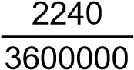 × 100 = 0.06% b 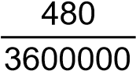 × 100 = 0.013%
- 5.88%
3
Sucrose conc. / mol dm⁻³ | Initial mass / g | Final mass / g | Mass change / g | Percentage change in mass
0.9 | 1.79 | 1.06 | −0.73 | −40.8%
0.7 | 1.86 | 1.30 | −0.56 | −30.1%
0.5 | 1.95 | 1.70 | −0.25 | −12.8%
0.3 | 1.63 | 1.76 | +0.13 | +8.0%
0.1 | 1.82 | 2.55 | +0.73 | +40.1%
4 a 1 cm³ b 0.005 s c 0.05 °C
5
Measurement made | Equipment used | Absolute error | Relative error
Length of a fluid column in a respirometer is 6 mm | mm scale | 0.5 mm | 0.5  ×100 = 8.3%  6
Volume of a syringe is 12 cm³ of liquid | 0.5 cm³ divisions | 0.25 cm³ | 0.25  ×100 = 2.1%  12
Change in mass of 1.6 g | balance with 2 d.p. | 0.005 g | 0.005×2  ×100 = 0.6%  1.6

6 Scatter graphs and lines of best fit
- 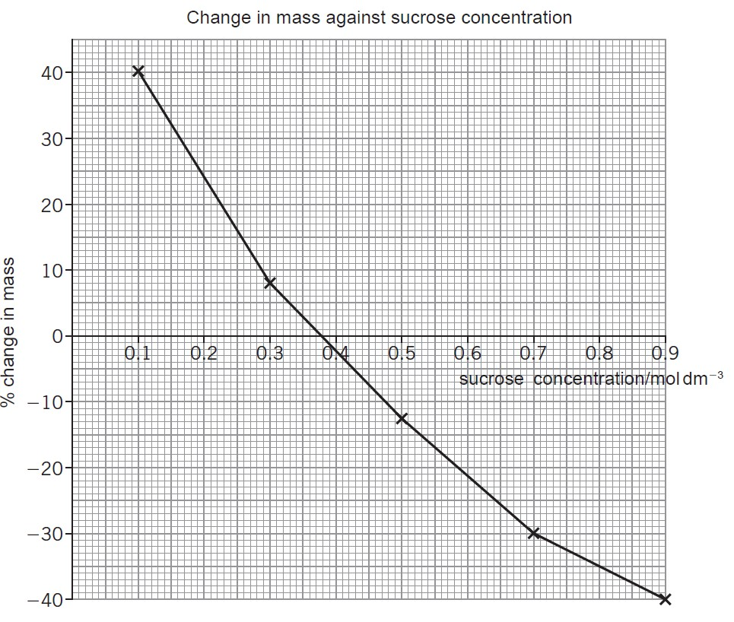.
- Table 1: Strong correlation. Positive at the start. As light intensity increases, the increase in the rate of photosynthesis decreases (so the graph levels off).
Table 2: Strong correlation. Negative at the start. As time increases, the rate of the decrease of the concentration decreases (so the graph levels off).

Useful information and activities
There are a number of activities throughout this resource. The answers to some of the activities are available on our secure website, e-AQA. Your teacher will be able to provide you with these answers.

SI units
Every measurement must have a size (eg 2.7) and a unit (eg metres or ºC). Sometimes, there are different units available for the same type of measurement. For example, ounces, pounds, kilograms and tonnes are all used as units for mass.
To reduce confusion, and to help with conversion between different units, there is a standard system of units called the SI units which are used for most scientific purposes.
These units have all been defined by experiment so that the size of, say, a metre in the UK is the same as a metre in China.
The seven SI base units are:
Physical quantity | Usual quantity symbol | Unit | Abbreviation
mass | m | kilogram | kg
length | l or x | metre | m
time | t | second | s
electric current | I | ampere | A
temperature | T | kelvin | K
amount of substance | N | mole | mol
luminous intensity | (not used at A-level) | candela | cd

All other units can be derived from the SI base units.
For example, area is measured in square metres (written as m²) and speed is measured in metres per second (written as ms^{–1}).
It is not always appropriate to use a full unit. For example, measuring the width of a hair or the distance from Manchester to London in metres would cause the numbers to be difficult to work with.
Prefixes are used to multiply each of the units. You will be familiar with centi (meaning 1/100), kilo (1000) and milli (1/1000) from centimetres, kilometres and millimetres.
There is a wide range of prefixes. The majority of quantities in scientific contexts will be quoted using the prefixes that are multiples of 1000. For example, a distance of 33 000 m would be quoted as 33 km.
The most common prefixes you will encounter are:
Prefix | Symbol | Multiplication factor
Tera | T | 1012 | 1 000 000 000 000
Giga | G | 109 | 1 000 000 000
Mega | M | 106 | 1 000 000
kilo | k | 10³ | 1000
deci | d | 10-1 | 0.1 | 1/10
centi | c | 10-2 | 0.01 | 1/100
milli | m | 10-3 | 0.001 | 1/1000
micro | μ | 10-6 | 0.000 001 | 1/1 000 000
nano | n | 10-9 | 0.000 000 001 | 1/1 000 000 000
pico | p | 10-12 | 0.000 000 000 001 | 1/1 000 000 000 000
femto | f | 10–15 | 0.000 000 000 000 001 | 1/1 000 000 000 000 000

Activity 1
Which SI unit and prefix would you use for the following quantities?
- The time between heart beats
- The length of a leaf
- The distance that a migratory bird travelled each year
- The width of a cheek cell
- The mass of a rabbit
- The mass of iron in the body
- The volume of the trunk of a large tree
Sometimes, there are units that are used that are not combinations of SI units and prefixes.
These are often multiples of units that are helpful to use. For example, one litre is 0.001 m³, or one day is 86 400 seconds.

Activity 2
Choose the most appropriate unit, and estimate the size of each of the following.

- The mass of an elephant

- The mass of an earthworm

- The volume of water in a teardrop

- The volume of water in a pond

- The time taken for a sunflower to grow

- The temperature difference between the blood in the heart and in the ear on a cold day

- The width of a hair

- The length that your fingernails grow each day

- The total length of each of the hairs on your head

Activity 3
Put the following in order of size:
height of an elephant; length of DNA strand; width of a hair; height of a tree; width of a sodium ion; length of a nerve cell; length of a heart; width of a red blood cell; size of a virus; length of a finger; length of a mosquito; length of a human digestive system; width of a field; length of a water molecule.

Important vocabulary for practical work
You will have come across most of the words used in practical work in your
GCSE studies. It is important that you use the right definition for each word.
Activity 4
Join the boxes to link the word to its definition.

Accurate |  | A statement suggesting what may happen in the future.

Data |  | An experiment that gives the same results when a different person carries it out, or a different set of equipment or technique is used.

Precise |  | A measurement that is close to the true value.

Prediction |  | An experiment that gives the same results when the same experimenter uses the same method and equipment.

Range |  | Physical, chemical or biological quantities or characteristics.

Repeatable |  | A variable that is kept constant during an experiment.

Reproducible |  | A variable that is measured as the outcome of an experiment.

Resolution |  | This is the smallest change in the quantity being measured (input) of a measuring instrument that gives a perceptible change in the reading.

Uncertainty |  | The interval within the true value can be expected to lie.

Variable |  | The spread of data, showing the maximum and minimum values of the data.

Control variable |  | Measurements where repeated measurements show very little spread.

 | Dependent variable |  | Information, in any form, that has been collected.

Cells
All life on Earth exists as cells. These have basic features in common.
Activity 5
Complete the table.

Structure | Function
Cell-surface membrane
Chloroplast
Cell vacuole
Mitochondria
Nucleus
Cell wall
Chromosomes
Ribosomes

Draw the structure of a plant cell and an animal cell.
On each cell, add labels showing each of the structures in the table, if they exist.

Photosynthesis and respiration
Two of the most important reactions that take place in living things are photosynthesis and respiration. They both involve transfer of energy.
Activity 6
Complete the table.
Which of the answers for aerobic respiration would be different for anaerobic respiration? Add these answers to the table in a different colour.
 |  | Photosynthesis | Aerobic respiration
Which organisms carry out this process?

Where in the organisms does the process take place?
Energy store at the beginning of the process | Sun
Energy store at the end of the process |  |  | In cells
Reactants needed for the process

Products of the process

Overall word equation
Balanced symbol equation for the overall process

Principles of moving across boundaries
In biology, many processes involve moving substances across boundaries.
Match the examples to the principle(s) involved. For each, give a brief description of why it is relevant
Osmosis | Examples  Drinking a sports drink after exercise  Gas exchange in the lungs  Absorbing nutrients from food into the body  Moving ions into cells  The effect of salt on slugs  Penguins huddling together to keep warm  Potato pieces get heavier when put in pure water  Potato pieces get lighter when put in very salty water  Cacti do not have thin, large leaves
Active transport
Diffusion
Changing surface area or length

Genetic inheritance

Activity 8
Huntington’s disease is an example of a disease where the mutation causing the disease is dominant. h: normal (recessive)
H: mutation (dominant)

 |  | Pater | nal alleles
 |  | H |  | h
Maternal alleles | h
 | h

Cystic fibrosis is an example of a disease where the mutation causing the disease is recessive.
F: normal (recessive)
f: mutation (dominant)

 |  | Pater | nal alleles
 |  | F |  | f
Maternal alleles | F
 | f

For each of the Punnett squares:
- Complete the diagrams to show the alleles for each child.
- State which parent and child is:
  - healthy • has the disease
  - a carrier.

Each of the following statements is false. Re-write each one so that it becomes true.
- The first Punnett square shows that one in every four children from this couple will have Huntington’s disease.

- The second Punnett square shows that there is a one in three chance that a child born to this couple will have cystic fibrosis.

- All children of the second couple will either be carriers or suffer from cystic fibrosis.

- The percentage of children who are sufferers on the diagram is the same as the percentage of children each couple will have who are sufferers.

- Having one child who is born with cystic fibrosis means that the next three children will not have the disease.

- A 50:50 chance is the same as a 0.25 probability.

Analysing data
Biological investigations often result in large amounts of data being collected. It is important to be able to analyse this data carefully in order to pick out trends.

Activity 9: Mean, media, mode and scatter graphs
A student investigated an area of moorland where succession was occurring. She used quadrats to measure the area covered by different plant species, bare ground and surface water every 10 metres along a transect. She also recorded the depth of soil at each quadrat. Her results are shown in the table.

 | Area covered in each quadrat A to E in cm²
 | A | B | C | D | E
Bog moss | 55 | 40 | 10 | – | –
Bell heather | – | – | – | 15 | 10
Sundew | 10 | 5 | – | – | –
Ling | – | – | – | 15 | 20
Bilberry | – | – | – | 15 | 25
Heath grass | – | – | 30 | 10 | 5
Soft rush | – | 30 | 20 | 5 | 5
Sheep’s fescue | – | – | 25 | 35 | 30
Bare ground | 20 | 15 | 10 | 5 | 5
Surface water | 15 | 10 | 5 | – | –
Soil depth / cm | 3.2 | 4.7 | 8.2 | 11.5 | 14.8
– indicates zero cover.
Calculate:
- the mode area of soft rush in the sample
- the mean soil depth
- the median amount of bare ground in the sample.

Activity 9: Mean, media, mode and scatter graphs (continued)
Use the data from the table to plot a scatter graph of soil depth against the area covered by bare ground, soft rush and bog moss (use different colours or markers for each).

Activity 9: Mean, media, mode and scatter graphs (continued)
- What conclusions does your graph suggest?

- How confident are you in these conclusions?

Activity 10: Analysing tables
Lung cancer, chronic bronchitis and coronary heart disease (CHD) are associated with smoking. Tables 1 and 2 give the total numbers of deaths from these diseases in the UK in 1974.
Table 1 Men
Age/years | Number of deaths (in thousands)
 | lung cancer | chronic bronchitis | coronary heart disease
35-64 | 11.5 | 4.2 | 31.7
65-74 | 12.6 | 8.5 | 33.3
75+ | 5.8 | 8.1 | 29.1
Total (35-75+) | 29.9 | 20.8 | 94.1

Table 2 Women
 | Age/years | Number of death (in thousands)
 |  | lung cancer | chronic bronchitis | coronary heart disease
 | 35–64 | 3.2 | 1.3 | 8.4
 | 65–74 | 2.6 | 1.9 | 18.2
 | 75+ | 1.8 | 3.5 | 42.3
 | Total (35–75+) | 7.6 | 6.7 | 68.9

Activity 10: Analysing tables (continued)
- Of the men who died aged 35-64 from one of these three causes, what percentage of them died of lung cancer?

- What percentage of deaths from chronic bronchitis in women happened to women aged 65-74?

- Deaths from lung cancer drop as people get older. Is there a bigger percentage difference for men or women from 35-64 to 75+?

- What fraction of coronary heart disease deaths of men over 34 are in the 75+ bracket? What about for women?

Activity 11: Analysing complex graphs
The volume of air breathed in and out of the lungs during each breath is called the tidal volume. The breathing rate and tidal volume were measured for a cyclist pedaling at different speeds. The graph shows the results.

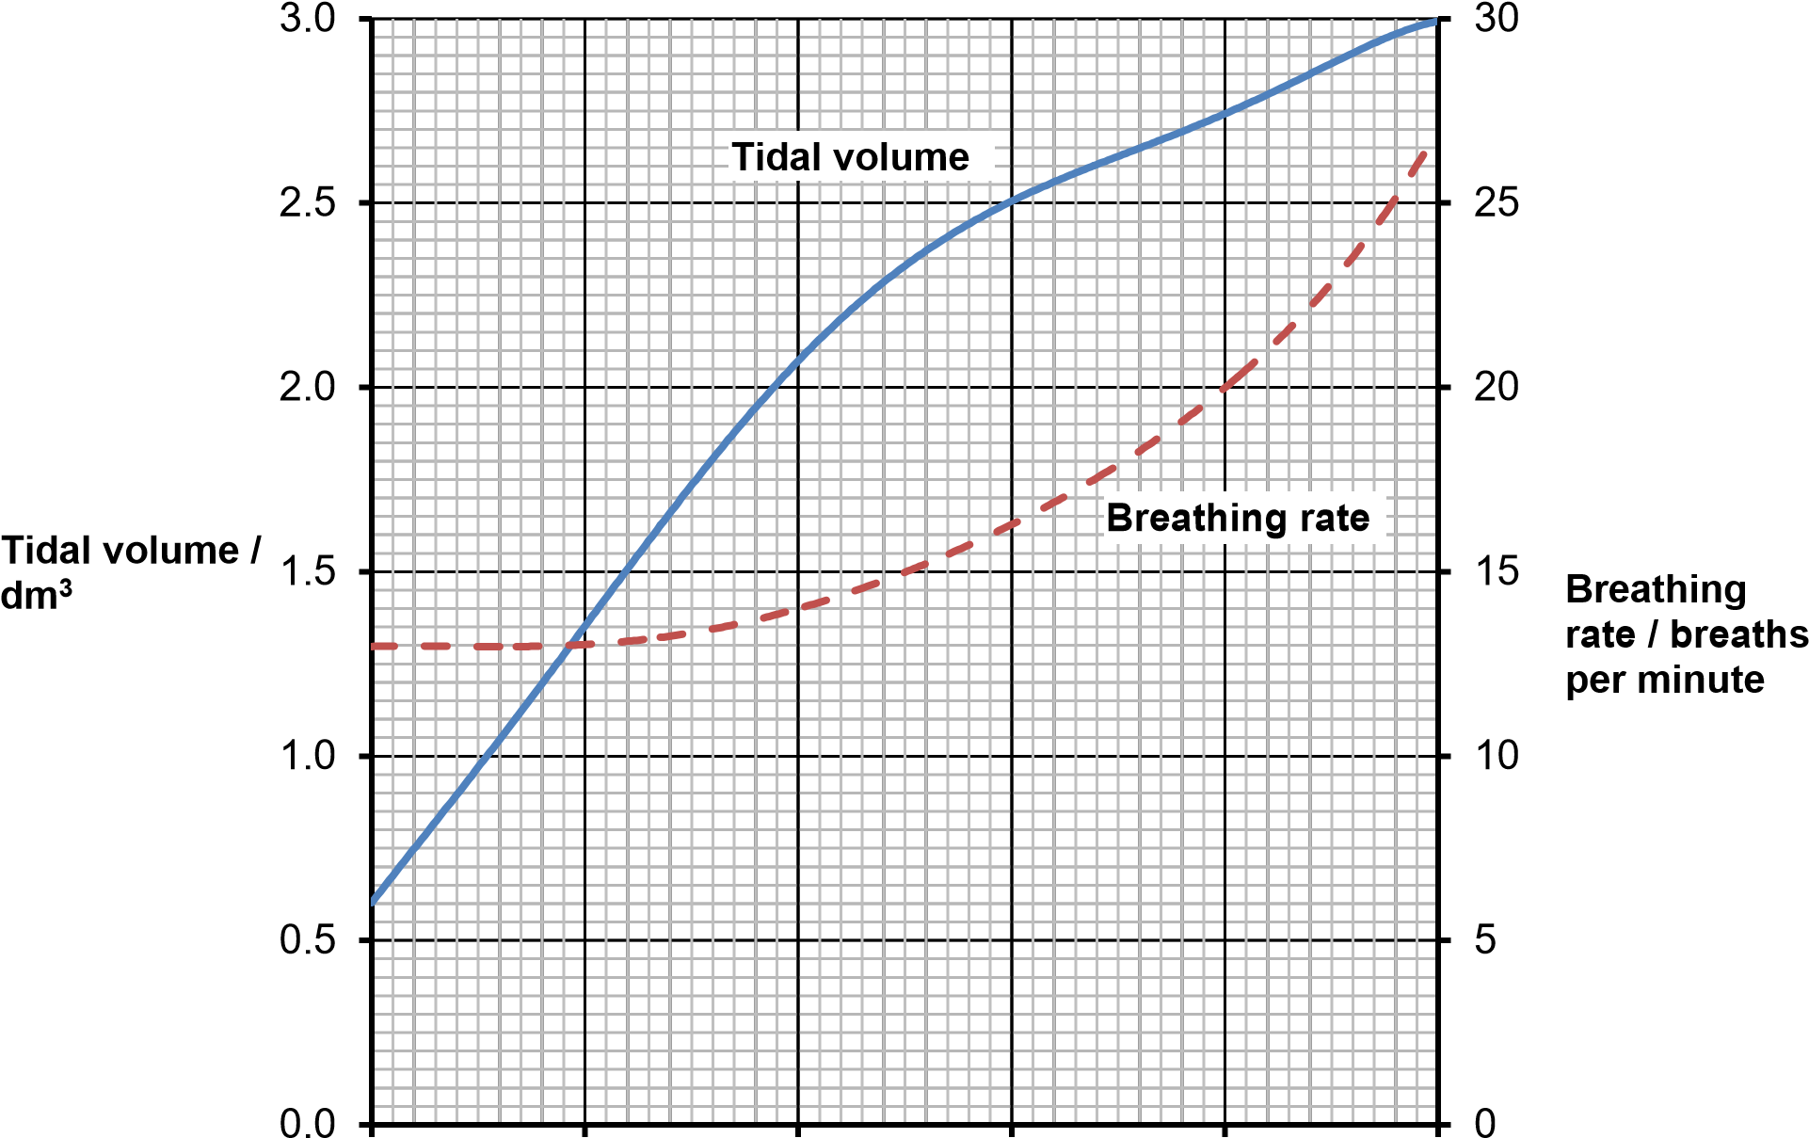
0 5 10 15 20 25
Cycling speed / km h^{–1}

- What was the tidal volume when the cycling speed was 17 km h^{–1}?
- What was the breathing rate when the cycling speed was 8 km h^{–1}?
- What was the change in breathing rate when the cyclist changed from
10 to 20 km h^{–1}? Express this as a percentage.
- At what speed did the breathing rate start to increase?
- The tidal volume increased linearly with cycling speed up to about 10 km h^{–1}. Calculate the increase in volume for each increase in speed of 1 km h^{–1}.
- For this initial linear section, what is the equation of the tidal volume line? Hint: use y=mx + c

