Applied Law
Transition Booklet

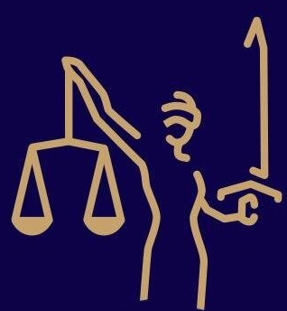

NAME:

This booklet will help prepare you for studying Applied Law.
Make sure you read it carefully and complete all of the activities.
It will require you to research on the internet and at times newspapers.

DEADLINE: It must be completed and shown to your teacher in your first Law lesson in September.

If you would like more information about what is involved in this course then you can visit the exam board website – https://qualifications.pearson.com/en/qualifications/btec-nationals/applied-law-2017.html

Please note we will be studying the extended certificate.

Key Word List - Intro to Law
To start with, here are some basic key words/phrases that you will encounter along the course.
Task - is to write your own definition of them where possible.

Key Word | Definition | Own Definition
Actus Reus | ‘the guilty act’.
Appeal | The process by which a more senior court reviews the decision of a lower court.
Civil Law | The system of law concerned with private interactions between members of a community; rather than criminal law.
Common Law | The law developed mainly from judicial decisions based on precedent as opposed to statute; synonymous with case law.
Damages | Monetary compensation awarded by a court.
Doctrine | A legal rule or principle.
Green Papers | Used to gain views about proposed legislation from interested bodies; an initial consultation document, responses to which may or may not be acted upon.
Guilty | A court's verdict that the person charged with a crime is legally responsible for that crime.
Oblique intention | The defendant foresees that the consequence of their actions is virtually certain.
Jury | A group of people selected to reach a verdict in a legal case, based upon the evidence presented and instructions on the relevant law.
Lay people | Individuals involved with the legal process but without legal qualifications, eg magistrates and jurors.
Magistrate | A Justice of the Peace who presides over cases in the magistrates' court.
Mens rea | ‘the guilty mind’.
Obiter Dicta | ‘Other things said’; comments and remarks not part of the legal rule.
Omission | Failure to perform an act; inaction.
Parliamentary supremacy | Parliament creates the highest form of law, which must be applied by the courts; Parliament can legislate on any matter and is not bound by its predecessors.
Precedent | A judicial decision which binds equal or lower courts in its jurisdiction and which can be persuasive to higher courts in cases with similar facts.
Ratio Decidendi | The legal reason for a decision; the rule established by the decision, binding on equal or lower courts.
Stare Decisis | Latin: ‘to stand by things decided’. In legal practice: the principle that precedent should determine legal decision making in cases involving similar facts.
Statute | A binding piece of legislation, synonymous with Act.
Statutory interpretation | The process by which courts interpret and apply legislation.
Subjective recklessness | The defendant is aware of a risk but proceeds regardless.
Transferred malice | When the mens rea of one offence can be transferred to another offence.
White Papers | Used to make clear Government’s preferred approach to a future piece of legislation.

TASK 2 - Read the following case summary and annotate around the text, pointing out all related legal concepts. E.g.Crown Court = is a criminal law court

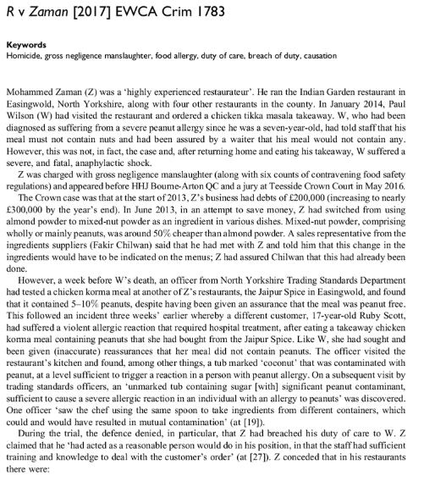

Task 3 - State the key differences between criminal and civil law

 | Criminal Law | Civil Law
Examples of a case that would go to court
Purpose of the trial?
Who brings the case to court?
Outcomes of a case
Standard of proof required
Burden of proof is on who?
Where do the trials take place?

Task 4 - Below are the 5 major non-fatal offences that are within the course for criminal law, read each offence and next to each offence summarise in your own words how the offence can be committed.

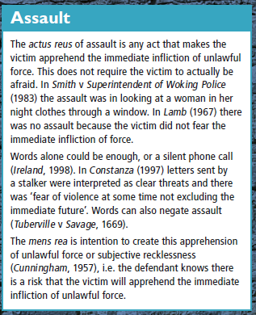

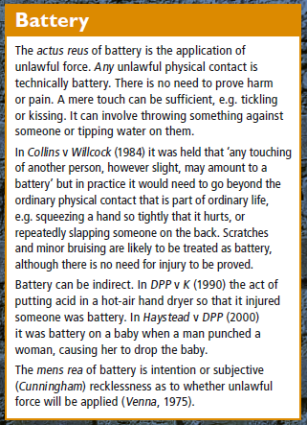

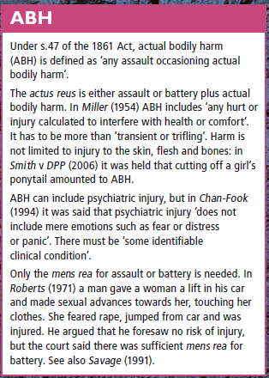

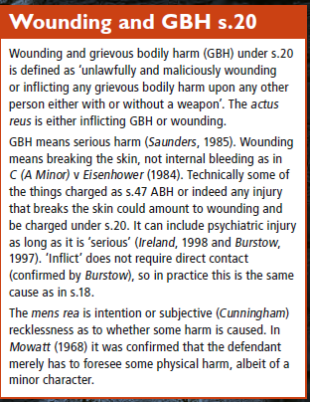

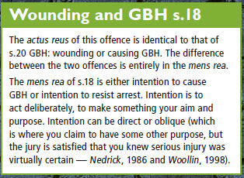

Task 5 - Research the following cases and summarise the key legal point for negligence.

CASE NAME | LEGAL POINT
DUTY OF CARE
Donoghue v Stevenson | e.g. Gave us the ‘neighbour principle’ and that we must take reasonable care to ensure that we do not injure those around us that we can reasonably foresee
Caparo v Dickman
Kent v Griffiths
BREACH OF DUTY
Nettleship v Weston
Paris v SBC
Bolton v Stone
Mullin v Richards
Bolam
DAMAGE CAUSED
Barnett v Chelsea Hospital
Wagon Mound
Smith v Leech Brain
CONTRIBUTORY NEGLIGENCE
Sayers v Harlow UDC
RES IPSA LOQUITUR - ‘The things speak for itself’
Scott v St Katherine Docks

TASK 6 - Research the following professions and explain how the qualification route to becoming one (after completion of A-levels) and the key differences between their roles.

Solicitors and Barristers

 | Solicitors | Barristers
Qualification Route

Roles within the profession (summarise)

TASK 7 - Read the following scenarios for claims of negligence and complete the following tasks for each one:

- Highlight the key legal information that might be useful for the claim of negligence
- Underneath the scenario, outline if the claimant would have a chance of being successful and explain why so and maybe why not.
- If the claimant is claiming for £100,000 for personal injury, find out what route this would have to take in terms of track and court.

Robyn fitted a handrail over the bath for Elsie, her elderly and very overweight aunt.
A few days later, when Elsie was getting out of the bath, the handrail came away from the wall. Elsie fell backwards into the bath and suffered severe head injuries. If this matter were to be taken to court, it is estimated that a successful claim in negligence would result in damages exceeding £100 000, excluding the minor damage to the bathroom.

Susan, aged sixteen, had recently started a care course at college and was on her first work experience placement, looking after Tim, aged two. Tim demanded to do some painting and, in order to keep him quiet, Susan agreed. She found some old pots of paint in the shed and gave Tim some cotton wool to spread the paint on sheets of paper. Some of the pots had a small label marked ‘Danger, Toxic’, which Susan did not notice or read. Tim suffered poisoning as a result of handling the paint, but fortunately recovered after a short spell in hospital.

