Topic/Skill | Definition/Tips | Example
1. Expression | A mathematical statement written using symbols, numbers or letters, | $$3x + 2 or 5y^{2}$$
2. Equation | A statement showing that two expressions are equal | $$2y – 17 = 15$$
5. Simplifying Expressions | Collect ‘like terms’.  Be careful with negatives.  $x^{2}$ and $x$ are not like terms. | $$2x+3y+4x-5y+3=6x-2y+3$$  $$3x+4-x^{2}+2x-1=5x-x^{2}+3$$
6. $x$times $x$ | The answer is $x^{2}$ not $2x$. | Squaring is multiplying by itself, not by 2.
7. $p×p×p$ | The answer is $p^{3}$ not $3p$ | If $p=2$, then $p^{3}$=$2×2×2=8$, not $2×3=6$
8. $p+p+p$ | The answer is 3p not $p^{3}$ | If $p=2$, then $2+2+2=6$, not $2^{3}=8$
9. Expand | To expand a bracket, multiply each term in the bracket by the expression outside the bracket. | $$3\left(m+7\right)=3x+21$$
10. Expanding Double Brackets | To multiply out a pair of double brackets, multiply each term in the first brackets by each term in the second brackets. | 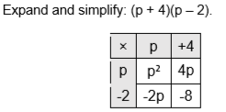  $$p^{2}+2p-8$$
11. Expanding Triple Brackets | To multiply out triple brackets, multiply each term in the first brackets by each term in the second brackets. Then multiply this answer by each term in the third brackets. | 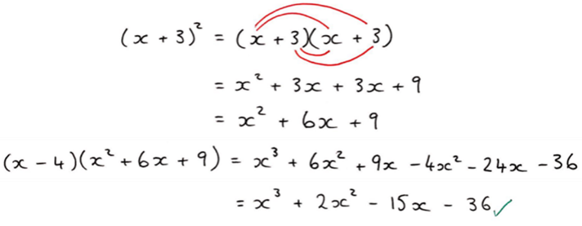
12. Factorise | The reverse of expanding.  Factorising is writing an expression as a product of terms by ‘taking out’ a common factor or highest common factor | $6x-15=3(2x-5)$, where 3 is the common factor.  ${3x}^{2}y^{2}+9xy=3xy(xy+3)$, where $3xy$ is the highest common factor.
13. Solve | To find the answer/value of something  Use inverse operations on both sides of the equation (balancing method) until you find the value for the letter. | Solve $2x-3=7$  Add 3 on both sides  $$2x=10$$  Divide by 2 on both sides  $$x=5$$
14. Writing Formulae and Equations | Substitute letters for words in the question. | Bob charges £3 per window and a £5 call out charge.  $$C=3N+5$$  Where N=number of windows and C = cost
15. Quadratic | A quadratic expression is of the form  $$ax^{2}+bx+c$$  where $a, b$ and $c$ are numbers, $a≠0$ | Examples of quadratic expressions:  $$x^{2}$$  $$8x^{2}-3x+7$$  Examples of non-quadratic expressions:  $$2x^{3}-5x^{2}$$  $$9x-1$$
16. Factorising Quadratics | When a quadratic expression is in the form $x^{2}+bx+c$ find the two numbers that add to give b and multiply to give c. | $$x^{2}+7x+10=(x+5)(x+2)$$  (because 5 and 2 add to give 7 and multiply to give 10)  $$x^{2}+2x-8=(x+4)(x-2)$$  (because +4 and -2 add to give +2 and multiply to give -8)
17. Factorising Quadratics when $a≠1$ | When a quadratic is in the form  $$ax^{2}+bx+c$$  1. Multiply a by c = ac  2. Find two numbers that add to give b and multiply to give ac.  3. Re-write the quadratic, replacing $bx$ with the two numbers you found.  4. Factorise in pairs – you should get the same bracket twice  5. Write your two brackets – one will be the repeated bracket, the other will be made of the factors outside each of the two brackets. | Factorise $6x^{2}+5x-4$  1. $6×-4=-24$  2. Two numbers that add to give +5 and multiply to give -24 are +8 and -3  3. $6x^{2}+8x-3x-4$  4. Factorise in pairs:  $$2x\left(3x+4\right)-1(3x+4)$$  5. Answer = $(3x+4)(2x-1)$

