Topic/Skill | Definition/Tips | Example
1. Fraction | A mathematical expression representing the division of one integer by another.  Fractions are written as two numbers separated by a horizontal line. | $\frac{2}{7}$ is a ‘proper’ fraction.  $\frac{9}{4}$ is an ‘improper’ or ‘top-heavy’ fraction.
2. Numerator | The top number of a fraction. | In the fraction $\frac{3}{5}$, 3 is the numerator.
3. Denominator | The bottom number of a fraction. | In the fraction $\frac{3}{5}$, 5 is the denominator.
4. Unit Fraction | A fraction where the numerator is one and the denominator is a positive integer. | $\frac{1}{2},\frac{1}{3},\frac{1}{4} etc.$are examples of unit fractions.
5. Reciprocal | The reciprocal of a number is 1 divided by the number.  The reciprocal of $x$ is $\frac{1}{x}$  When we multiply a number by its reciprocal we get 1. This is called the ‘multiplicative inverse’. | The reciprocal of $5$ is $\frac{1}{5}$  The reciprocal of $\frac{2}{3}$ is $\frac{3}{2}$, because  $$\frac{2}{3}×\frac{3}{2}=1$$
6. Mixed Number | A number formed of both an integer part and a fraction part. | $3\frac{2}{5}$ is an example of a mixed number.
7. Improper Fractions | Fraction in which the numerator is bigger than the denominator. | $\frac{7}{5}$ is an example of an improper fraction.
8. Simplifying Fractions | Divide the numerator and denominator by the highest common factor. | $$\frac{20}{45}=\frac{4}{9}$$
9. Equivalent Fractions | Fractions which represent the same value. | $$\frac{2}{5}=\frac{4}{10}=\frac{20}{50}=\frac{60}{150} etc.$$
10. Comparing Fractions | To compare fractions, they each need to be rewritten so that they have a common denominator.  Ascending means smallest to biggest.  Descending means biggest to smallest. | Put in to ascending order : $\frac{3}{4}, \frac{2}{3}, \frac{5}{6}, \frac{1}{2}$.  Equivalent: $\frac{9}{12}, \frac{8}{12}, \frac{10}{12}, \frac{6}{12}$  Correct order: $\frac{1}{2}, \frac{2}{3}, \frac{3}{4}, \frac{5}{6}$
11. Converting between Mixed numbers and Improper Fractions | How many of the denominator can you get out of the numerator?  Find the total number of unit fraction in the mixed number. | 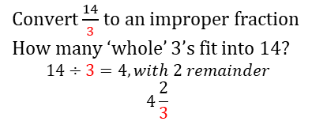  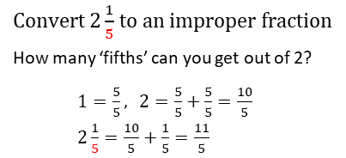
12. Adding or Subtracting Fractions | Find the LCM of the denominators to find a common denominator.  Use equivalent fractions to change each fraction to the common denominator.  Then just add or subtract the numerators and keep the denominator the same. | 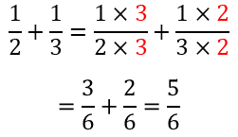  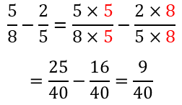
13. Multiplying Fractions | Multiply the numerators together and multiply the denominators together. | $$\frac{3}{8}×\frac{2}{9}=\frac{6}{72}=\frac{1}{12}$$
14. Dividing Fractions | ‘Keep it, Flip it, Change it – KFC’  Keep the first fraction the same  Flip the second fraction upside down  Change the divide to a multiply  Multiply by the reciprocal of the second fraction. | $$\frac{3}{4}÷\frac{5}{6}$$  $$=\frac{3}{4}×\frac{6}{5}$$  $$=\frac{18}{20}=\frac{9}{10}$$
15. Fraction of an Amount | Divide by the bottom, times by the top | Find $\frac{2}{5}$of £60  $$60÷5=12$$  $$12 ×2=24$$
16. One quantity as a fraction of another. | Make the first quantity the numerator  Make the second quantity the denominator.  Simplify | Write 12 as a fraction of 40.  $$\frac{12}{40}=\frac{6}{20}=\frac{3}{10} or \frac{12}{40}=\frac{3}{10}$$

