Year 9
Term 5 Knowledge organiser
This organiser relates to work unit 3.1 Applications of Materials
There are 5 questions in total, each with 4 parts. You will be asked what type of material will be used for a given application and 3 reasons why the material is correct.
Applications covered
Wind turbine blades
Engine Cylinder head
Pillar Drill chuck guard
Anti-vibration mounts
Centre punch
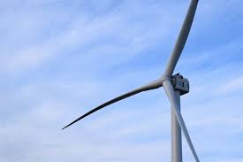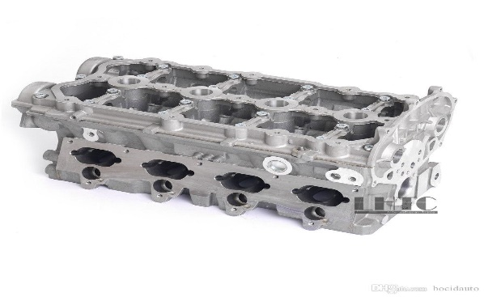
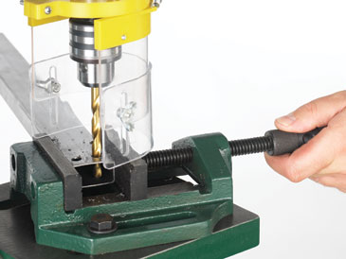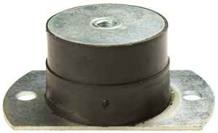
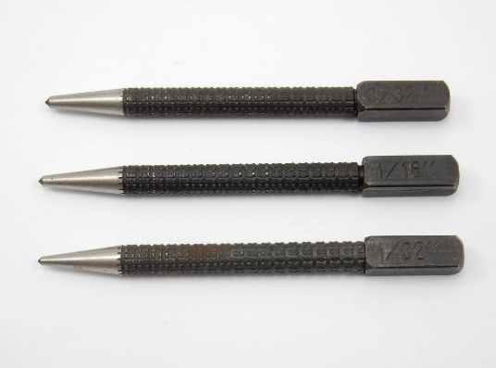
Considerations
Many things that are manufactured for real life applications need to abide by a set of rules

Ease to make/manufacture
Cost effectiveness
Weather conditions
Life span Legal requirements
Impact on the environment
Stress loading

