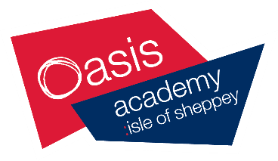
Oasis Academy Isle of Sheppey
Sixth Form Application 2020/21

SECTION 1 Personal Details
Full Name ……………………………………………………………………. Date of Birth ……………………………….
Address ……………………………………………………………………………………………………………………………….
………………………………………………………………………………Post Code .....……………………………………….
Mobile ……………………………………………………… Home No ……………………………………………………….
Email …………………………………………………………………………………………………………………………………...

SECTION 2 Previous School
Previous school …………………………………………………………………………………………………………………..
Address ………………………………………………………………………………………………………………………………
……………………………………………………………………………….. Post Code ………………………………………..
Name of Referee from previous school ……………………………………………………………………………..
Referee Position …………………………………………………………………………………………………………………
Email address of Referee ……………………………………………………………………………………………………

SECTION 3 Predicted grades
English Lang |  | Maths |  | Science
English Lit
SECTION 4
Course Choices – Please indicate below which courses you wish to study by ticking your choice. You can select 3 subjects
All applications are considered on an individual basis, students who do not achieve grade 4 or above in English and Maths will be entered for GCSE re-sit.
Level | Subject | Selection
BTEC L3 | Applied Criminology
BTEC L3 | Applied Law
BTEC L3 | Applied Psychology
A-Level | Art
A-Level | Biology
A-Level | Chemistry
BTEC L3 | Construction
BTEC L3 | Creative Media Studies
BTEC L3 | Dance
BTEC L3 | Drama
A-Level | English Language & Literature
A-Level | Film Studies
BTEC L3 | Financial Studies
BTEC L3 | Health & Social Care
A-Level | History
A-Level | Psychology
A-Level | Sociology
BTEC L3 | Sport

SECTION 5 Signature
The offer of a place in Oasis Academy Isle of Sheppey Sixth Form is dependent on meeting the minimum grade requirements indicated above, including those for specific subjects.
Student signature ………………………………………………………… Date ………………………………………
Parent signature …………………………………………………………... Date ………………………………………

When complete please hand into the Minster or Sheerness reception addressed to Miss Kempt. External applicants return to Miss Kempt, Oasis Academy Isle of Sheppey, Marine Parade, Sheerness, ME12 2BE

