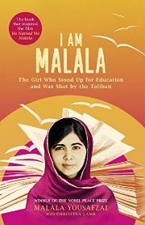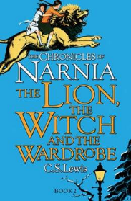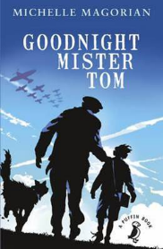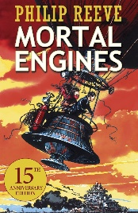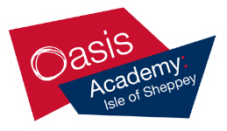

‘The Lion, the Witch and the Wardrobe’ by C.S. Lewis

To earn your first House Points at Oasis Academy: Isle of Sheppey, hand in your completed postcard to your mentor on the first day back! Enjoy ☺

Top books to read before year 7

‘I am Malala’ by Malala Yousafzai

‘Goodnight Mr Tom’ by Michelle Magorian

‘Mortal Engines’ by Phillip Reeve