Favourite Fiction

Name: ..............................................................................................

The three works of fiction I have decided to read are:

1 Title: ................................................................................................ Author: ........................................................................................... Type of book: ..................................................................................
2 Title: ................................................................................................

Author: ........................................................................................... Type of book: ..................................................................................

3 Title: ................................................................................................ Author: ...........................................................................................
Type of book: ..................................................................................

Task

Now choose a character from one of the books you have read, or a book that you have recently just read. Imagine that character came to your school for a day! How would they behave?

How would your friends react? What would your teachers say?
Remember your character can be from the past. It might be fun to imagine what a character from history might think of your school!

Your character may be a hero or a villain! What might they get up to? It could be an animal or a mythical creature!

Once you have chosen your character, write an account of the day they came to your school!

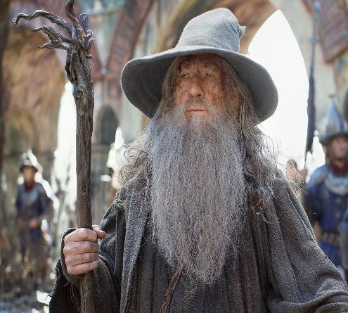Remember to use lots of descriptions to make your writing lively and entertaining. Write about 300 words.

