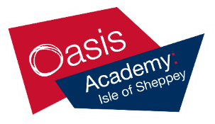**Welcome to science at Oasis Isle of Sheppey**

SCIENCE TRANSITION TASK 2

We are really looking forward to seeing you in September!

Mini Beast Survey

Mini beasts (insects) are really excellent indicators of a good habitat and environment. When pollution levels are low, we tend to see lots more insects such as bees and butterflies about. In

2020, the lockdown has actually led to a massive reduction in air pollution, and hopefully you would have seen a big increase in insects!

Insects are really important. Bees, moths, and butterflies are all examples of pollinators. These helps fruit, vegetables and plants reproduce. Worms and beetles break down dead plants to create more soil.

Activity 1: Whilst you are going for a walk, sitting in the park or in your garden, choose one 30- minute session and try to keep a tally of the number of mini-beasts that you can see! If you have to lift up stones or logs to find woodlice, please place the stones or logs back carefully again as this is the creature’s habitat!

Hazard: don’t try and grab any bees or wasps. Admire them from a distance!

|  |  |
| --- | --- |
| **Insect** | **Tally** |
| Bee |  |
| Wasp |  |
| Ladybug |  |

Tally table continues on the next page:

|  |  |
| --- | --- |
| Insect | Tally |
| Woodlouse |  |
| Butterfly |  |
| Blue Bottle  Fly |  |

Activity 2: Take a photo of a mini-beast in action! Whilst doing your mini-beast survey can you take a photo of one of them and write a very short description.

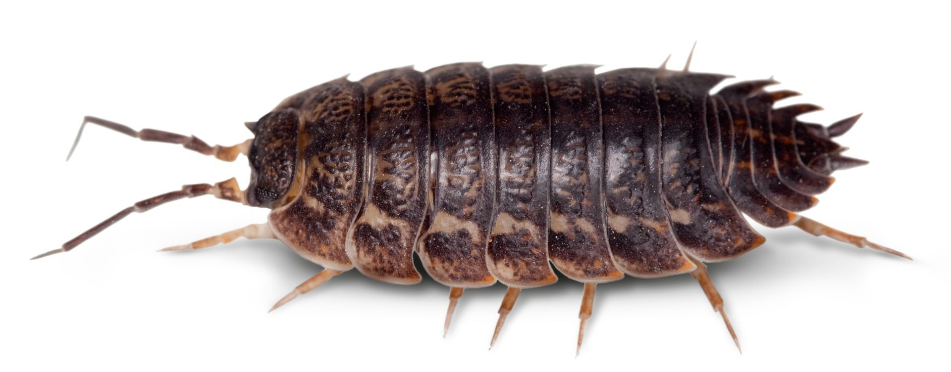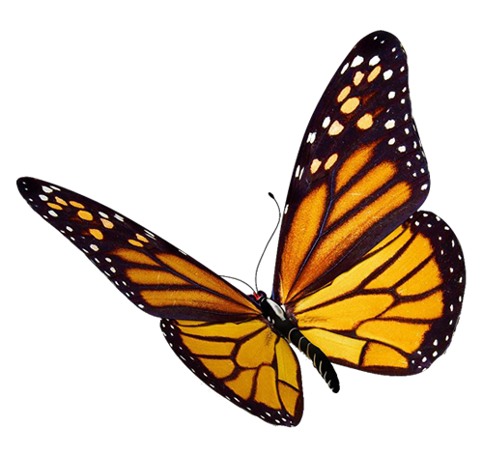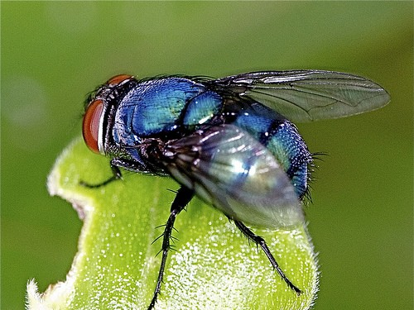

Where was your mini-beast at the time? What was your mini-beast doing?

You can write your ideas down here:

Bring your Mini-beast tally, photo and description with you to school in September where you can hand it in to your new science teacher!